Characteristics of High School Physics Problem-Solving Skills and Integrating the PBL Model Assisted by E-Book

¹Irgy Redityo Dawana, ^{2*} Dwikoranto
State University of Surabaya, Indonesia
*Corresponding Author e-mail: dwikoranto@unesa.ac.id

Received:…………..; Revised:…………; Published: …………..
Abstract
This research discusses the implementation of the Problem-Based Learning model assisted by E-Book to improve students' problem-solving skills on renewable energy materials. The purpose of this research is to identify the characteristics of physics problem-solving through the knowledge profile of students at the high school level as a consideration in the application of the PBL model and the use of E-Book assisted learning media to improve problem-solving skills. The research method used is a preliminary study with qualitative descriptive analysis. The instruments used include the problem-solving skills test, interview questionnaire, and student response questionnaire. The findings showed that students' problem-solving skills were generally in the low category. Of the total learners, 87 students were in the low category, 2 students in the medium category, and 1 student in the high category. Although students have been able to understand the problem, they still experience problems in providing answers and checking back due to lack of habit in working on problem-solving-based problems. Therefore, it is necessary to practice and use learning models, as well as E-Book technology, which can help in the process of teaching and learning activities and increase students' learning motivation. Thus, it is expected that students' problem-solving skills can be improved through the right learning approach and the use of relevant technology.
Keywords: E-Book, Problem-Based Learning, Problem-Solving, Renewable Energy
How to Cite: First author., Second author., & Third author. (20xx). The title. Prisma Sains: Jurnal Pengkajian Ilmu dan Pembelajaran Matematika dan IPA IKIP Mataram, vol(no), xx-yy. doi:https://doi.org/10.33394/j-ps.vxxiyy

https://doi.org/10.33394/j-ps.vxxiyy | Copyright© 2019, First author et al  This is an open-access article under the CC-BY License.

INTRODUCTION
This study discusses the characteristics of students' problem-solving skills in physics learning in high school with a focus on the profile of students' initial ability in problem-solving. This research is based on the demands of the world of education which is currently oriented towards developing 21st-century skills which include 4C skills, namely communication, collaboration, critical thinking and problem-solving, and creativity and innovation (Admoko et al., 2021; A. P. Astuti et al., 2019; Jalinus, 2021; Samadun & Dwikoranto, 2022; Taar & Palojoki, 2022). Problem-solving skills are one of the four main skills required in 21st-century education, as these skills are essential in overcoming complex challenges and problems in the era of globalization and increasingly advanced technology (Kartikasari & Usodo, 2022; Rahayu et al., 2022). Problem-solving skills can be considered the most complex and significant stage of learning compared to other stages of learning (Raviv et al., 2022; Ummah & Yuliati, 2020).
In learning physics in high school, problem-solving skills are very important because physics is one of the fields of study that requires high problem-solving skills (N. H. Astuti et al., 2021; Ayudha & Setyarsih, 2021; Prahani et al., 2022). Learners must be able to identify problems, formulate hypotheses, and test these hypotheses through experiments or calculations (Ananda & Atmojo, 2022; Chevalier et al., 2020; Is’ ad & Sukarmin, 2022; Schukajlow et al., 2022). After that, learners must be able to evaluate the results obtained and make appropriate conclusions (Silamon et al., 2020). According to (Amin et al., 2019; Anggraini et al., 2021; Qotrunnada, 2022) physics learning can foster and develop problem solving skills in students. Based on the opinion of (Ceberio et al., 2016; Good et al., 2020; Herayanti et al., 2020; Senhora et al., 2022) an effective way to learn Physics is to solve Physics problems by solving Physics problems independently and structured. To be able to solve physics problems, students must be able to collect relevant information, analyze the relationship between the facts or information provided, plan appropriate problem solving strategies, and evaluate the results that have been obtained (Ambaryani & Putranta, 2022; Dwikoranto, 2022; Melawati et al., 2022; Qomariyah et al., 2023). This shows that problem solving ability is an important part of the learning process (Hidaayatullaah et al., 2020).
The characteristics of learners' problem-solving skills can be seen from the profile of their initial problem-solving ability. The profile of learners' initial problem solving ability can also be an indication of the characteristics of their problem solving skills (García-Moya et al., 2022). The profile of learners' initial problem solving ability includes the ability to identify problems, analyze problems, design strategies, test hypotheses, and find solutions. Therefore, through the initial problem solving ability profile, educators can design appropriate learning to improve learners' problem solving skills. Problem solving skills can be known by using steps based on Polya with 4 stages, namely (1) understanding the problem, (2) devising a plan, (3) carrying out the plan, and (4) looking back (Gunawan et al., 2020; Polya, 2004; Soebagyo et al., 2022).
Renewable energy material is an important part of physics learning that requires problem-solving skills in facing the challenges of the energy crisis in the future. Therefore, effective learning methods or models are needed so that students can overcome problems and find solutions in meeting current and future energy needs (Adriyawati et al., 2020; De la Torre et al., 2021; Ntona et al., 2015; Rizki et al., 2023). These learning methods and models must be able to help students understand how to optimize the use of renewable energy sources, and evaluate the effectiveness and efficiency of energy use (Meuer et al., 2021; Nordin & Samsudin, 2021; Sroufe & Ramos, 2015). This aims to provide a comprehensive understanding of the environmental and economic impacts of using renewable energy, so that students can understand how to maintain sustainability and pay attention to environmental aspects in the use of energy sources (Adriyawati et al., 2020; Tozzi Jr & Jo, 2017).
Teachers have a very important role in planning and implementing learning that is able to train and develop students' thinking skills (Sumartini, 2016), in addition to helping students understand the concepts taught (Fatimah et al., 2023). Especially in renewable energy material, teachers must be able to develop learning that can help students master problem-solving skills and life skills to overcome challenges related to the availability, management, and utilization of energy sources (Fauzia & Kelana, 2020; Hrybiuk, 2019; Leite, 2017; Nguyen et al., 2020; Nibbi et al., 2019). In an effort to improve students' problem solving skills, choosing the right learning model is very important. Based on the results of the literature review, a scientific approach that emphasizes student-centered learning with the help of technological media, such as Problem Based Learning (PBL) is recommended as an effective learning model (Ayudha & Setyarsih, 2021; Noviatika et al., 2019). In PBL, students are given stimulation in the form of problems that must be solved independently with the hope of improving students' problem solving skills (Anam et al., 2020; Setyani et al., 2021).
The above gap refers to the need to use additional technology to support the PBL model to successfully improve learners' problem-solving skills. By using e-learning technology in learning, teachers have the opportunity to apply digital technology in physics learning (Dawana, Setyarsih, et al., 2022; Krasnova & Shurygin, 2020). The use of e-learning in learning has the potential to be effective in developing students' skills and providing innovation in teaching (Al Rawashdeh et al., 2021; Prasistayanti et al., 2019). Some previous studies have proven the effectiveness of e-learning technology in physics learning. For example, in a study conducted by (A. I. Mahardika et al., 2021) the development of electronic modules on simple harmonic motion material proved effective in improving student learning outcomes, with an n-gain value of 0.37 in the moderate category. Another study conducted by (Haque et al., 2021) showed that the use of interactive E-Books in learning momentum and impulse can provide motivation and create a comfortable independent learning atmosphere for students. Through the use of E-Books, teachers can create flexibility in learning, presenting interesting content in the form of videos, images, and interactive learning materials (Dawana, Dwikoranto, et al., 2022; Ebied & Rahman, 2015; Lai, 2016).
Based on the problems and descriptions above, this study aims to identify the characteristics of physics problem solving through the knowledge profile of students, as well as a consideration in the application of PBL models and the use of E-Book assisted learning media. This is expected to help teachers in designing effective learning to improve students' problem solving skills.

METHOD
This research is a preliminary study that uses data analysis techniques in the form of qualitative descriptive analysis (Neswary & Prahani, 2022). This research aims to find out the actual situation at school and add information related to the problem in more detail. This research does not test hypotheses, so it can be said that this research is more exploratory than verification (Pristianti & Prahani, 2022). The results of this study will be used as a consideration to improve the innovation of learning models and media in the school, with the aim of improving the problem solving skills of high school students. Therefore, this research can provide valuable information for the school to make improvements and improve the quality of learning in the school.
The subjects in this study were Xth grade high school students in Surabaya with a total of 91 students. This study used research instruments, namely a problem-solving skills test, interviews with teachers, and student response questionnaires. This study used purposive side technique in sampling. In data analysis, this study used a test questionnaire and a survey to get responses from students using google form (Asrial et al., 2022). In addition, researchers also conducted interviews with teachers and some students to obtain more in-depth information related to students' problem solving skills in high school. In this study, a qualitative descriptive analysis technique was used to explain the actual situation in accordance with existing facts. This research was conducted by following the research stages described in Figure 1.

Figure 1. Research Methods

To find out the characteristics of students' problem solving skills, it is necessary to give a problem solving skills test. The test sheet is given to students consisting of 5 essay questions. The questions are equipped with indicators of problem solving skills based on Polya with 4 indicators, namely (1) understanding the problem, (2) devise a plan, (3) carry out the plan, and (4) looking back (Polya, 2004). Furthermore, students were given 10 response questionnaires in the form of responses related to physics learning at school. In the next stage of the research, researchers conducted interviews with physics teachers to obtain further information related to the teaching and learning process in the classroom, the use of E-Books as learning media, and training of problem solving skills for students. Interviews were conducted with the aim of matching the answers given by teachers and students and obtaining a more complete picture of the topic.
This preliminary research has limitations, as it was only conducted on a specific sample and may not be generalizable to a wider population. Therefore, further research with a more rigorous research design can be conducted to strengthen the findings of this study.

RESULTS AND DISCUSSION

Test Results of Problem-Solving Skills in High School Level Students
This research was conducted by giving a test in the form of an essay consisting of 5 questions which contained 4 indicators of problem solving skills. Learners are expected to be able to answer the questions given by identifying the problems contained in the problem, planning a plan to solve the problem, implementing the plan in solving the problem, and evaluating the results of the process of the answers that have been given whether they can solve the problems they provide. Based on the research that has been conducted, the results of problem solving skills are shown in Figure 2.
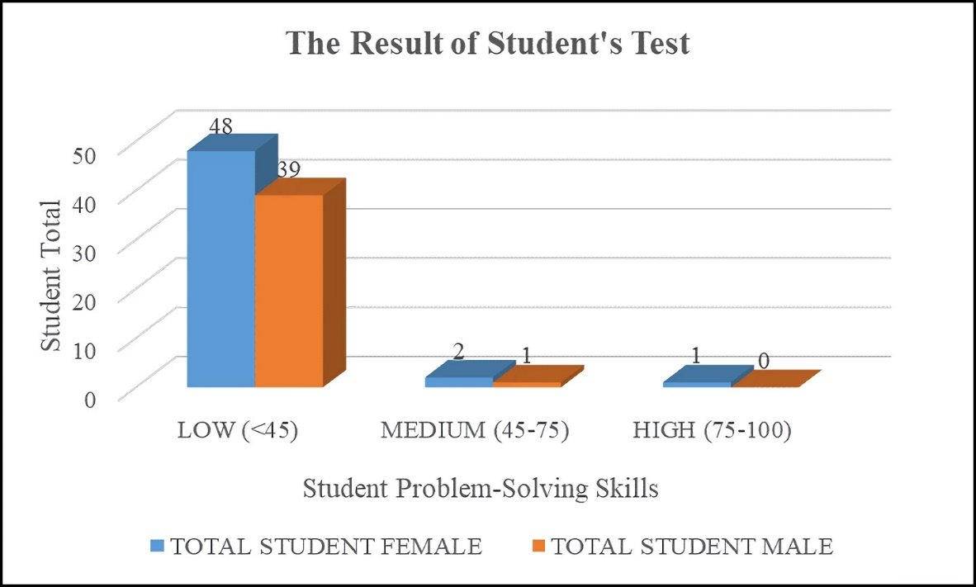
Figure 2. The result of Students’s Problem-Solving Skills Assesment

Figure 2 shows the test scores of high school students' problem solving skills. Based on these results, it is known that the level of students' problem solving skills is still low. This is in accordance with research from (Afnan et al., 2023) where the level of problem solving skills of students is still low for both women and men. The graph shows that there are 87 students in the low category, namely 48 female students and 39 male students. While only 3 students (2 female and 1 male) were in the medium category, and only 1 female student obtained the high category. Therefore, it can be concluded that the level of problem solving skills of female students is higher than male students.
Some previous studies have shown that male students' problem solving skills tend to be lower than female students (N. I. Mahardika & Zainuddin, 2022). This is due to the tendency of male students to focus more on the final answer rather than systematic steps in solving problems, which can result in answers that are less precise and do not meet the indicators of problem solving skills (Good et al., 2022). On the other hand, female students tend to be more selective in solving problems, considering the steps needed to reach the right solution (Baehaqi et al., 2023). However, other factors can also affect students' problem-solving skills, such as teacher-focused learning (Melawati et al., 2022; Uden et al., 2022). Therefore, efforts need to be made to improve problem-solving skills in all students, regardless of their gender, and encourage learning that involves interaction and active participation from students in developing problem-solving skills.

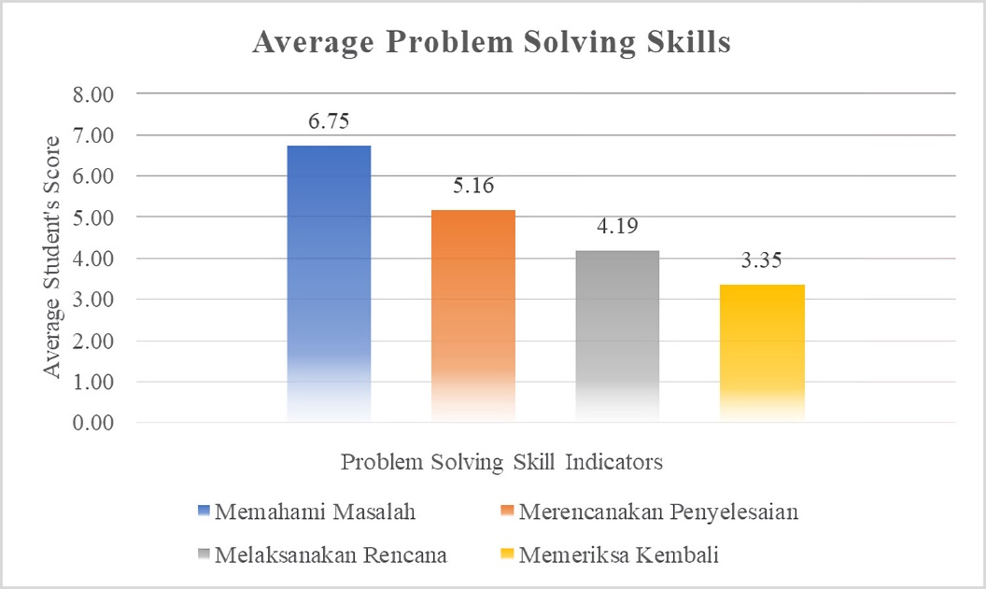
Figure 3. Average problem-solving skills of each indikator

Figure 3 is the result of research based on the problem solving skills test, obtained the average value of each indicator obtained by students. Based on these data, it shows that there is a significant difference between the average scores of each category of problem solving skills. The "Understand the Problem" category gets the highest score with an average of 6.75, while the "Looking back" category gets the lowest score with an average of 3.35. This shows that students have a good ability to understand problems, but their ability to plan, execute, and re-examine problem solving still needs to be improved. This means that students tend to have difficulty or are not confident in providing answers to check back answers in a problem(Dini & Maarif, 2022). This can affect students' ability to solve problems and find the right solution (Prastyo & Wulandari, 2023). Therefore, efforts need to be made to improve students' problem solving skills in these categories, through appropriate practice and learning to improve the ability to plan, execute, and re-examine problem solving (Afnan et al., 2023; Daryanes et al., 2023; Haeruddin et al., 2022). In addition, it is also important to provide appropriate and constructive feedback so that students can re-examine their answers with more confidence and identify mistakes made (Dood & Watts, 2022; Yuriev et al., 2017), so as to improve their understanding of the problem and enhance their problem-solving skill.
To achieve success in solving physics problems, not only knowledge of physics concepts is needed, but also students' ability to connect all information and concepts to solve problems (Kim et al., 2022). The answers given by students to each question can be an indication of the level of their problem-solving ability related to the problem (Schöbel et al., 2023; Wang et al., 2023). However, not all students can answer completely using the appropriate problem solving indicators. There are some students who may leave their answers blank on certain indicators, thus affecting their level of problem solving ability.
Therefore, it is important for physics teachers to pay special attention to students' problem-solving abilities, including providing exercises and feedback that focus on developing problem-solving skills (Abdullaeva, 2022; McCrum, 2017; Zhu et al., 2023). This can be done through the use of various learning strategies that encourage students to think critically and creatively in solving physics problems (Almulla & Al-Rahmi, 2023; Xu et al., 2023; Zulyusri et al., 2023), as well as providing constructive feedback to students to help them improve their problem-solving skills gradually (Almulla & Al-Rahmi, 2023; Maries & Singh, 2023). The following are examples of student answers with indicators of problem-solving skills:

- Understanding the Problem
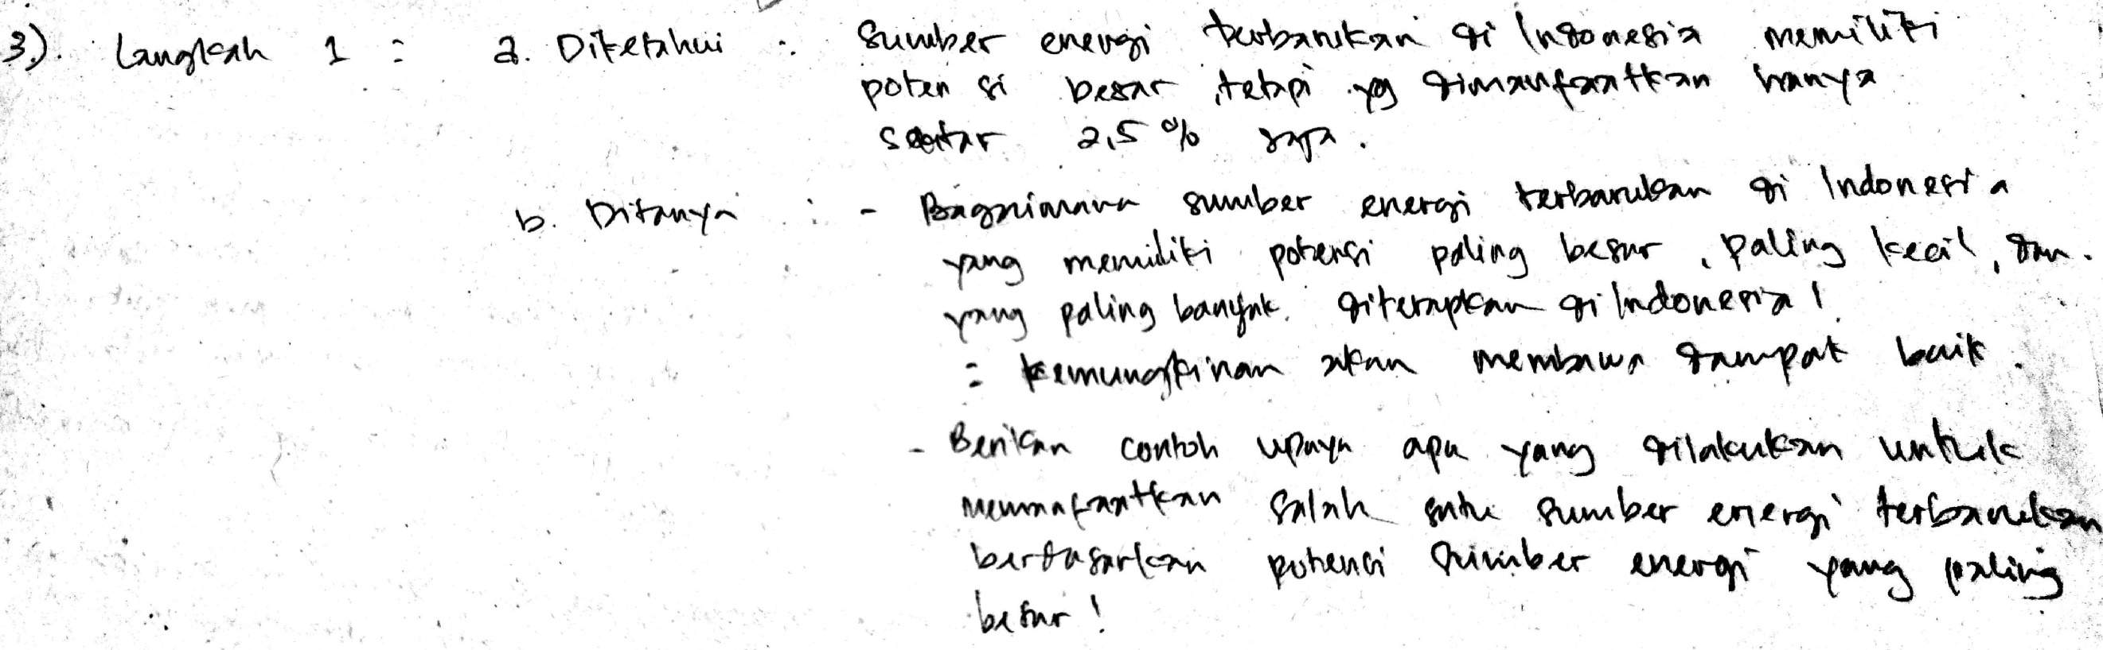
Figure 4. Student answers on the indicator of understanding the problem

Figure 4 is the first indicator of problem solving skills, namely understanding the problem, students are asked to carefully and thoroughly understand the problems faced and the questions asked in the problem. This is an important first step in the problem solving process. Based on the analysis of students' answers in Figure 4, it is known that the majority of students can understand the problem well, but there are some students who are still confused in understanding the problem in the problem addressed. This is because students are used to solving physics problems by giving what is known and asked before answering questions (Zakeus, 2022). This indicator has the highest value compared to other indicators.

- Devise a Plan
At the stage of planning a solution, students must provide a plan for what to do in solving a question. So that students can make a plan for the steps to solve the problem given.
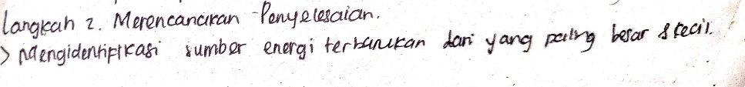
Figure 5. Students' answers on the indicator of planning the solution with less precision and correctness

Based on the answers in Figure 5, students are still unable to plan well the problem solving questions given correctly and precisely according to what is presented in the question. Students have not been able to provide complete solution steps by not providing a solution plan to provide examples of efforts made to utilize alternative energy. This is common because students are still lacking in looking closely at the questions given in physics problems (Harun et al., 2019). If students do not understand the problem in the question, it will result in failure to identify the concept of the problem and have an impact on low problem solving (Kenedi et al., 2019).

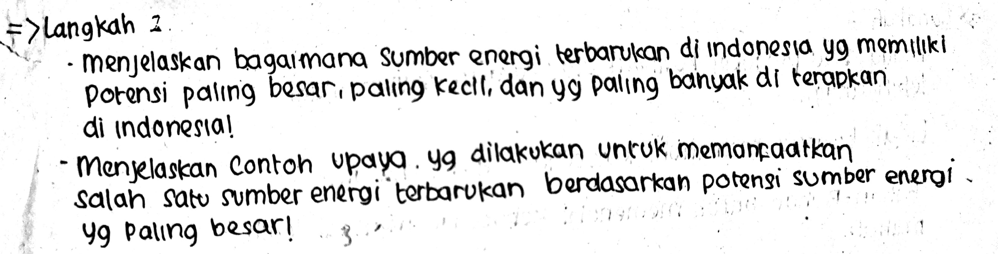
Figure 6. Students' answers on the indicator of planning the solution correctly and completely
As a comparison, the following picture shows an example of the answers of students who have been able to provide answers to plan the solution well. In Figure 6 shows that students have been able to provide a solution plan well and correctly according to the questions given.

- Carry out the Plan
At the stage of implementing the plan, learners are asked to follow the solution plan that has been prepared previously. Learners must be able to explain the steps that will be taken to solve the problem at hand. The solution steps described by learners must be well structured and pay attention to the correct sequence (Han et al., 2022). Learners can use methods or strategies that are appropriate to the type of problem at hand (Nurkhin & Pramusinto, 2020).
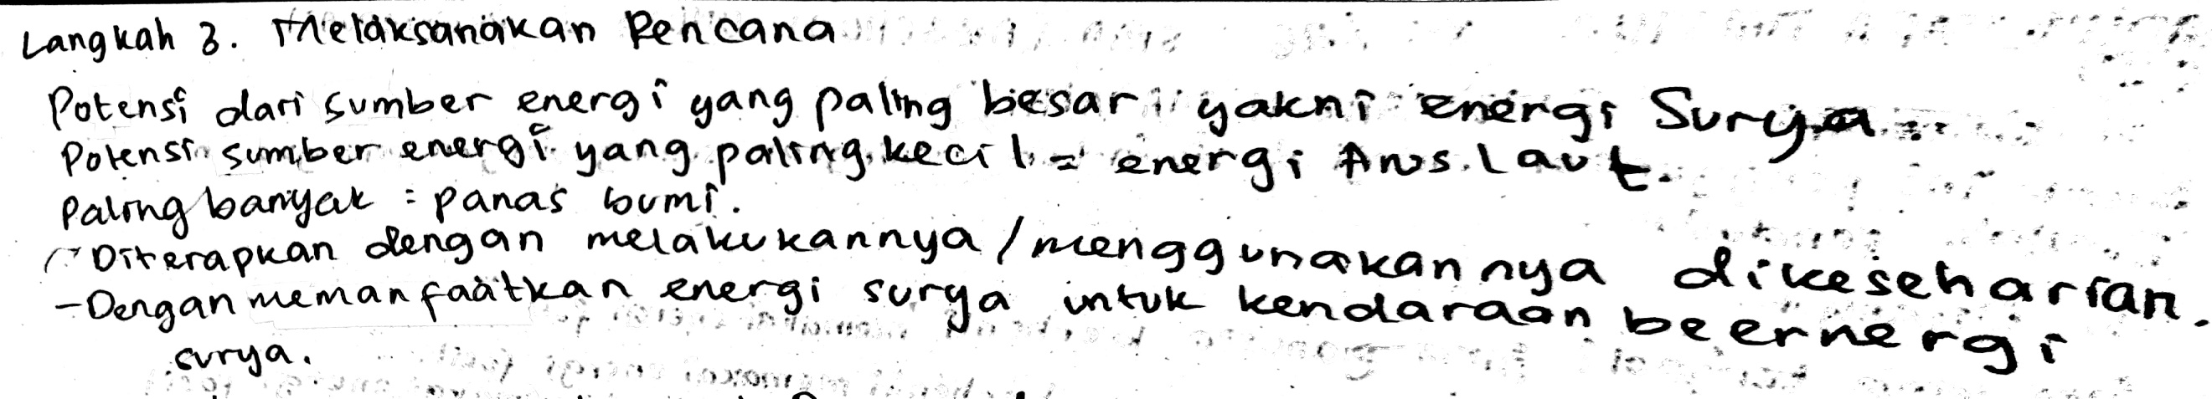
Figure 7. Student answers on the indicator of implementing the plan
Based on Figure 7, it is known that students' answers have been able to explain the steps of solving the problem, although it is still incomplete. However, there are some learners who are less careful in solving the questions given. This can happen because learners still have difficulty in understanding the problem in the problem, so they have not been able to implement the plan properly. Learners' inability to understand the problem deeply can affect their ability to implement the plan effectively (Ummah & Yuliati, 2020). If learners do not fully understand the problem at hand, they may take inappropriate steps or miss important aspects of problem solving.

- Looking Back
At the looking back stage is the most important stage in problem solving, learners need to recheck the steps they have taken in the problem solving process. They must ensure that there are no errors or omissions in the process. In addition, learners must also check the calculations or understanding they use in solving problems (Astra et al., 2020). They need to ensure that the steps taken are correct and in accordance with relevant concepts or theories.
Then, learners can refer to theoretical results that are relevant to the problem being solved. By comparing their answer with the relevant theory, they can check the correctness of the answer. If their answer is consistent with the theory and the steps they have taken, they can be confident in the correctness of the answer. However, if any discrepancies or errors are found, learners need to identify and correct the errors.
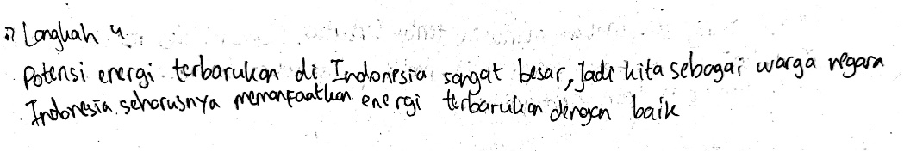
Figure 8. Students' answers on the indicator of rechecking the results
In Figure 8, it shows that students still have difficulty in answering questions correctly according to the questions presented. They have not been able to do a back check by evaluating the questions given and providing answers that match the questions. This resulted in most learners only providing the final answer without providing a conclusion or solution that must be done to solve the problem. The inability of learners to evaluate and provide appropriate conclusions can be caused by several factors. Some learners may have difficulty in understanding the question thoroughly or not properly understanding the steps needed to solve the problem. They may also lack practice in double-checking the answers they have given.
Based on the results of the analysis, it can be seen that the level of problem solving skills of students is still low. The factor that can influence this is the lack of understanding of concepts (Andriyani & Suniasih, 2021). If learners have a low understanding of the concepts related to the problem at hand, they will have difficulty in applying their knowledge to solve problems effectively (Simanjuntak et al., 2021). This lack of understanding of concepts can be an obstacle in analyzing problems properly. This is in line with research from (Capriconia & Mufit, 2022) which says that students still cannot solve problems because they have not been able to understand the problem well, and have not understood the theory well. Thus, students have difficulty in solving problem solving problems.
Student Response Results on Physics Learning:
After completing the essay test to measure problem-solving skills, the next step was to ask students to provide responses to physics learning at school. The response consists of 10 statements that can be selected on a scale from strongly disagree, disagree, agree, to strongly agree, which is represented by numbers 1 to 4 using google form. The results of the questionnaire responses are then represented in Table 2. In addition, researchers also conducted interviews with students to gain a deeper understanding of students' responses to physics learning at school.
Table 2. Students' responses to physics learning and problem-solving skills at school
No |  | Student Response Results (%)
No | Statement | Strongly Disagree | Disagree | Agree | Strongly Agree
1 | Physics is a fun subject | 3,2 | 40,9 | 46,2 | 9,7
2 | I find learning physics boring | 11,8 | 53,8 | 30,1 | 4,3
3 | I find it difficult to understand physics material, especially Renewable Energy material. | 7,5 | 37,6 | 48,4 | 6,5
4 | Renewable Energy material is important to learn because it is related to everyday life | 1,1 | 6,4 | 66,7 | 25,8
5 | I learn physics not only from books and teachers, but also using other learning resources such as E-Books, E-Modules, Websites and Virtual Practicum. | 9,7 | 20,4 | 49,5 | 20,4
6 | Conventional book-assisted lecture learning method is more often used by teachers than problem-based learning method. | 5,4 | 30,1 | 55,9 | 8,6
7 | I am often trained with problem solving skills | 4,3 | 35,5 | 50,5 | 9,7
8 | Problem solving skills are important to teach in schools | 0 | 4,3 | 51,6 | 44,1
9 | I like learning physics using Interactive E-Books more. | 1,1 | 15,1 | 65,6 | 18,2
10 | I am interested in learning physics using Interactive E-Book that contains materials, videos, and Virtual Laboratory. | 2,2 | 9, | 55,9 | 32,3

Table 2 shows that the majority of students (46.2%) agree that physics is a fun subject, but most (53.8%) consider physics learning boring. Furthermore, more than half of students (48.4%) find it difficult to understand physics material, especially related to Renewable Energy material. And the majority of students (66.7%) agreed that Renewable Energy material is important to learn because it is related to everyday life. Then, the problem-based learning (PBL) method is less frequently used by teachers than the lecture method with books, The lecture method is often carried out by teachers, Teachers should facilitate students by providing authentic problems during learning so that students can explore many Physics concepts related to students' daily lives (Dewi & Dwikoranto, 2021; Jeong & So, 2020; Nova et al., 2021). Further related to students' problem-solving skills, the majority of students (50.5%) felt they were often trained with problem-solving skills. Almost all students (95.7%) agreed that problem-solving skills are important to teach in school. The majority of students (65.6%) liked learning physics using Interactive E-Books, and almost all students (87.2%) were interested in learning physics using Interactive E-Books containing materials, videos, and Virtual Laboratories.
From these data, it can be concluded that some students find physics learning boring and find it difficult to understand certain materials. However, the majority of students realize that physics material, especially related to Renewable Energy, is important to learn because it is related to everyday life. In addition, most students have also used different physics learning resources and feel trained with problem-solving skills. This shows that there needs to be a variety of more interesting and interactive methods and learning resources in physics learning so that students can be more interested and understand the material better.

Results of Interview with Physics Teacher at school
To strengthen the research data, researchers conducted interviews with teachers to obtain more detailed information related to physics learning at school (Rini & Aldila, 2023; Saphira & Prahani, 2022). Interviews were conducted with teachers to ask for opinions related to learning models and physics learning outcomes at school. Based on the results of the interview, currently the school has only implemented a new curriculum this year, namely the 2022/2023 school year, especially in schools in Surabaya, namely the learning independence curriculum, so that teachers are still adapting to the new curriculum. in previous learning, physics learning at school was still teacher-centered, and still used conventional methods so that it rarely applied the PBL model. So that there has been no special treatment carried out by the teacher to improve students' problem solving skills. In addition, physics learning at school, rarely applies learning innovation, which results in the effect on the motivation, attitude and interest of students towards physics learning at school.
Conventional learning models can affect the level of students' problem solving skills (Fitriani et al., 2020). In this model, education is more teacher-centered, so learners have little opportunity to develop problem-solving skills actively (Emaliana, 2017). This model also often emphasizes passive understanding of concepts and memorization of information, which can hinder the development of learners' critical and analytical thinking (Fey, 2022; La Braca & Kalman, 2021). Learning separated from real life can also make it difficult for learners to transfer problem-solving skills to real-world situations (Szabo et al., 2020). In addition, time constraints and a crowded curriculum often limit learners' opportunities to explore problem-solving skills in depth.
To improve the level of learners' problem-solving skills, a more active, learner-centered and problem-solving-oriented learning approach is needed. This approach should encourage critical thinking, analysis, collaboration and practical application in real-life situations. Thus, learners will be able to develop better problem-solving skills that are relevant to the real world.

Relevant research
Several studies have been conducted to understand and analyze the impact of the application of PBL models and E-Book media, namely integrating the application of PBL models with interactive E-Book aids, especially in physics learning. Based on literature studies with relevant research related to the application of PBL with E-Books are as follows: (1) the application of the PBL model using E-Book can be effective in improving learning outcomes, motivation and interest in learning, especially in physics learning(Hediansah & Surjono, 2019; Rahim et al., 2020; Susanto et al., 2022). 2) 2) The application of the PBL model with E-Book is a learning innovation that can improve students' understanding to be able to explain physics phenomena properly assisted by videos in e-books (Neswary & Prahani, 2022; Novita, 2023). 3) E-Books can also be integrated with virtual labs so that students can easily access practicum activities (Adam & Suprapto, 2019; Mufit et al., 2022). So it is expected that the implementation of the pBL model assisted by E_Book will be used as an effective learning model and interesting learning innovation for students, so that it will increase enthusiasm in teaching and learning activities.
Based on the results of the research and analysis of the profile of students' initial problem-solving skills, several characteristics of problem-solving skills can be found as follows:
Understanding the Problem: Learners have a fairly good ability to understand the problem at hand. They are not yet able to fully identify the elements of the problem and understand the questions posed in the problem well.
Planning the Solution: Learners' ability in planning the steps of the solution still needs to be improved. They still have difficulty in providing an appropriate and complete plan in solving the problem.
Implementing the Plan: Learners tend to be able to carry out the solution plans they have made. However, there are still errors and omissions in the process of implementing the solution steps.
Looking back: Learners have challenges in re-examining the answers and steps they have taken. They are less able to conduct an in-depth evaluation of the answers they have given and identify possible errors.
In this case, the characteristics of problem-solving skills that can be observed are that students have a good ability to understand the problem, but their ability to plan, execute and re-examine the solution still needs to be improved. They tend to have difficulty or lack confidence in rechecking answers and identifying possible errors. To improve students' problem solving skills in these categories, it is necessary to integrate the Problem-Based Learning (PBL) model assisted by E-Book. Integrating the PBL model will provide opportunities for students to learn actively through real and relevant problem-solving experiences (Dita et al., 2021). In the context of physics learning, physics teachers can use E-Books as an interactive and interesting learning resource to facilitate problem-based learning.
During the PBL process, learners will be involved in actively planning, executing, and re-examining problem solving. They will be encouraged to think critically and creatively in finding solutions, collaborate with fellow learners (Nurkhin & Pramusinto, 2020), and use available resources, including E-Books, to gain better information and understanding. In addition, it is important for physics teachers to provide appropriate and constructive feedback to learners during the PBL process (Gunawan et al., 2019). This feedback can help learners re-examine their answers with more confidence, identify mistakes made, and lead them to a better understanding of the problem at hand (Hamerski et al., 2022). Through the use of E-Books, teachers can also provide more interactive and in-depth feedback, for example by providing comments related to learners' answers or asking questions that trigger reflective thinking.
By integrating the E-Book-assisted PBL model, students will have a more interesting, interactive, and directed learning experience in developing their problem-solving skills (Haryanti et al., 2020). They will be involved in contextual and relevant problem-solving activities, and have the opportunity to gradually improve their ability to plan, execute, and re-examine problem solving. In this PBL model, students will be actively involved in solving problems related to daily life and gain a better understanding of physics concepts (Samadun & Dwikoranto, 2022). The use of E-Books will facilitate learning by providing easy access to interactive information, which plays an important role in helping students understand concepts and effective problem-solving strategies (Mufit et al., 2022). Through this research, it is expected that a deeper understanding of the physics problem solving skills of high school students and the effectiveness of the PBL model enhanced with E-Books in improving problem solving skills will be obtained.

CONCLUSION
Based on the results of the research conducted, it was concluded that students' problem solving skills were still low. The indicator that showed the lowest skill level was "looking back," while the indicator with the highest score was "understanding the problem." Gender-based analysis showed that females had a higher level of problem-solving skills than males. This research emphasizes the importance of practicing problem-solving skills to students by educators, especially in the context of renewable energy materials. The results of surveys and tests with problem-solving indicators show that these skills can be improved through appropriate learning approaches. The findings also show that there are still many schools that implement traditional physics learning with the lecture method and conventional teaching materials. However, students showed interest in learning using E-Books. Therefore, it is important to recognize the importance of innovation in learning models that aim to improve students' problem-solving skills. The findings of this study indicate the need for the development of innovative learning models in accordance with technological developments, especially in the context of physics learning. By applying appropriate methods and utilizing technology, it is expected that students' problem solving skills can be effectively improved. Educators need to pay attention to the importance of adopting an active, learner-centered, and problem-solving-oriented approach in an effort to improve students' problem-solving skills. Thus, the conclusion of this study underscores the need to develop innovative learning approaches that are in line with technological developments in order to improve students' problem-solving skills.

RECOMMENDATION
It is expected that in future research there will be innovations in the teaching and learning process with the aim of increasing students' interest and problem solving skills. One innovation that can be considered is the application of the PBL Learning Model assisted by E-Book.

REFERENCES
Abdullaeva, B. P. (2022). Use of Team Sports in Physical Education Activities in Preschool Educational Organizations in Our Country and Abroad. Periodica Journal of Modern Philosophy, Social Sciences and Humanities, 12, 116–120.
Adam, A. S., & Suprapto, N. (2019). One-stop physics e-book package development for senior high school learning media. International Journal of Emerging Technologies in Learning (Online), 14(19), 150.
Admoko, S., Hanifah, N., Suprapto, N., Hariyono, E., & Madlazim, M. (2021). The implementation of argument driven inquiry (ADI) learning model to improve scientific argumentation skills of high school students. Journal of Physics: Conference Series, 1747(1), 12046.
Adriyawati, A., Utomo, E., Rahmawati, Y., & Mardiah, A. (2020). Steam-project-based learning integration to improve elementary school students’ scientific literacy on alternative energy learning. Universal Journal of Educational Research, 8(5), 1863–1873.
Afnan, R., Munasir, M., Budiyanto, M., & Aulia, M. I. R. (2023). The Role of Scientific Literacy Instruments For Measuring Science Problem Solving Ability. IJORER: International Journal of Recent Educational Research, 4(1), 45–58.
Al Rawashdeh, A. Z., Mohammed, E. Y., Al Arab, A. R., Alara, M., & Al-Rawashdeh, B. (2021). Advantages and disadvantages of using e-learning in university education: Analyzing students’ perspectives. Electronic Journal of E-Learning, 19(3), 107–117.
Almulla, M. A., & Al-Rahmi, W. M. (2023). Integrated Social Cognitive Theory with Learning Input Factors: The Effects of Problem-Solving Skills and Critical Thinking Skills on Learning Performance Sustainability. Sustainability, 15(5), 3978.
Ambaryani, S. E., & Putranta, H. (2022). Improving Learners’ Metacognitive Skills with Self-Regulated Learning Based Problem-Solving. International Journal of Instruction, 15(1), 139–154.
Amin, B. D., Haris, A., & Swandi, A. (2019). Implementation of physics learning based on hypermedia to enhance student’s problem solving skill. International Journal of Teaching and Education, 7(2), 1–11.
Anam, K., Sudarwo, R., & Wiradharma, G. (2020). Application of the Problem Based Learning Model to Communication Skills and Mathematical Problem Solving Skills in Junior High School Students. JTAM (Jurnal Teori Dan Aplikasi Matematika), 4(2), 155–165.
Ananda, P. D., & Atmojo, S. E. (2022). The Impact of the Discovery Learning Model on Problem-Solving Ability and Scientific Attitude of Elementary School Teacher Education Students. International Journal of Elementary Education, 6(2).
Andriyani, N. L., & Suniasih, N. W. (2021). Development of learning videos based on problem-solving characteristics of animals and their habitats contain in IPA subjects on 6th-grade. Journal of Education Technology, 5(1), 37–47.
Anggraini, R. T., Hidayat, A., Fauziyah, S., Pramono, N. A., Supriana, E., & Ali, M. (2021). The building of students’ problem solving skills through STEM aproach with virtual simulation media. Journal of Physics: Conference Series, 1842(1), 12073.
Asrial, A., Syahrial, S., Kurniawan, D. A., Alirmansyah, A., Sholeh, M., & Zulkhi, M. D. (2022). The Influence of Application of Local-wisdom-based Modules toward Peace-loving Characters of Elementary School Students. Indonesian Journal on Learning and Advanced Education (IJOLAE), 4(2), 157–170.
Astra, I. M., Raihanati, R., & Mujayanah, N. (2020). Development of electronic module using creative problem-solving model equipped with HOTS problems on the kinetic theory of gases material. Jurnal Penelitian & Pengembangan Pendidikan Fisika, 6(2), 181–194.
Astuti, A. P., Aziz, A., Sumarti, S. S., & Bharati, D. A. L. (2019). Preparing 21st century teachers: Implementation of 4C character’s pre-service teacher through teaching practice. Journal of Physics: Conference Series, 1233(1), 12109.
Astuti, N. H., Rusilowati, A., & Subali, B. (2021). STEM-based learning analysis to improve students’ problem solving abilities in science subject: A literature review. Journal of Innovative Science Education, 10(1), 79–86.
Ayudha, C. F. H., & Setyarsih, W. (2021). Studi literatur: Analisis praktik pembelajaran fisika di sma untuk melatih keterampilan pemecahan masalah. Jurnal Pendidikan Fisika Undiksha, 11(1), 16–28.
Baehaqi, M. R., Parta, I. N., & Chandra, T. D. (2023). Kemampuan Komunikasi Matematis Tulis Siswa Bergaya Belajar Visual Dalam Menyelesaikan Masalah Ditinjau dari Perbedaan Gender. Jurnal Cendekia: Jurnal Pendidikan Matematika, 7(1), 550–561.
Capriconia, J., & Mufit, F. (2022). Analysis of Concept Understanding and Students’ Attitudes towards Learning Physics in Material of Straight Motion. Jurnal Penelitian Pendidikan IPA, 8(3), 1453–1461.
Ceberio, M., Almudí, J. M., & Franco, Á. (2016). Design and application of interactive simulations in problem-solving in university-level physics education. Journal of Science Education and Technology, 25, 590–609.
Chevalier, M., Giang, C., Piatti, A., & Mondada, F. (2020). Fostering computational thinking through educational robotics: A model for creative computational problem solving. International Journal of STEM Education, 7(1), 1–18.
Daryanes, F., Darmadi, D., Fikri, K., Sayuti, I., Rusandi, M. A., & Situmorang, D. D. B. (2023). The development of articulate storyline interactive learning media based on case methods to train student’s problem-solving ability. Heliyon, 9(4).
Dawana, I. R., Dwikoranto, Setiani, R., & Marsini. (2022). E-Book Learning Research in Physics Education During the Last Five Years: A Review and Bibliometric Study. Journal of Physics: Conference Series, 2392(1), 12016. https://doi.org/10.1088/1742-6596/2392/1/012016
Dawana, I. R., Setyarsih, W., Suprapto, N., & Dwikoranto, D. (2022). The effectiveness of virtual class-based e-learning with video-assisted google classroom as a physics learning media (2016-2020). Momentum: Physics Education Journal, 6(2), 188–198.
De la Torre, R., Onggo, B. S., Corlu, C. G., Nogal, M., & Juan, A. A. (2021). The role of simulation and serious games in teaching concepts on circular economy and sustainable energy. Energies, 14(4), 1138.
Dewi, L., & Dwikoranto, D. (2021). Analisis Pendekatan Pembelajaran Contextual Teaching and Learning (CTL) Terhadap Peningkatan Hasil Belajar Fisika dengan Metoda Library Research. PENDIPA Journal of Science Education, 5(2), 237–243.
Dini, D. F. R., & Maarif, S. (2022). Students’ problem-solving ability: An analytical practice viewed from the aspect of sociomathematical norm. Desimal: Jurnal Matematika, 5(1), 91–102.
Dita, P. P. S., Utomo, S., & Sekar, D. A. (2021). Implementation of Problem Based Learning (PBL) on interactive learning media. Journal of Technology and Humanities, 2(2), 24–30.
Dood, A. J., & Watts, F. M. (2022). Students’ strategies, struggles, and successes with mechanism problem solving in organic chemistry: a scoping review of the research literature. Journal of Chemical Education, 100(1), 53–68.
Dwikoranto, D. (2022). Using toulmin’s argument pattern on problem solving model to improve problem-solving analysis ability: Learning alternatives during the COVID-19 pandemic. IJORER: International Journal of Recent Educational Research, 3(2), 200–209.
Ebied, M. M. A., & Rahman, S. A. A. (2015). The Effect of Interactive e-Book on Students’ Achievement at Najran University in Computer in Education Course. Journal of Education and Practice, 6(19), 71–82.
Emaliana, I. (2017). Teacher-centered or student-centered learning approach to promote learning? Jurnal Sosial Humaniora (JSH), 10(2), 59–70.
Fatimah, F. S., Asy’ari, H., Sandria, A., & Nasucha, J. A. (2023). Learning Fiqh Based on the TAPPS (Think Aloud Pair Problem Solving) Method in Improving Student Learning Outcomes. At-Tadzkir: Islamic Education Journal, 2(1), 1–15.
Fauzia, N. L. U., & Kelana, J. B. (2020). Natural Science Problem Solving in Elementary School Students Using the Project Based Learning (PjBL) Model. Jurnal Ilmiah Sekolah Dasar, 4(4), 596–603.
Fey, C. F. (2022). A perspective on the potential of Chinese business schools: A call for greater attention to context, differentiation, and developing an indigenous model. Management and Organization Review, 18(5), 982–999.
Fitriani, A., Zubaidah, S., Susilo, H., & Al Muhdhar, M. H. I. (2020). The effects of integrated problem-based learning, predict, observe, explain on problem-solving skills and self-efficacy. Eurasian Journal of Educational Research, 20(85), 45–64.
García-Moya, M., Polo-Blanco, I., Blanco, R., & Goñi-Cervera, J. (2022). Teaching cartesian product problem solving to students with autism spectrum disorder using a conceptual model-based approach. Focus on Autism and Other Developmental Disabilities, 10883576221121806.
Good, M., Maries, A., & Singh, C. (2022). Additional unexpected benefits of rewarding students for effective problem solving strategies: supporting gender equity in physics. Physics Education, 57(5), 55005.
Good, M., Marshman, E., Yerushalmi, E., & Singh, C. (2020). Graduate teaching assistants’ views of broken-into-parts physics problems: Preference for guidance overshadows development of self-reliance in problem solving. Physical Review Physics Education Research, 16(1), 10128.
Gunawan, G., Harjono, A., Herayanti, L., & Husein, S. (2019). Problem-based learning approach with supported interactive multimedia in physics course: Its effects on critical thinking disposition. Journal for the Education of Gifted Young Scientists, 7(4), 1075–1089.
Gunawan, G., Mashami, R. A., & Herayanti, L. (2020). Gender description on problem-solving skills in chemistry learning using interactive multimedia. Journal for the Education of Gifted Young Scientists, 8(1), 561–589. https://doi.org/10.17478/jegys.627095
Haeruddin, H., Kamaluddin, K., Kade, A., & Pabianan, A. R. (2022). Analysis of attitudes and approaches to problem solving: gender differences and education levels. Radiasi: Jurnal Berkala Pendidikan Fisika, 15(1), 12–21.
Hamerski, P. C., McPadden, D., Caballero, M. D., & Irving, P. W. (2022). Students’ perspectives on computational challenges in physics class. Physical Review Physics Education Research, 18(2), 20109.
Han, Y., Liu, H., & Ji, F. (2022). A sequential response model for analyzing process data on technology-based problem-solving tasks. Multivariate Behavioral Research, 57(6), 960–977.
Haque, R. A., Karim, S., & Sari, I. M. (2021). Penerapan Model Flipped Classroom Berbantuan E-Book Interaktif untuk Meningkatkan Kompetensi Literasi Sains Momentum dan Impuls Peserta Didik. Jurnal Riset Pendidikan Fisika, 6(2), 108–117. http://journal2.um.ac.id/index.php/jrpf/article/view/21463%0Ahttp://journal2.um.ac.id/index.php/jrpf/article/download/21463/8973
Harun, L., Darhim, D., Dahlan, J. A., Harisman, Y., Sovia, A., & Bakar, M. T. (2019). Students’ gesture of naive, routine, and shopisticated behavior oriented on mathematical problem solving. Journal of Physics: Conference Series, 1157(4), 42074.
Haryanti, N., Wilujeng, I., & Sundari, S. (2020). Problem based learning instruction assisted by e-book to improve mathematical representation ability and curiosity attitudes on optical devices. Journal of Physics: Conference Series, 1440(1), 12045.
Hediansah, D., & Surjono, H. D. (2019). Building Motivation and Improving Learning Outcomes with Android-Based Physics Books: Education 4.0. Anatolian Journal of Education, 4(2), 1–10.
Herayanti, L., Widodo, W., Susantini, E., & Gunawan, G. (2020). The effectiveness of blended learning model based on inquiry collaborative tutorial toward students’ problem-solving skills in physics. Journal for the Education of Gifted Young Scientists, 8(3), 959–972.
Hidaayatullaah, H. N., Suprapto, N., Mubarok, H., & Wulandari, D. (2020). Implementation of problem based learning to train physics students’ problem solving skills. Journal of Physics: Conference Series, 1491(1), 12053.
Hrybiuk, O. (2019). Improvement of the educational process by the creation of centers for intellectual development and scientific and technical creativity. Advances in Manufacturing II: Volume 2-Production Engineering and Management, 370–382.
Is’ ad, N., & Sukarmin, S. (2022). Implementation of problem-solving learning model assisted by student worksheets to improve critical thinking skills in the context of reaction rate. Jurnal Pijar Mipa, 17(2), 199–208.
Jalinus, N. (2021). Developing blended learning model in vocational education based on 21st century integrated learning and industrial revolution 4.0. Turkish Journal of Computer and Mathematics Education (TURCOMAT), 12(8), 1239–1254.
Jeong, H.-C., & So, W.-Y. (2020). Difficulties of online physical education classes in middle and high school and an efficient operation plan to address them. International Journal of Environmental Research and Public Health, 17(19), 7279.
Kartikasari, I. A., & Usodo, B. (2022). The effectiveness open-ended learning and creative problem solving models to improve creative thinking skills. Pegem Journal of Education and Instruction, 12(4), 29–38.
Kenedi, A. K., Helsa, Y., Ariani, Y., Zainil, M., & Hendri, S. (2019). Mathematical Connection of Elementary School Students to Solve Mathematical Problems. Journal on Mathematics Education, 10(1), 69–80.
Kim, N. J., Vicentini, C. R., & Belland, B. R. (2022). Influence of scaffolding on information literacy and argumentation skills in virtual field trips and problem-based learning for scientific problem solving. International Journal of Science and Mathematics Education, 1–22.
Krasnova, L. A., & Shurygin, V. Y. (2020). Blended learning of physics in the context of the professional development of teachers. International Journal of Technology Enhanced Learning, 12(1), 38–52.
La Braca, F., & Kalman, C. S. (2021). Comparison of labatorials and traditional labs: The impacts of instructional scaffolding on the student experience and conceptual understanding. Physical Review Physics Education Research, 17(1), 10131.
Lai, C.-S. (2016). Integrating E-Books into Science Teaching by Preservice Elementary School Teachers. Journal of Education in Science, Environment and Health, 2(1), 57–66.
Leite, V. (2017). Innovative learning in engineering education: Experimenting with short-term project-oriented research and project-based learning. 2017 IEEE 26th International Symposium on Industrial Electronics (ISIE), 1555–1560.
Mahardika, A. I., Pertiwi, H., & Miriam, S. (2021). Pengembangan Emorish Untuk Meningkatkan Keterampilan Pemecahan Masalah Pada Pembelajaran Fisika. Jurnal Kependidikan: Penelitian Inovasi Pembelajaran, 5(2). https://doi.org/10.21831/jk.v5i2.40251
Mahardika, N. I., & Zainuddin, A. (2022). Application of Formative Assessment to Analyze Students’ Problem-Solving Skills. Prisma Sains: Jurnal Pengkajian Ilmu Dan Pembelajaran Matematika Dan IPA IKIP Mataram, 10(2), 226–236.
Maries, A., & Singh, C. (2023). Helping students become proficient problem solvers Part I: A brief review. Education Sciences, 13(2), 156.
McCrum, D. P. (2017). Evaluation of creative problem-solving abilities in undergraduate structural engineers through interdisciplinary problem-based learning. European Journal of Engineering Education, 42(6), 684–700.
Melawati, O., Evendi, E., Halim, A., Yusrizal, Y., & Elisa, E. (2022). The influence of the use of student worksheet problem-based to increase problem solving skills and learning outcomes. Jurnal Penelitian Pendidikan IPA, 8(1), 346–355.
Meuer, J., Lamaro, F., & Vetterli, N. (2021). Embedding energy optimization in organizations: A case study of a Swiss decentralized renewable energy system. Energy and Buildings, 235, 110710.
Mufit, F., Asrizal, A., Puspitasari, R., & Annisa, A. (2022). Cognitive Conflict-Based E-Book with Real Experiment Video Analysis Integration to Enhance Conceptual Understanding of Motion Kinematics. Jurnal Pendidikan IPA Indonesia, 11(4).
Neswary, S. B. A., & Prahani, B. K. (2022). Profile of students’ physics critical thinking skills and application of problem based learning models assisted by digital books in physics learning in high school. Jurnal Penelitian Pendidikan IPA, 8(2), 781–789.
Nguyen, T. P. L., Nguyen, T. H., & Tran, T. K. (2020). STEM education in secondary schools: Teachers’ perspective towards sustainable development. Sustainability, 12(21), 8865.
Nibbi, L., Chiaramonti, D., & Palchetti, E. (2019). Project BBChina: a new master program in three Chinese universities on bio-based circular economy; from fields to bioenergy, biofuel and bioproducts. Energy Procedia, 158, 1261–1266.
Nordin, N., & Samsudin, M. A. (2021). The effect of online project-based learning on students’ attitudes towards renewable energy. Mohd Ali Samsudin, Abdul Hadi Harun, Norfarah Nordin, Noor Hasyimah Haniza & Corrienna Abdul-Talib (2014). The Effect of Online Project-Based Learning on Students’ Attitudes towards Renewable Energy, Malaysian Journal of Distance Education, 16(2), 39–57.
Nova, D. A. O., Dwikoranto, D., & Lestari, N. A. (2021). Analisis persepsi siswa terhadap pembelajaran fisika berbasis ecopedagogy dengan metode daring selama pandemi COVID-19. ORBITA: Jurnal Kajian, Inovasi Dan Aplikasi Pendidikan Fisika, 7(1), 19–26.
Noviatika, R., Gunawan, G., & Rokhmat, J. (2019). Pengaruh Model pembelajaran berbasis masalah berbantuan mobile pocket book fisika terhadap kemampuan pemecahan masalah peserta didik. Jurnal Pendidikan Fisika Dan Teknologi, 5(2), 240–246.
Novita, R. R. (2023). Physics E-book with Augmented Reality to Improve Students’ Interest in Physics. JPI (Jurnal Pendidikan Indonesia), 12(1).
Ntona, E., Arabatzis, G., & Kyriakopoulos, G. L. (2015). Energy saving: Views and attitudes of students in secondary education. Renewable and Sustainable Energy Reviews, 46, 1–15.
Nurkhin, A., & Pramusinto, H. (2020). Problem-Based Learning Strategy: Its Impact on Students’ Critical and Creative Thinking Skills. European Journal of Educational Research, 9(3), 1141–1150.
Polya, G. (2004). How to Solve It: A New Aspect of Mathematical Method. Princeton university press.
Prahani, B. K., Rizki, I. A., Nisa, K., Citra, N. F., Alhusni, H. Z., & Wibowo, F. C. (2022). Implementation of online problem-based learning assisted by digital book with 3D animations to improve student’s physics problem-solving skills in magnetic field subject. JOTSE, 12(2), 379–396.
Prasistayanti, N. W. N., Santyasa, I. W., & Warpala, I. W. S. (2019). Pengaruh desain e-learning terhadap hasil belajar dan keterampilan berpikir kreatif siswa dalam mata pelajaran pemrograman pada siswa SMK. Kwangsan: Jurnal Teknologi Pendidikan, 7(2), 138–155.
Prastyo, D., & Wulandari, F. E. (2023). The Effect of Booklets Based on Project Based Learning on Solving Environmental Problems in Junior High Schools. Jurnal Penelitian Pendidikan IPA, 9(2), 698–705.
Pristianti, M. C., & Prahani, B. K. (2022). Profile of students’ physics problem solving skills and problem based learning implementation supported by website on gas kinetic theory. Jurnal Pendidikan Progresif, 12(1), 375–393.
Qomariyah, S., Darmayanti, R., Rosyidah, U., & Ayuwanti, I. (2023). Indicators and Essay Problem Grids on Three-Dimensional Material: Development of Instruments for Measuring High School Students’ Mathematical Problem-Solving Ability. JEMS: Jurnal Edukasi Matematika Dan Sains, 11(1), 261–274.
Qotrunnada, N. A. (2022). Analysis of the Difficulties of High School Students in Improving Problem Solving Ability in Physics Learning. International Journal of Current Educational Research, 1(1), 84–101.
Rahayu, I. D., Permanasari, A., & Heliawati, L. (2022). The Effectiveness of Socioscientific Issue-Based Petroleum Materials Integrated with The Elsmawar Website on Students’ Scientific Literacy. Journal of Innovation in Educational and Cultural Research, 3(2), 279–286.
Rahim, F. R., Suherman, D. S., & Muttaqiin, A. (2020). Exploring the effectiveness of e-book for students on learning material: A literature review. Journal of Physics: Conference Series, 1481(1). https://doi.org/10.1088/1742-6596/1481/1/012105
Raviv, L., Lupyan, G., & Green, S. C. (2022). How variability shapes learning and generalization. Trends in Cognitive Sciences.
Rini, E. F. S., & Aldila, F. T. (2023). Practicum Activity: Analysis of Science Process Skills and Students’ Critical Thinking Skills. Integrated Science Education Journal, 4(2), 54–61.
Rizki, I. A., Suprapto, N., & Hariyono, E. (2023). Designing Vertical Axis Wind Turbine Prototype as Future Renewable Energy Source in STEAM Learning.
Samadun, S., & Dwikoranto, D. (2022). Improvement of Student’s Critical Thinking Ability sin Physics Materials Through The Application of Problem-Based Learning. IJORER: International Journal of Recent Educational Research, 3(5), 534–545.
Saphira, H. V., & Prahani, B. K. (2022). Profile of senior high school students’ critical thinking skills and the need of implementation PBL model assisted by augmented reality book. Jurnal Pendidikan Sains Indonesia (Indonesian Journal of Science Education), 10(3), 579–591.
Schöbel, S. M., Janson, A., & Leimeister, J. M. (2023). Gamifying online training in management education to support emotional engagement and problem-solving skills. Journal of Management Education, 47(2), 166–203.
Schukajlow, S., Blomberg, J., Rellensmann, J., & Leopold, C. (2022). The role of strategy-based motivation in mathematical problem solving: The case of learner-generated drawings. Learning and Instruction, 80, 101561.
Senhora, F. V, Chi, H., Zhang, Y., Mirabella, L., Tang, T. L. E., & Paulino, G. H. (2022). Machine learning for topology optimization: Physics-based learning through an independent training strategy. Computer Methods in Applied Mechanics and Engineering, 398, 115116.
Setyani, N. S., Susilowati, L., Sholihah, Q., & Lenggono, K. A. (2021). Application of Electronic Problem-Based Learning (E-PBL) during the COVID-19 Pandemic in Entrepreneurial Attitude. Eurasian Journal of Educational Research, 95, 156–175.
Silamon, M. A., Roshayanti, F., & Siswanto, J. (2020). Profil Keterampilan Pemecahan Masalah Kinematika Gerak Lurus Pada Siswa Kelas X IPA SMA Negeri 2 Semarang. Jurnal Inovasi Dan Pembelajaran Fisika (JIPF), 7(1), 41–47.
Simanjuntak, M. P., Hutahaean, J., Marpaung, N., & Ramadhani, D. (2021). Effectiveness of Problem-Based Learning Combined with Computer Simulation on Students’ Problem-Solving and Creative Thinking Skills. International Journal of Instruction, 14(3), 519–534.
Soebagyo, J., Umam, K., Istikharoh, I., & Suhendri, H. (2022). An Analysis of Students’ Mathematical Problem-Solving Ability at Class VII Social Arithmetic Materials Based on Learning Styles. Formatif: Jurnal Ilmiah Pendidikan MIPA, 12(1).
Sroufe, R., & Ramos, D. P. (2015). Leveraging Collaborative, Thematic Problem-Based Learning to Integrate Curricula. Decision Sciences Journal of Innovative Education, 13(2), 151–176. https://doi.org/10.1111/dsji.12063
Sumartini, T. S. (2016). Kemampuan Pemecahan Masalah Matematika dalam Menyelesaikan Soal Cerita Berdasarkan Langkah Polya. Jurnal Pendidikan Matematika STKIP Garut, 5(2), 1–7. https://scholar.googleusercontent.com/scholar?q=cache:jfDgJQUQWmcJ:scholar.google.com/+Peningkatan+Kemampuan+Pemecahan+Masalah+Matematis+Siswa+melalui+Pembelajaran+Berbasis+Masalah&hl=id&as_sdt=0,5
Susanto, T. T. D., Dwiyanti, P. B., Marini, A., Sagita, J., Safitri, D., & Soraya, E. (2022). E-Book with Problem Based Learning to Improve Student Critical Thinking in Science Learning at Elementary School. International Journal of Interactive Mobile Technologies (IJIM), 16(20), 4–17. https://doi.org/10.3991/ijim.v16i20.32951
Szabo, Z. K., Körtesi, P., Guncaga, J., Szabo, D., & Neag, R. (2020). Examples of problem-solving strategies in mathematics education supporting the sustainability of 21st-century skills. Sustainability, 12(23), 10113.
Taar, J., & Palojoki, P. (2022). Applying interthinking for learning 21st-century skills in home economics education. Learning, Culture and Social Interaction, 33, 100615.
Tozzi Jr, P., & Jo, J. H. (2017). A comparative analysis of renewable energy simulation tools: Performance simulation model vs. system optimization. Renewable and Sustainable Energy Reviews, 80, 390–398.
Uden, L., Sulaiman, F., & Lamun, R. F. (2022). Factors Influencing Students’ Attitudes and Readiness towards Active Online Learning in Physics. Education Sciences, 12(11), 746.
Ummah, I. K., & Yuliati, N. (2020). The Effect of Jumping Task Based on Creative Problem Solving on Students’ Problem Solving Ability. International Journal of Instruction, 13(1), 387–406.
Wang, M., Yu, R., & Hu, J. (2023). The relationship between social media-related factors and student collaborative problem-solving achievement: an HLM analysis of 37 countries. Education and Information Technologies, 1–19.
Xu, E., Wang, W., & Wang, Q. (2023). The effectiveness of collaborative problem solving in promoting students’ critical thinking: A meta-analysis based on empirical literature. Humanities and Social Sciences Communications, 10(1), 1–11.
Yuriev, E., Naidu, S., Schembri, L. S., & Short, J. L. (2017). Scaffolding the development of problem-solving skills in chemistry: guiding novice students out of dead ends and false starts. Chemistry Education Research and Practice, 18(3), 486–504.
Zakeus, S. (2022). Peningkatan Kemampuan Komunikasi Matematis Siswa Melalui Penerapan Model Pembelajaran Problem Based Learning. Journal of Comprehensive Science (JCS), 1(4), 482–503.
Zhu, G., Su, X., Du, J., Chen, Q., Xiong, B., & Chiang, F.-K. (2023). A quasi-experimental study on the influence of different media scaffolds toward physics problem-solving processes. Interactive Learning Environments, 31(2), 980–993.
Zulyusri, Z., Elfira, I., Lufri, L., & Santosa, T. A. (2023). Literature Study: Utilization of the PjBL Model in Science Education to Improve Creativity and Critical Thinking Skills. Jurnal Penelitian Pendidikan IPA, 9(1), 133–143.

