SEA URCHEN (Echinoidea) DIVERSITY IN THE COASTAL AREA AT MAWASANGKA DISTRICT, CENTRAL BUTON REGENCY

^{*1}Maretik, ²Yanti, dan ³Fitrianti Handayani
^{1,2} Program Studi Pendidikan Biologi, Fakultas Keguruan dan Ilmu Pendidikan, Universitas Sembilanbelas November Kolaka. Jl. Pemuda No.339. Kecamatan Kolaka, Kabupaten Kolaka, Sulawesi tenggara 93517 Indonesia
³ Program Studi Agroteknologi, Fakultas Pertanian Perikanan dan Peternakan, Universitas Sembilanbelas November Kolaka. Jl. Pemuda No.339. Kecamatan Kolaka, Kabupaten Kolaka, Sulawesi tenggara 93517 Indonesia
*Email: maretik237@gmail.com

Received:…………..; Revised:…………; Published: …………..
Abstract
Sea urchins are marine invertebrates that are grouped in the Echinoidea class and Echinodermataphylum. Mawasangka is a district that has a large coastal area with a fairly good seagrass and coral reef ecosystem that plays an important role in the life cycle process of marine organisms, for instant as a habitat and food source for sea urchins. However, until now, information about the diversity of sea urchins in the coastal areas in Mawasangka District has not been reported. Thus, this research is very important. This research began with a location survey, field observation, and sampling. Supporting data such as temperature, pH, brightness, depth and salinity were also measured. The results showed that the number of species in 3 research locations in the coastal area of ​​Mawasangka District was 5 species, consisting of 3 species from the genus Diadema, namely Diadema cytosum, Diadema antillarium, and Diadema savignyi, and 2 species from the Echinotrix genus, namely Echinothrix calamaris and Echinothrix diadema. The highest number of species diversity was found on the Pasi Kobungi beach. This happened because the habitat and environmental conditions at Pasi Kobungi Beach were very compatible for 5 species found. The species with the greatest abundance was sea urchins from the species of Diadema cytosum. It was found out that the coral reef substrate and seagrass in three research locations were important habitats for the growth of Diadema setosum and were easy to adapt to the environment. Due to the abundance of sea urchins from the Diadema cytosum species as well as many benefits of it for the environment, it can be concluded that the condition of the coastal area of ​​Mawasangka District is still classified as healthy and well preserved.
Keywords: Diversity , Sea Urchins, Echinoidea, Mawasangka
How to Cite: Maretik, Yanti, dan Handayani,F. (2022). Sea Urchen (Echinoidea) Diversity In The Coastal Area At Mawasangka District, Central Buton Regency. Prisma Sains: Jurnal Pengkajian Ilmu dan Pembelajaran Matematika dan IPA IKIP Mataram, vol(no), xx-yy. doi:https://doi.org/10.33394/j-ps.vxxiyy

https://doi.org/10.33394/j-ps.vxxiyy | Copyright© 2019, First author et al  This is an open-access article under the CC-BY License.

INTRODUCTION
Sea urchins are marine invertebrates that are grouped in the Echinoidea class and Echinodermata phylum. These organisms has a very large population; the population reached up to 800 species in the world. Sea urchins are generally nocturnal or active at night (Zakaria, 2013). The body of sea urchins has a semi-round shape and is protected by a structure in the form of various shells and spines. In the shell, there are several organs including the reproductive organs in the form of gonads that can be consumed. Sea urchin can live in a variety of habitats such as coastal areas in seagrass beds and coral reef ecosystems. The existence of sea urchins in the seagrass area is closely related to their feeding activity as the main grazer in the seagrass beds (Juliawan, Dewiyanti and Nurfadillah, 2017).
Mawasangka is one of the districts located in Central Buton Regency, Southeast Sulawesi Province. This district has a large coastal area with a fairly good seagrass and coral reef ecosystem that play an important role in the life cycle process of marine organisms, for instant as a habitat and a food source for sea urchins. However, until now, information on the diversity of sea urchins in the coastal area at Mawasangka District has not been reported. Since one type of sea urchin species that reside in this area can be used as an indicator of environmental health, this study is very important. This study aimed to determine the diversity and abundance of sea urchin species which can be used as indicators to determine the environmental health status in the coastal area in Mawasangka District, Central Buton Regency.
METHOD
This study was carried out from May to June 2020 at the coastal area in Mawasangka District, Central Buton Regency. The instruments used in this study were GPS, nets, plastic buckets, digital cameras, underwater cameras, meters, large tweezers, raffia ropes, snorkeling tools, writing utensils, specimen bottles, mercury thermometer and salinometer. While the materials used were 70% alcohol, gloves, masks, pH paper and label paper.
This study used purposive sampling method, namely sampling that had been planned by the researchers. The sampling was carried out 3 times for each sea urchin collection. The sampling technique was carried out using a 50 x 50 meter single plot which consisting of sub-plots inside with 5 x 5 meters in size. The sub-plots were partitioned using raffia rope. The sub-plots were located from the lowest tide area towards the sea following the contour of the coral reef.
The observation toward sea urchins was to determine the number of species and abundance in each plot. It covered observations of morphology, types, anatomy, and digestion of sea urchins. After observing the morphology of the obtained sea urchin samples, identification of the sea urchins and types of sea urchins was performed by matching or comparing the color, body shape, spines of sea urchins with data in COREMAP on the website: www.coremap.or.id/ echinoderms. After that, the identification results of the types of sea urchin were documented using a digital camera.
Several environmental factors were also measured to determine water quality such as temperature, pH, brightness, depth and salinity. In addition, interviews with residents around the coastal area were also conductedto obtain information about sea urchins that they frequently encountered.
The data that had been obtained were then analyzed using the equation of sea urchin abundance (KR), diversity index (H ') and evenness index (e).
Sea Urchin Abundance (KR)
According to Odum (1993), the abundance can be calculated using the following formula:
KR = $\frac{ni}{N}$ x 100%
Where, KR = Individual Abundance
N = Total Number of Individual
ni = Number of Individual

Diversity Indices (H’)
Species diversity can be considered as an indicator of many types of macrobenthos and how the distribution of the number of individuals in each type and sampling location. The diversity index was determined using the Shannon-Weaver formula (Odum, 1993) as follows:
$$H^{'}=-\sum_{i=1}^{i}{Pi\ln{Pi}}$$
Where : H’ = Diversity Index
ni = Number of Individuals in one species
N = Total Number of Individual
S = Total number of species in the community (richness)
Pi = ni/N
Status:
H’<1 = Low species diversity, low distribution of individuals per species, low community stability, heavily polluted waters
1<H’<3 = Moderate diversity, moderate distribution of the number of individuals of each species, moderatestability of the community, moderately polluted waters
H’>3 = High diversity, high distribution of the number of individuals for each species, clean / unpolluted waters.
Evenness Index (e)
Kemerataan dapat dikatakan sebagai keseimbangan yaitu komposisi individu tiap jenis yang terdapat dalam suatu komunitas. Untuk menghitung keseragaman jenis dapat dihitung dengan menggunakan rumus Evennes (Odum, 1993) berikut:
Equity can be said to be a balance, namely the individual composition of each type contained in a community. To calculate species uniformity, it can be calculated using the Evennes formula (Odum, 1993) below:
$$e=\frac{H'}{H Max}$$
Where : e = Evenness Index
H’ = Diversity Index
H Max = Maximum Diversity Values (ln S)
Status:
e<0,4 = Low level of evenness of the population
0,4<e<0,6 = Medium level of evenness of population
e>0,6 =High level of evenness of the population
RESULTS AND DISCUSSION
This study was conducted in the coastal area of Mawasangka District, namely Kancebungi Beach, Balobone Beach and Pasi Kobungi Beach. Kancebungi Beach and Balobone Beach have a higher seagrass density at a distance of >100 meters from the shore compared to Pasi Kobungi Beach which is dominated by corals. Kancebungi Beach and Balobone Beach have sandy and muddy sediment conditions, while Pasi Kobungi Beach has slightly muddy and sandy sediment conditions. Some of the human activities in the coastal area of Mawasangka District were tourism activities, seaweed cultivation, fishing and sea urchin fishing.
There were 5 species of sea urchins found in the coastal area in Mawasangka District, consisting of 3 species from the genus Diadema and 2 species from the genus Echinotrix. The types of sea urchins found were dominated by Diadema setosum as many as 154 in total from 3 research locations and the least was from Diadema savignyi as many as 18 individuals.
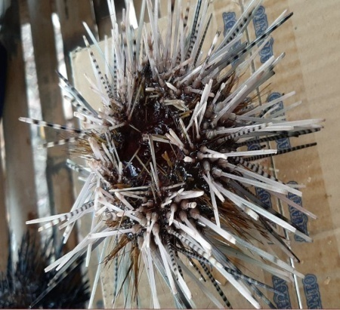
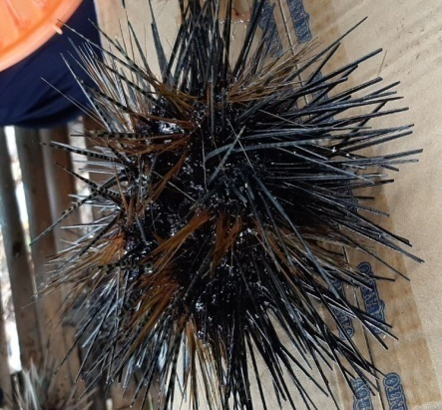
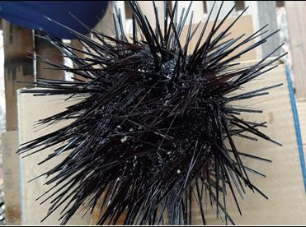
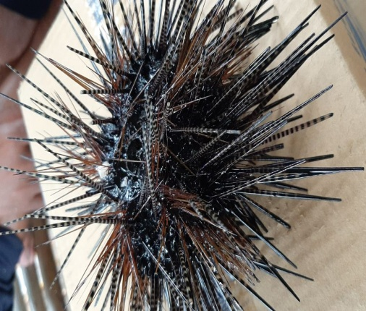
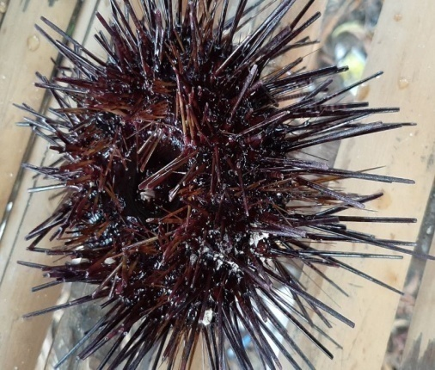

- (b) (c)

- (d)

Figure 1. (a) Diadema setosum,(b) Diadema antillarium, (c) Echinothrix calamaris, (d) Echinothrix diadema, (e). Diadema savignyi
The Abundance of Sea Urchins (Echinoidea)
Table 1. The Abundance of Sea Urchins at Research Locations
No | Species | Individual Abundance (KR)
 |  | Kancebungi Beach | BalobobeBeach | Pasi KobungiBeach
1 | Diadema setosum | 60,67 % | 34,09 % | 33,07 %
2 | Diadema antillarium | 6,74 % | 20,45 % | 25,29 %
3 | Echinothrix calamaris | 0 % | 0 % | 21,01 %
4 | Echinothrix diadema | 32,58 % | 45,45 % | 13,62 %
5 | Diadema savignyi | 0 % | 0 % | 7,00 %
Source: Research 2020

Diversity Index and Evenness Index
Table 2. Various Species of Sea Urchins found at the shores of Mawasangka District
No | Spesies | Nama Lokal | Lokasi Penelitian |  |  | Total
 |  |  | P. Kancebungi | P. Balobobe | P. Pasi kobungi
1 | Diadema setosum | Tayo | 54 | 15 | 85 | 154
2 | Diadema antillarium | Tayo | 6 | 9 | 65 | 80
3 | Echinothrix calamaris | Tayo | 0 | 0 | 54 | 54
4 | Echinothrix diadema | Tayo | 29 | 20 | 35 | 84
5 | Diadema savignyi | Tayo | 0 | 0 | 18 | 18
∑ |  |  | 89 | 44 | 257 | 390
H’ |  |  | 0,8503 (rendah) | 1,0498 (sedang) | 1,4991 (sedang)
H maks |  |  | 1,0986 | 1,0986 | 1,6094
e |  |  | 0,7740 (tinggi) | 0,9556 (tinggi) | 0,9314 (tinggi)
Source: Research 2020
Enviromental Parameter
Table 3. Enviromental Parameter Data at Research Locations
No | Parameter | Research Locations
 |  | P. Kancebungi | P. Balobobe | P. Pasi Kobungi
1 | Temperature (ºC) | 29 | 29 | 29
2 | Salinity (º/_{oo}) | 30 | 30 | 29
3 | pH | 5,5 | 5 | 6
4 | Substrat | Muddy, sandy | Muddy, sandy | Slightly Muddy andsandy
Souce: Research 2020
The total number of individual sea urchins found in the coastal area in Mawasangka District was 390 individuals consisting of 5 species from 2 genus. The genus Diadema was the genus with the highest number of species, namely 3 species and the genus Echinotrix as many as 2 species. This happens because the species of the genus Diadema have a high ability to survive and adapt so that they have a wide distribution. This finding was in line with Wulandewi et al (2015). They found that the Diadema Genus had the ability to live on tropical and subtropical beaches and had a wide distribution.
The highest abundance of sea urchins in this study was the type of Diadema cytosum, which is characterized by a black round body with a hard, calcareous shell filled with thorns. It has a reddish ring in the middle of the upper surface and there are five white dots located between each segment with 1 white point. The habitat of Diadema cytosum is on coral reefs, sandy areas and coral fragments. This species is the species which is most commonly found in the 3 research locations. This happens because the coral reef substrate is an important habitat for the growth of Diadema setosum and is easy to adapt to the environment, especially food in the form of seagrass and corals. This is in line with Thamrin et al (2011).Thamrin et al (2011) state that Diadema setosum in its habitat is herbivorous and is a type of grazer that lives in groups. Juliawan et al (2017) also provide a similar opinion that Diadema setosum has a place to live in coral reef ecosystems, where this type occupies sand flats, algae growth areas, coral fragments and dead coral. Sea urchins with the types of Diadema antillarium and Echinothrix diadema had almost even distribution because they were found in all study locations. It can be concluded that these species can also adapt to the environment. According to Timotius (2003), the role of Diadema antillarum is important for balancing coral reefs. If the population of Diadema antillarum increases, it can cause the death of larvae or young corals. Conversely, if the population decreases (absence grazing), the corals will be overgrown by algae which will result in the death of adult corals and there is no place for coral
The lowest abundance in this study was Diadema savignyi and Echinothrix calamaris. It is assumed that the low species habitat is not suitable for its survival. Both species’ habitat is sandy substrate, rocky areas, and coral reefs. This can be seen from these two species which are only found on Pasi Kobungi Beach with the lowest salinity compared to the other 2 research locations, namely 29 º/_{oo}and have the highest pH of the research location, namely 6. Besides that,Pasi Kobungi Beach is typically substrate sand and a bit muddy on the beach, which makes these 2 species survive in this coastal area. According to Dobo (2009), sea urchins which have a low species distribution are thought to be less able to compete with other types of food, namely seagrass and corals. In addition, according to Mustaqim et al (2013), the type of E. calamaris sea urchins are found mostly in the outer reaches. Another factor affecting its abundance is predators. Predators are one of the factors that mostly influence the distribution and abundance of sea urchins. Echinothrixcalamaris lives in coral reef areas close to the edge of the reef and hides under the coral to avoid predators.
The diversity index value in this study was classified as low to moderate (Table 2). The highest value was found in Balobone Beach and Pasi Kobungi Beach and the lowest value was found in Kancebungi Beach. This could happen because at the research location there were still many community activities in fishing, traveling and catching sea urchins themselves for sale or for daily consumption. This activity leads to the disruption of the habitat of sea urchins, such as cloudy water and damage to corals which affect the sea urchins in obtaining sunlight for algae growth as food. According to Wulandewi et al (2015), sea urchins obtain food from algae, seagrass and corals.
The evenness index value of sea urchins at the research location is high (Table 2) because it is more than 0.6. This shows that the abundance of sea urchins in each study location tends to be similar.
Environmental parameters are very important for coral and seagrass ecosystems as a habitat for sea urchins. From the observations made at the research locations, temperature, salinity, pH and the substrate were generally considered normal for coral habitats. The water temperature in three research locations was classified as the same, i.e.29ºC. This temperature was very supportive to the growth and life of sea urchins, and their habitats such as corals and seagrass. The maximum temperature for sea urchins was 36-40ºC. According to Suryanti et al (2014), sea urchins do not have special adaptations to increasing temperatures. The salinity of the waters at the study sites was found to be 29 to 20 º/_{oo}. This salinity value was quite suitable for the life of sea urchins. The range of salinity for the growth of sea urchins was 25-35 º/_{oo} (Supriharyono, 2007).
From the discussion, it can be seen that the most common sea urchin species found at the research location were Diadema setosum species. With regard to environmental health status, Diadema cytosum has an important role for the health of coastal areas and coral reefs. Some of the benefits were as an organism to shelter certain types of fish and as a balance to coral reefs. The presence of Diadema setosum species populations was important for coral reefs as a counterweight. Thus, the coastal area of Mawasangka District is a coastal area which is still classified as healthy and well-maintained. This is consistent with the statement of Suryanti et al. (2014), that the population balance of Diadema setosum will maintain the balance of algae and coral populations and is associated with coarser substrate conditions and clearer waters.Diadema setosum species utilize seagrass not only as a shelter but alsoas food source.
CONCLUSION
The total number of individual sea urchins found in the coastal area in Mawasangka District was 390 individuals consisting of 5 species from 2 genera. The genus Diadema is the genus with the highest number of species (3 species) and the other genus was Echinotrix with 2 species. The highest abundance of sea urchins was Diadema cytosum species and the lowest abundance was in Diadema savignyi and Echinothrix calamaris species. The diversity index was low to moderate and the evenness index was high.
The presence of a high population of Diadema setosum species in this study was very important to coral reefs as a shelter for certain types of fish and a counterweight to coral reefs. Thus, the coastal area of Mawasangka District is a coastal area which is still classified as healthy and well-maintained.
RECOMMENDATION
The highest abundance of sea urchins in this study was in the diadema cytosum species, so that in the future it can be continued research on the use of these types of sea urchins as natural antibiotics for the community.
ACKNOWLEDGMENT
Thanks to all those who have helped in this study, especially the research team and the Mawasangka District government who have given permission to conduct this study. This studywas funded by the government in the 2020 SIMLITABMAS national competitive research program.
REFERENCES
- Wulandewi.N.L.E, Subagio.J.N dan Wiryanto.J. 2015. Jenis Dan Desitas Bulu Babi (Echinoidea) Di Kawasan PAntai Sanur dan Serangan Denpasar Bali. Jurnal Simbiosis III, (1), 269-28
- Thamrin, S., YJ. Siregar, SH. 2011. Analisis Kepadatan Bulu babi (Echinoidea) Diadema setosum pada Kondisi Terumbu Karang Berbeda di Desa Mapur Kepulauan Riau. Ilmu Lingkungan, Riau, 5(1):45-53.
- Juliawan, Dewiyanti.I dan Nurfadillah. 2017. Kelimpahan dan Pola Penyebaran Bulu Babi (Echinoidea) Di Perairan Pulau Kiah Kota Sabang. Jurnal Ilmiah Mahasiswa Kelautan dan Perikanan Unsyiah, 2 (4), 541-54
- Timotius, S. 2003. Karakteristik Biologi Karang. Makalah Training Centre 7 – 12 Juli 2003. YayasanTerumbu Karang Indonesia (Terangi).
- Dobo, J. 2009. Tipologi komunitas lamun kaitannya dengan populasi bulu babi di Pulau Hatta Kepulauan Banda, Maluku. Tesis. Sekolah Pascasarjana Institut Pertanian Bogor.
- Mustaqim, M., Ruswahyuni dan Suryanti. 2013. Kelimpahan Jenis Bulu Babi (Echinoidea, Leske 1778) di Daratan dan Tubir Terumbu Karang di Perairan Sijago-Jago, Tapanuli Tengah. Jurnal of Marques 2(4): 61-70
- Suryanti dan Ruswahyuni. 2014. Perbedaan Kelimpahan Bulu Babi (Echinoidea) Pada Ekosistem Karang dan lamun Di Pancuran Belakang Karimunjawa Jepara. Jurnal Saintek Perikanan, 10 (1), 62-67
- Toha, Abdul hamid A. 2006. Manfaat Bulu Babi (Echinoidea) Dari Sumber Pangan Sampai Organisme Hias. Jurnal Ilmu-Ilmu Perairan dan Perikanan Indonesia, 13 (1), 77-82
- Zakaria, I. J. (2013). Komunitas Bulu Babi (Echinoidea) di Pulau Cingkuak, Pulau Sikuai dan Pulau Selatan Sumatera Barat. Prosiding Semirata FMIPA Universitas Lampung, 1(1), 38-187.
- Uma, B. & Parvathavarthini, R. (2010). Antibacterial Effect of Hexane Extract of Sea Urchin. International Journal of PharmTech Research, 2(3), 1677-1680.
- Thamrin, Y. J. Setiawan dan S. H. Siregar. 2011. Analisis Bulu Babi Diadema setosum Pada Kondisi Terumbu Karang Berbeda di Desa Mapur Kepulauan Riau. Jurnal Ilmu Lingkungan Universitas Riau. 5(1) :45- 48.
- Yulianto, A.R. 2010. Pemanfaatan Bulu Babi Secara Berkelanjutan pada Kawasan Padang Lamun . Tesis. Program Pascasarjana Biologi. Universitas Indonesia. Jakarta.
- Budiman, C.C., D.Y Katili., M.L.D. Langoy, dan P.V. Maabat. 2014. Keanekaragaman Echinodermata di Pantai Basaan Satu Kecamatan Ratatotok Sulawesi Utara. Jurnal MIPA UNSRAT Online 3(2): 97101.
- Mustaqim, M., Ruswahyuni dan Suryanti. 2013. Kelimpahan Jenis Bulu Babi (Echinoidea, Leske 1778) di Daratan dan Tubir Terumbu Karang di Perairan Sijago-Jago, Tapanuli Tengah. Jurnal of Marques 2(4): 61-70.
- Rahman, M.A., A. Arshad dan F.Md Yusoff. 2014. Sea Urchins (Echinodermata: Echinoidea): Their Biology, Culture and Bioactive Compounds. International Conference on Agricultural, Ecological and Medical Sciences (AEMS-2014) July 3-4 2014 London (United Kingdom).
- Aslan, L., 2010. Bulu babi (manfaat dan pembudidayaanya) Edisi Revisi. Unhalu Press: Kendari.
- Ayyagari, A.and Kondamudi, R.B.2014.Ecological significance of the association bet ween stomopneustes variolaris (Echinoidae) and lumbrineris latreilli (polychaeta) from Visakhapatnam Coast India. Jurnal Of Marine Biologi: India.
- Laning, T. H., Deny, S. Y., Joko, W., 2013. Sebaran bulu babi (Echinoidea) di kawasan Padang Lamun Pantai Merta Segara, Sanur-Bali. Jurnal Biologi 18 (2) : 41 – 45.
- Supono., Ucu, Y. A,. 2012. Kelimpahan dan keragaman echinodermata di Pulau Pari, Kepulauan Seribu. Jurnal Ilmu dan Teknologi Kelautan Tropis. 4, 1 : 114120.
- Lubis, S. A., Arief, A. P., Rofiza, Y. 2016. Spesies bulu babi (echinoidea) di perairan Pulau Panjang Kabupaten Bangka Tengah Provinsi Bangka Belitung. Jurnal Pendidikan Biologi Fakultas Keguruan Dan Ilmu Pendidikan. Universitas Pasir Pengaraian : 1-6.

