Filsafat
by Muhsinpd38@guru.sd.belajar.id 1

Submission date: 04-May-2024 06:57AM (UTC+0000)
Submission ID: 2370585315
File name: artikel_teks_inggris.docx (87.45K)
Word count: 5951
Character count: 36613

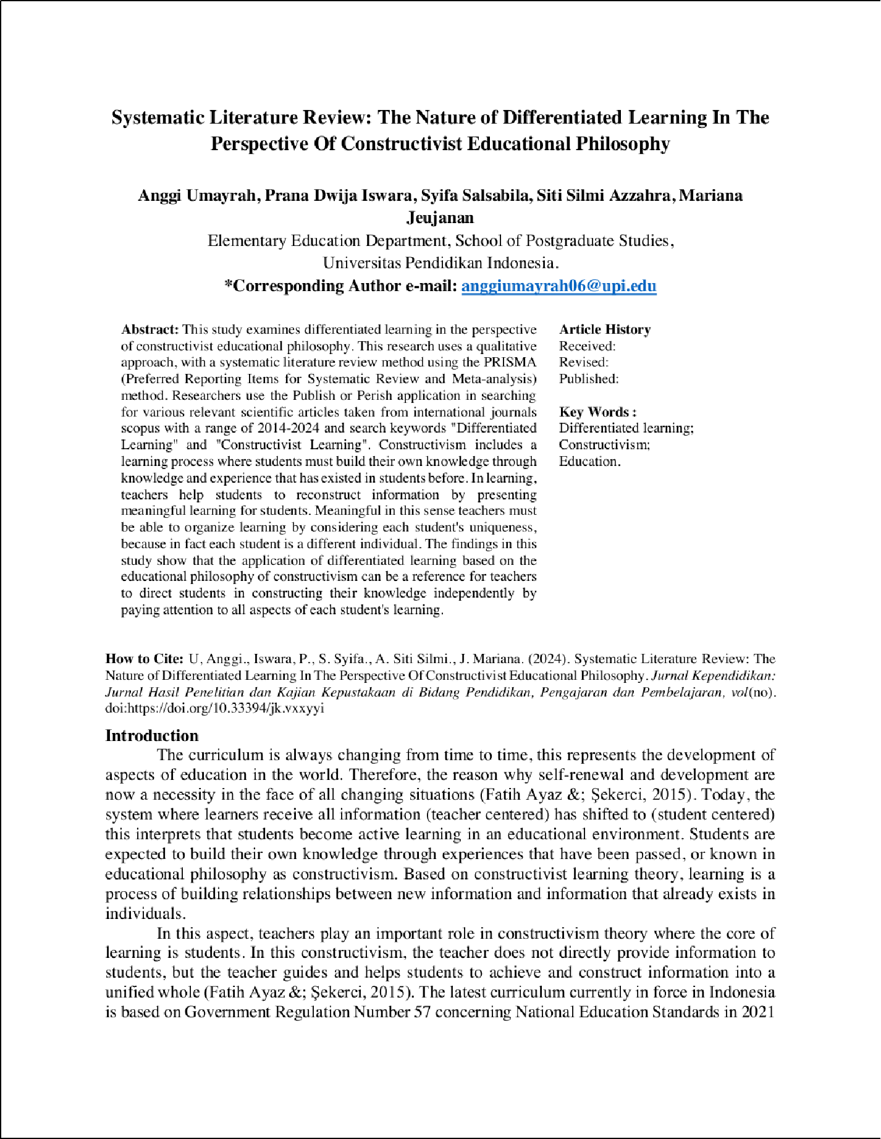

5

20

15

31

6

6

37

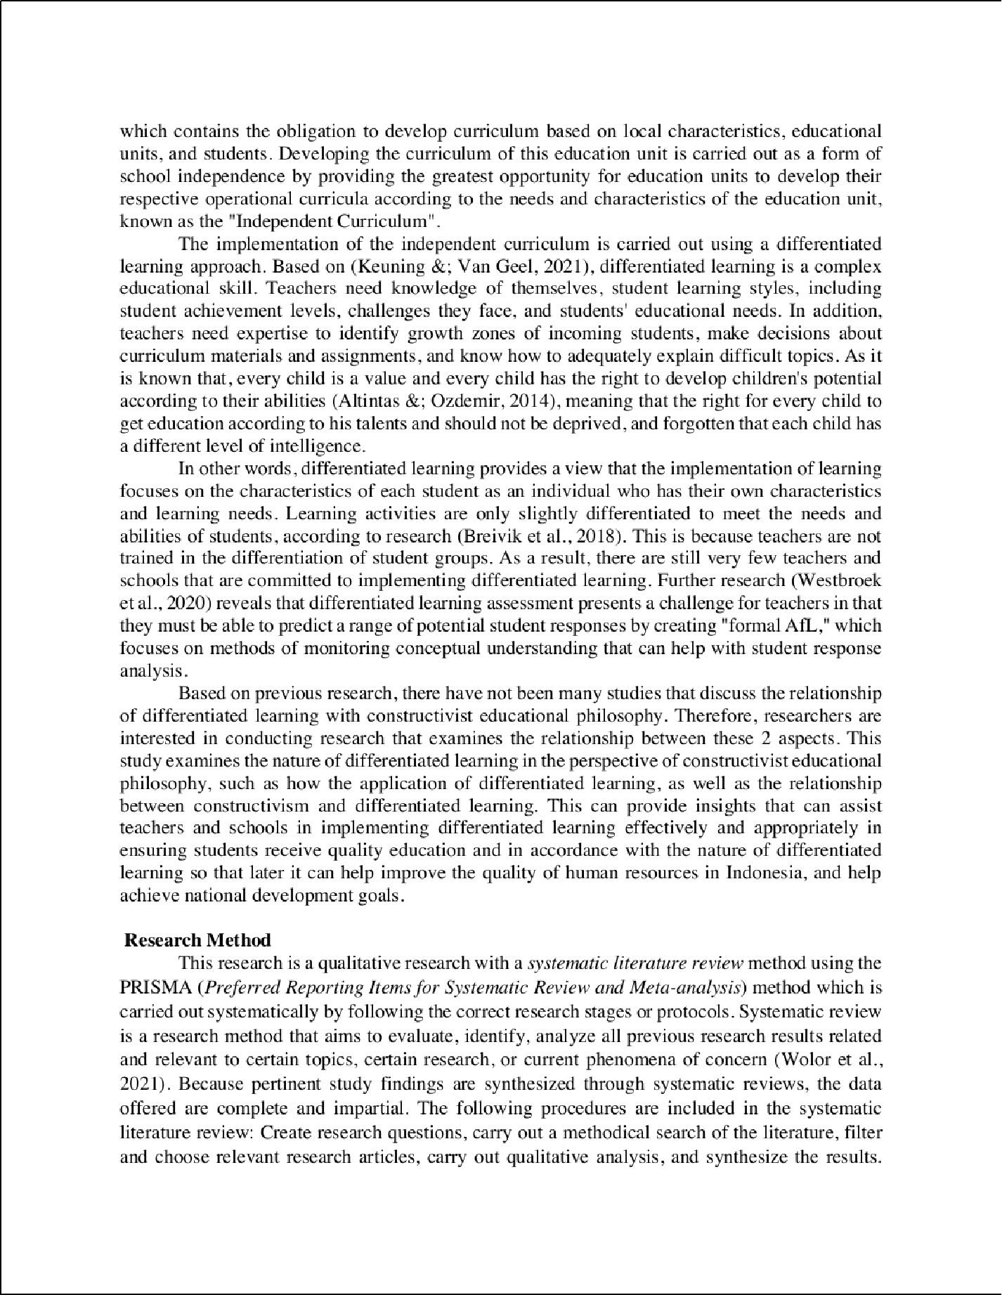

45

26

17

13
41
13
5

6
2

23

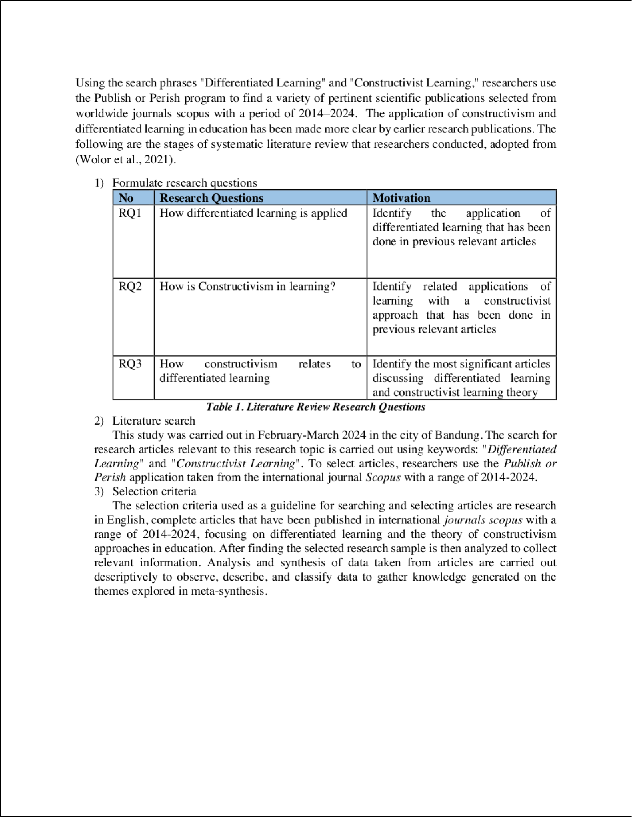

2

2

10

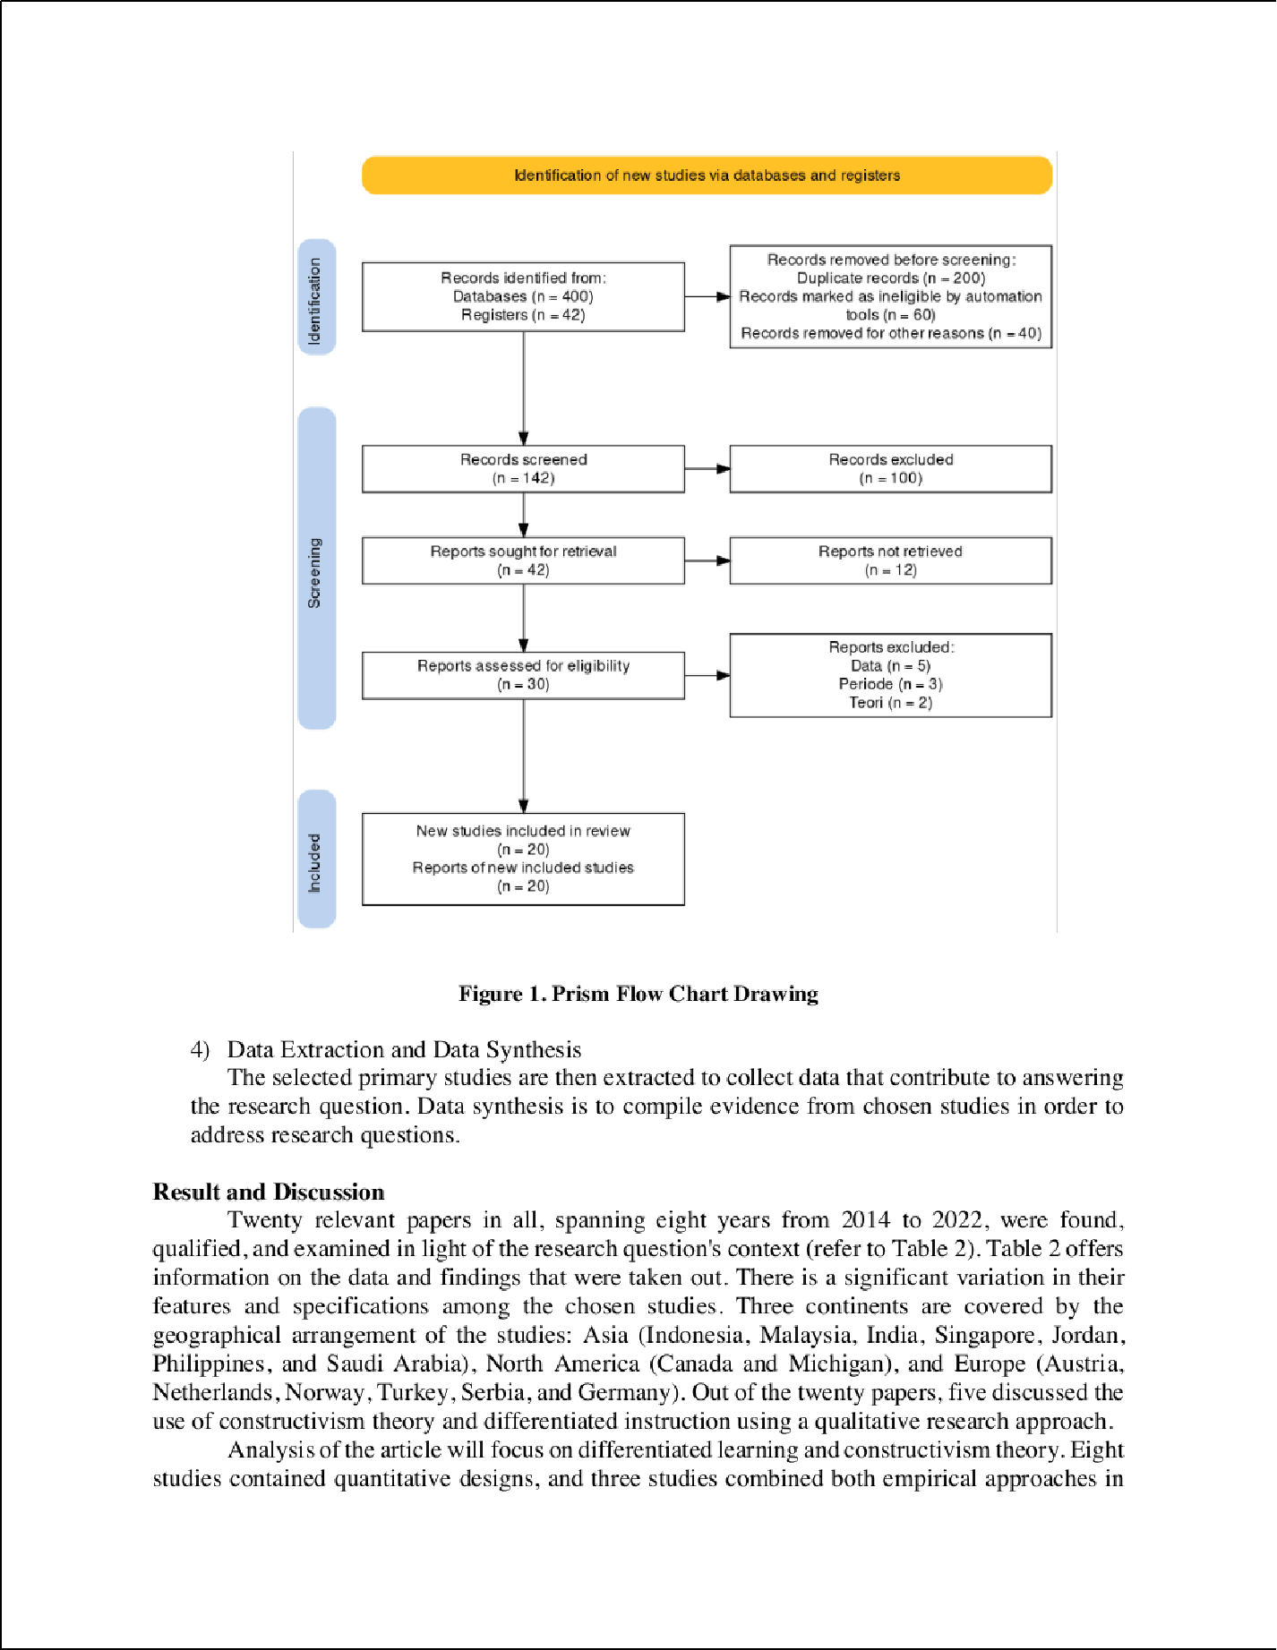

2
2

8

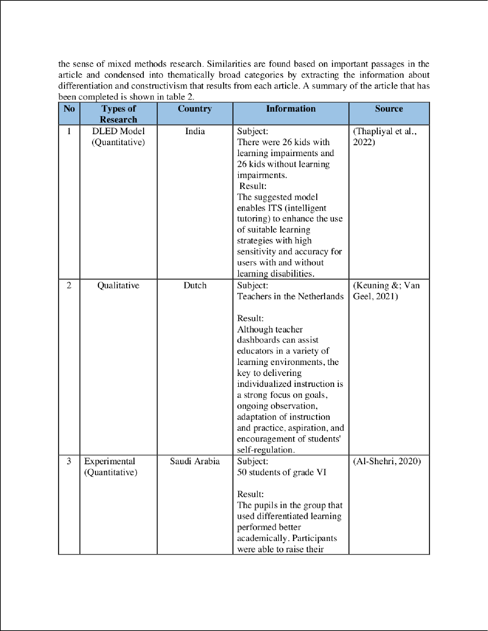

8
8

7

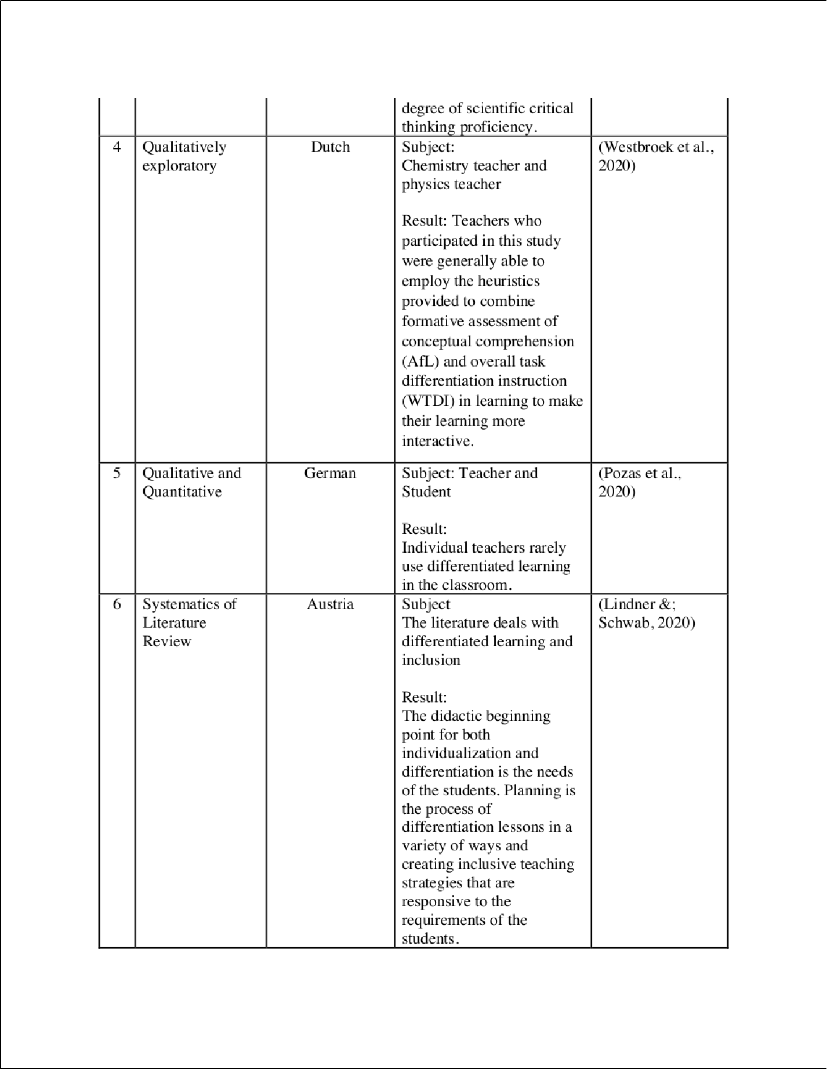

39

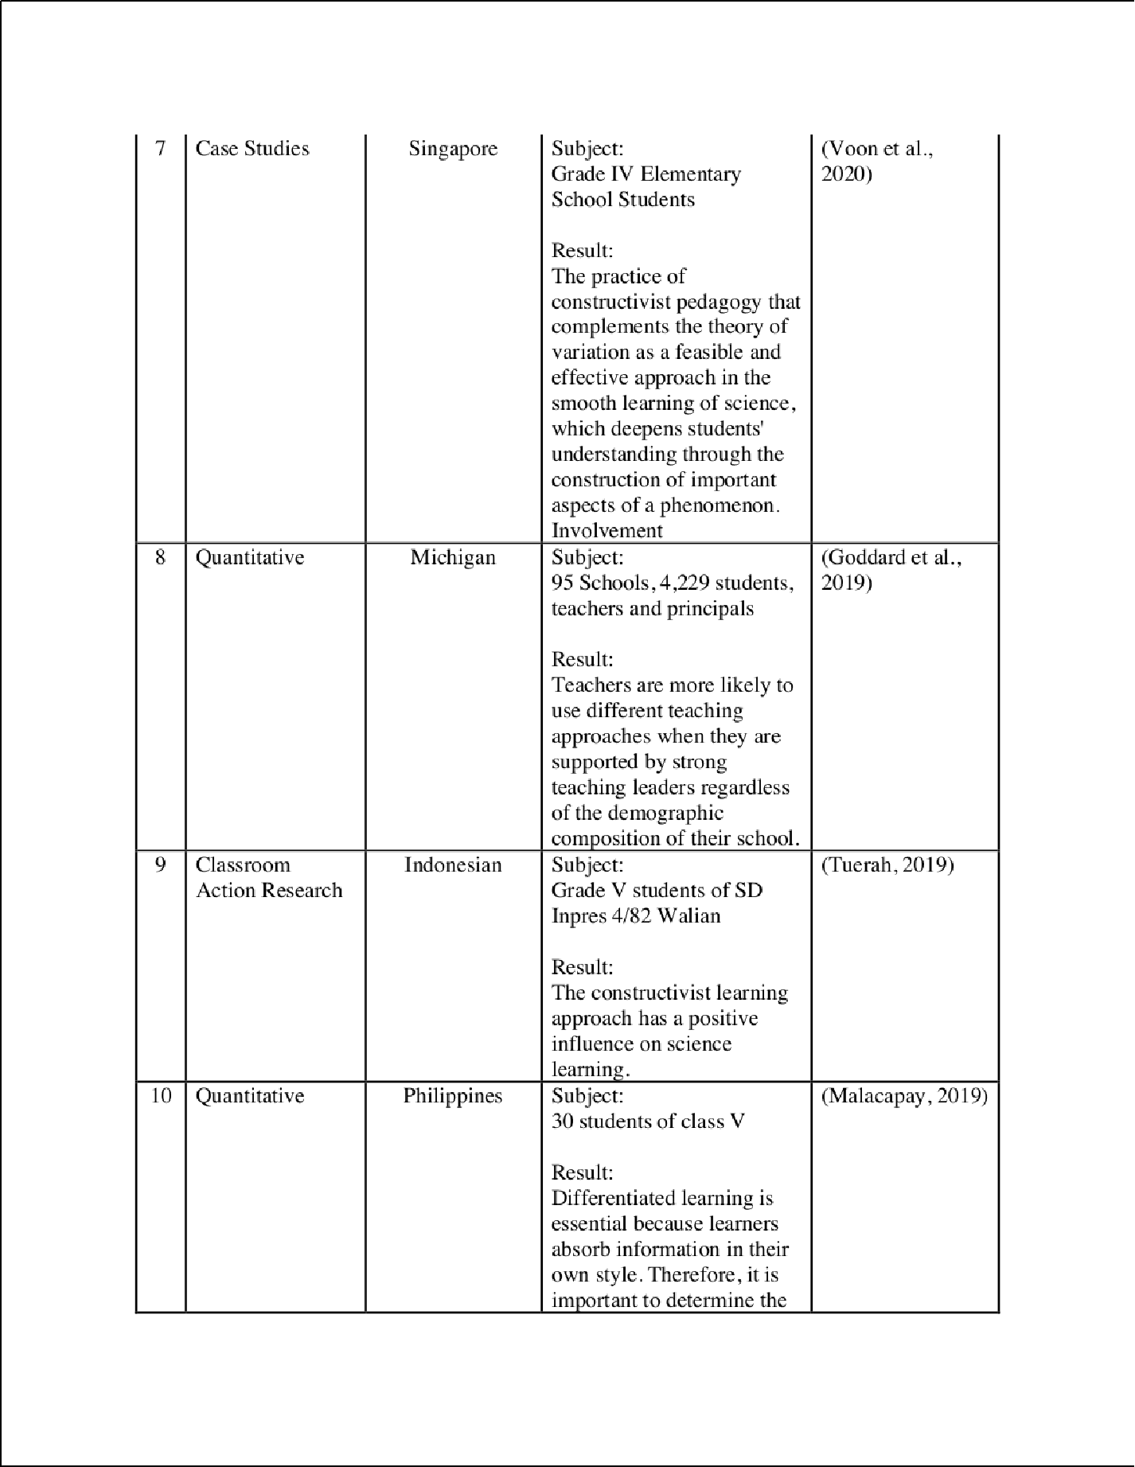

35

24

11

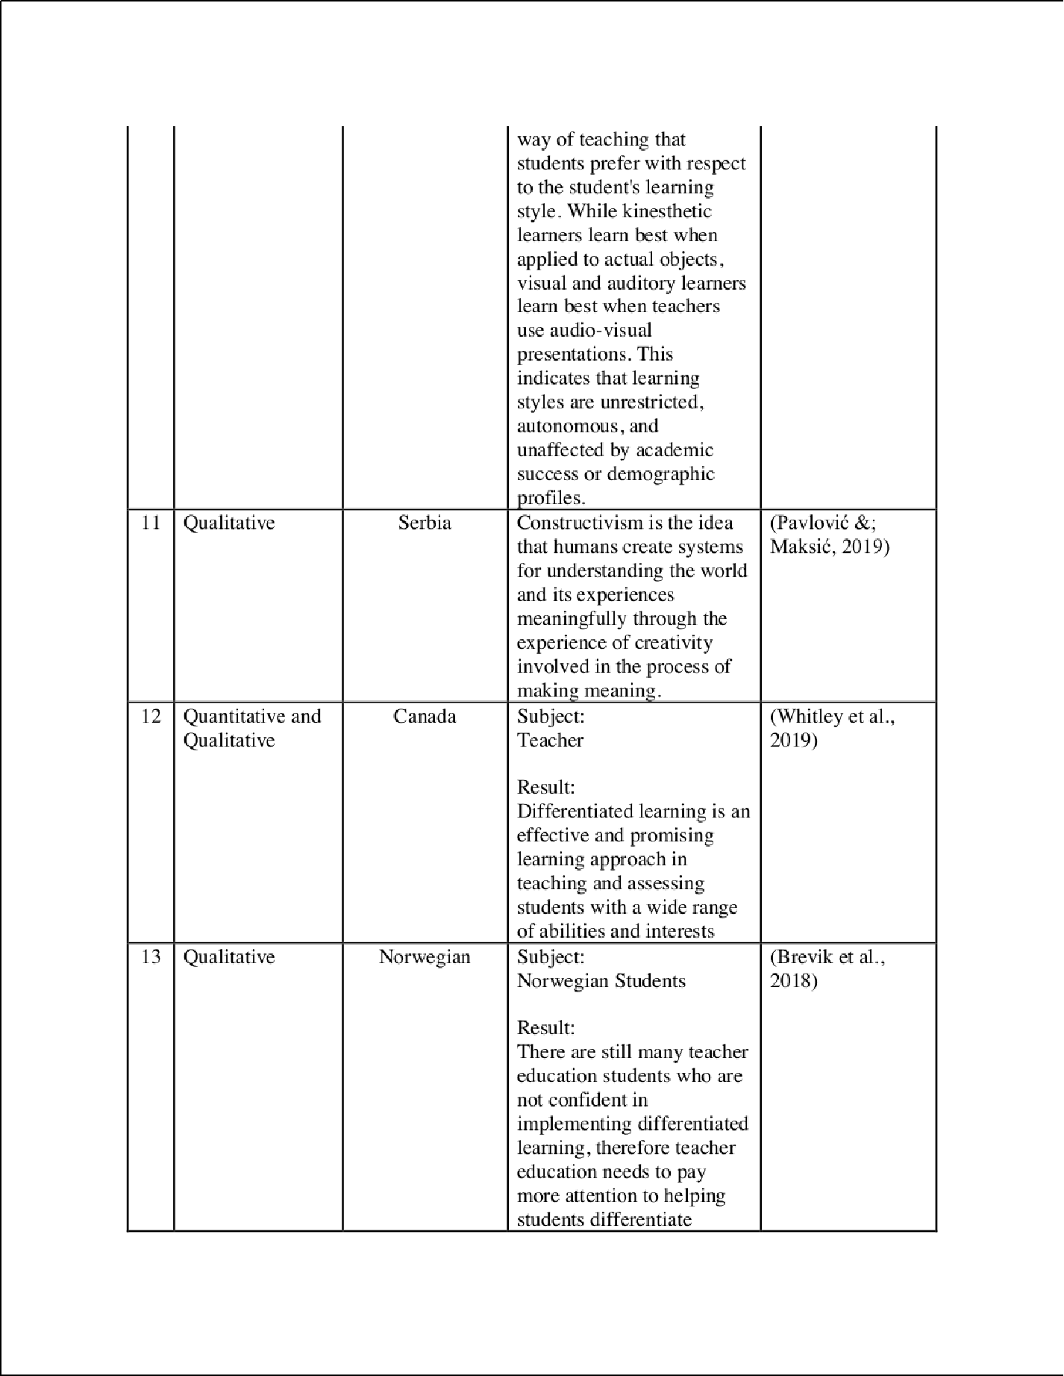

19

9

4

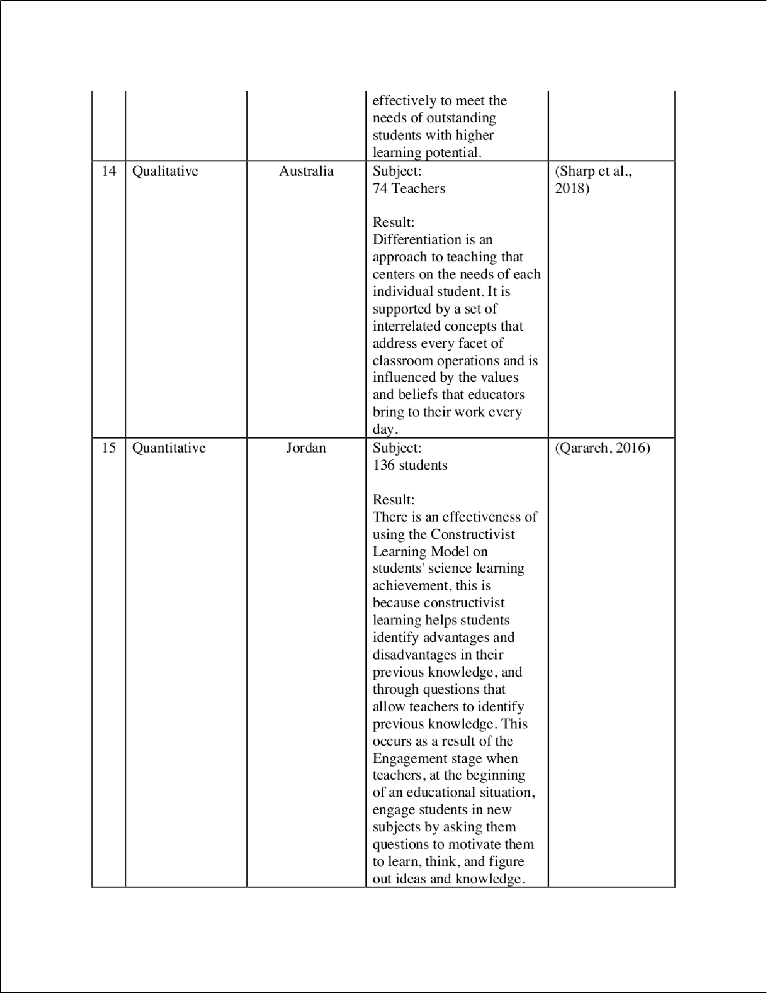

4

28

27

3

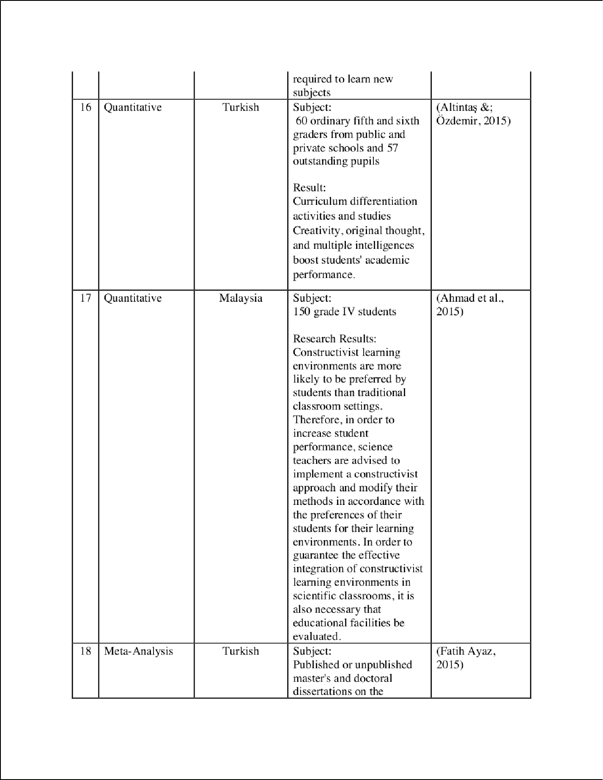

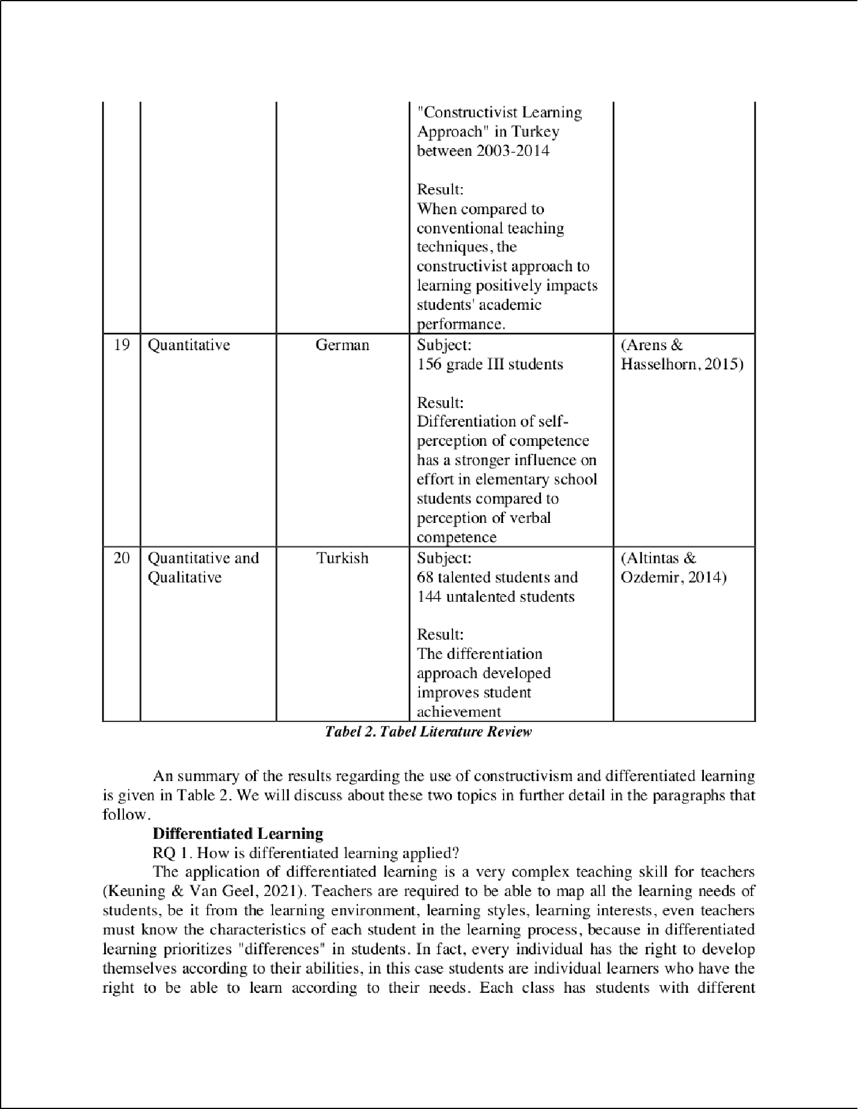

36

5

14

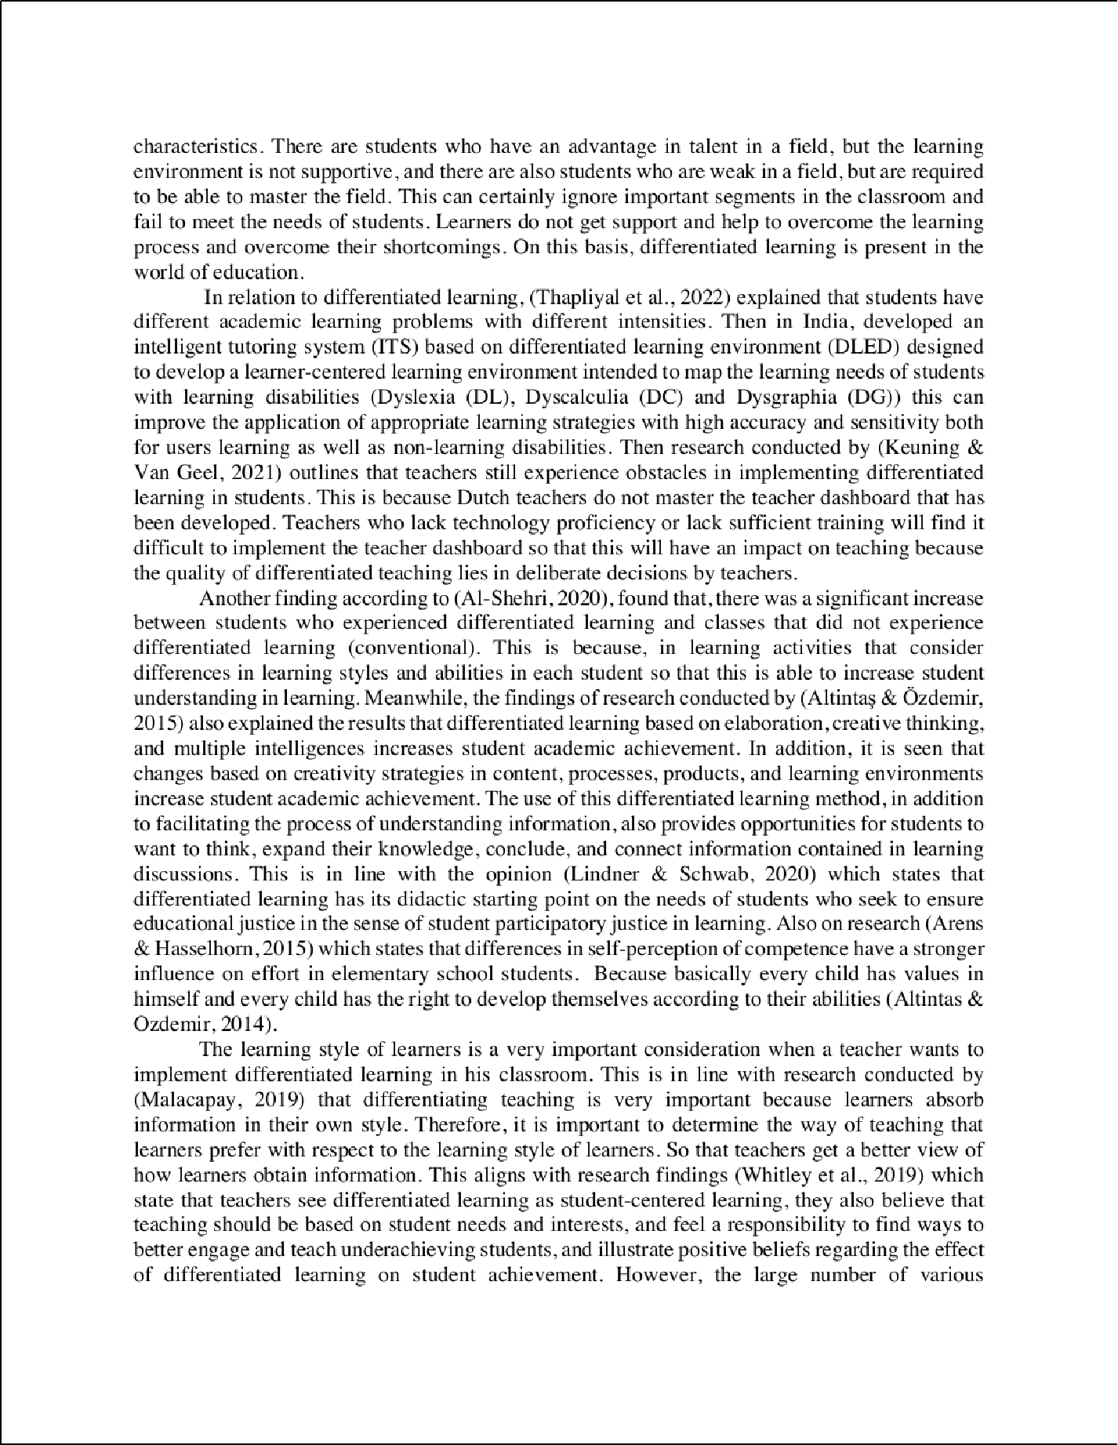

29
16

7
44
43
7
7

12

16

8

30

9 9
5

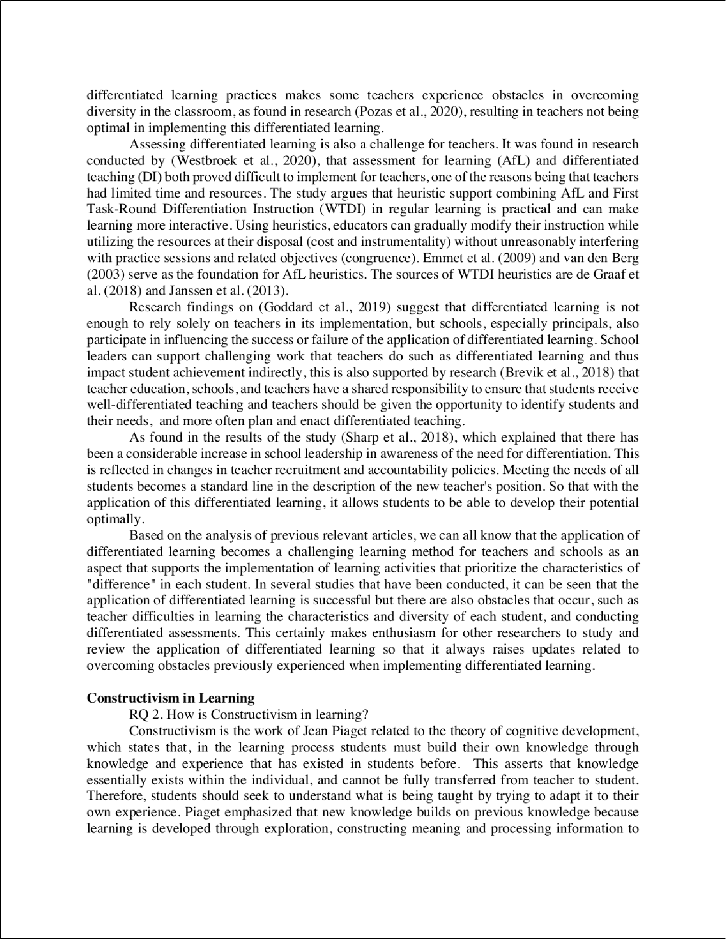

4
4

17

14

5

1

1
1
18

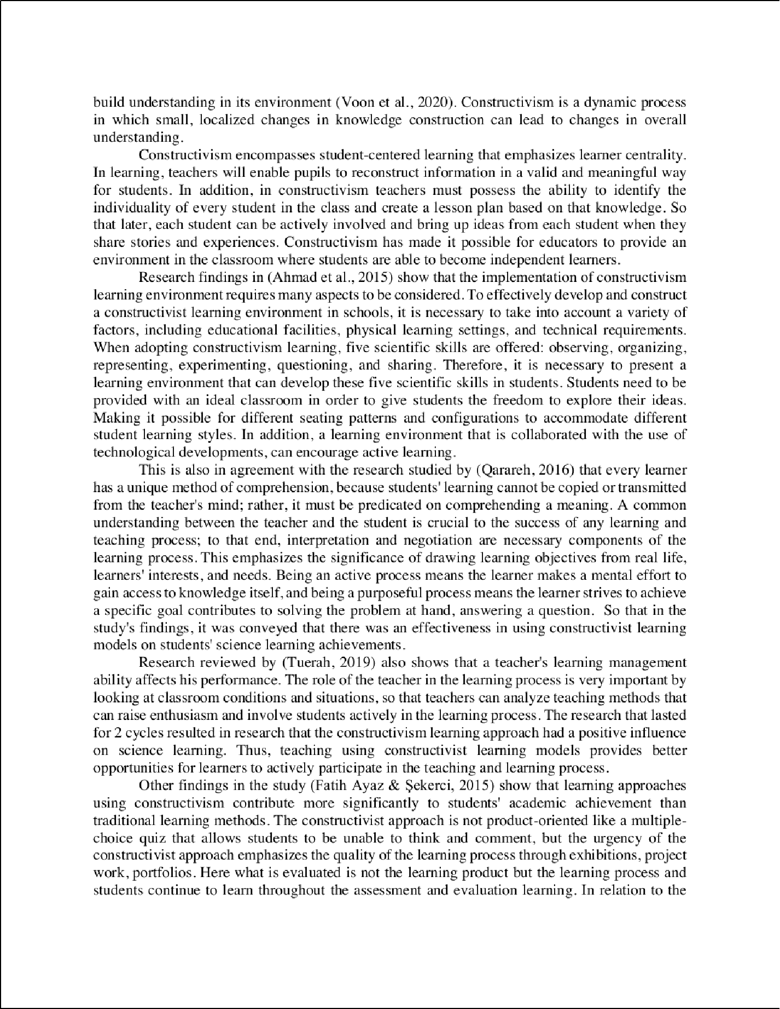

1

1

1
22
1
1

33
1

38

3

3
3

11

11
3

34

46

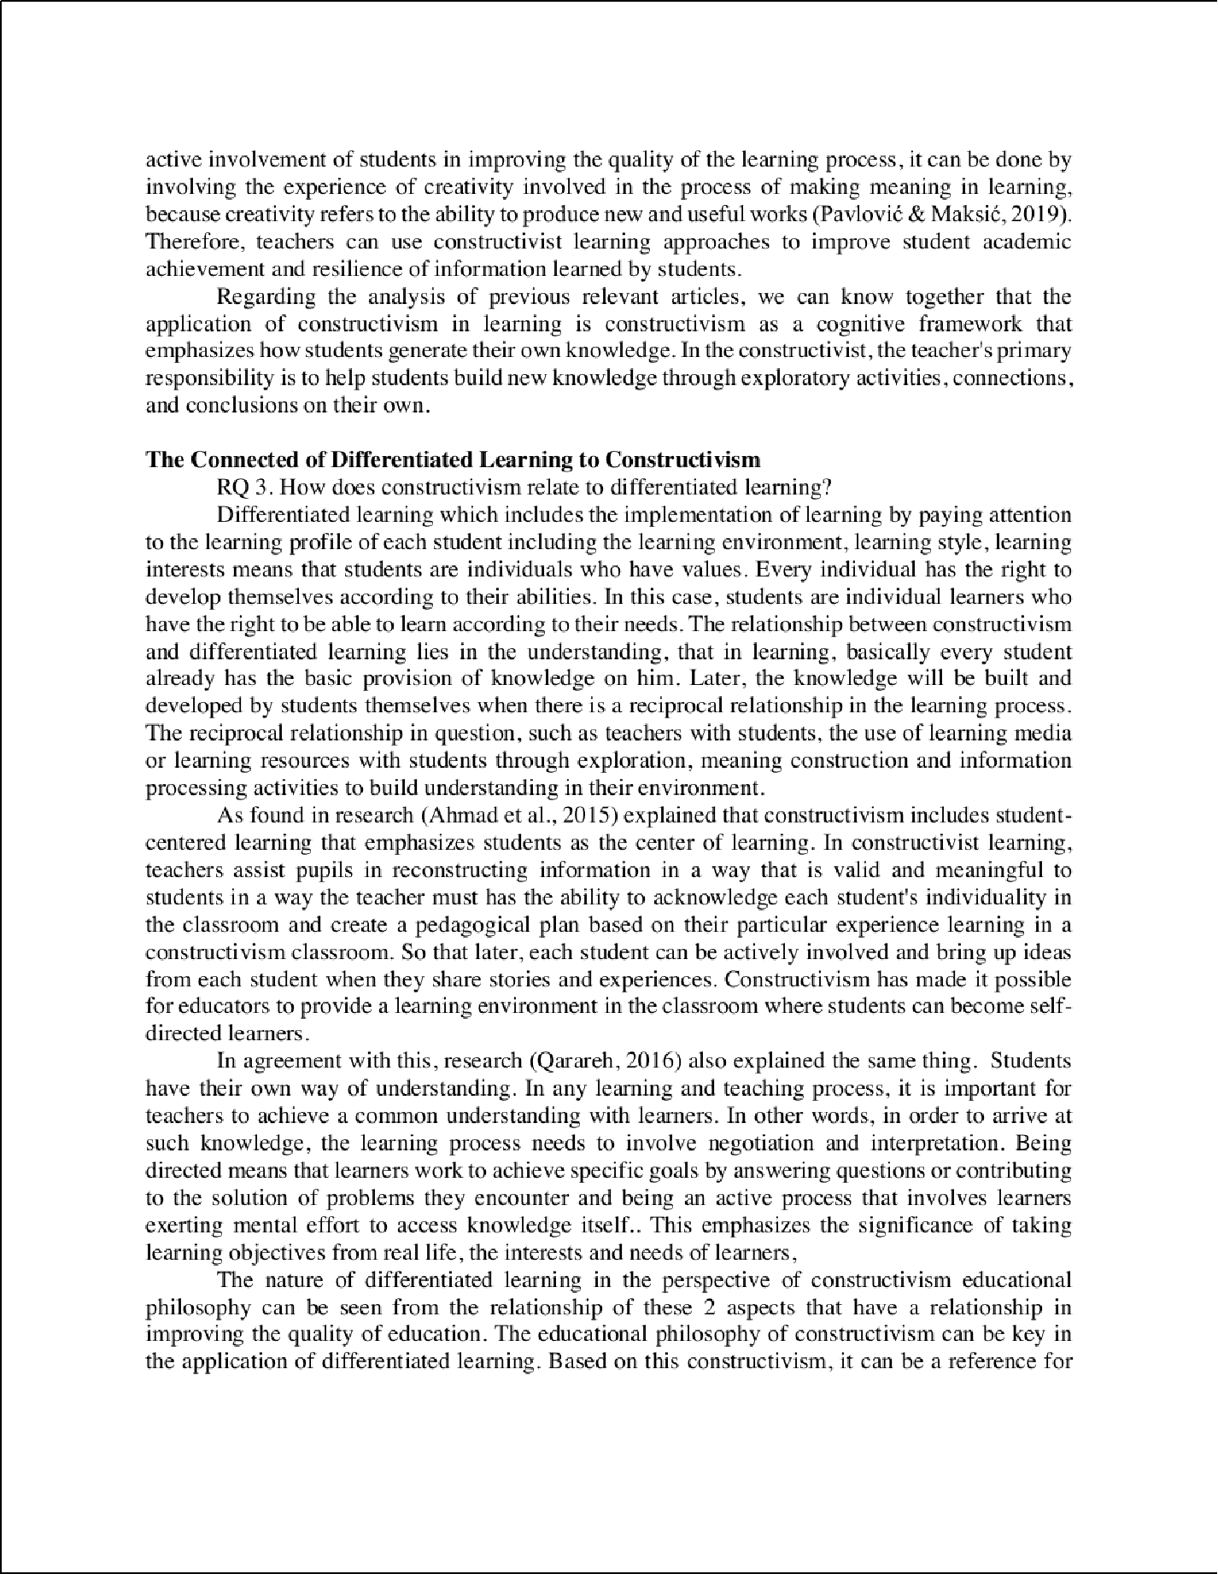

25
42

14

1

40

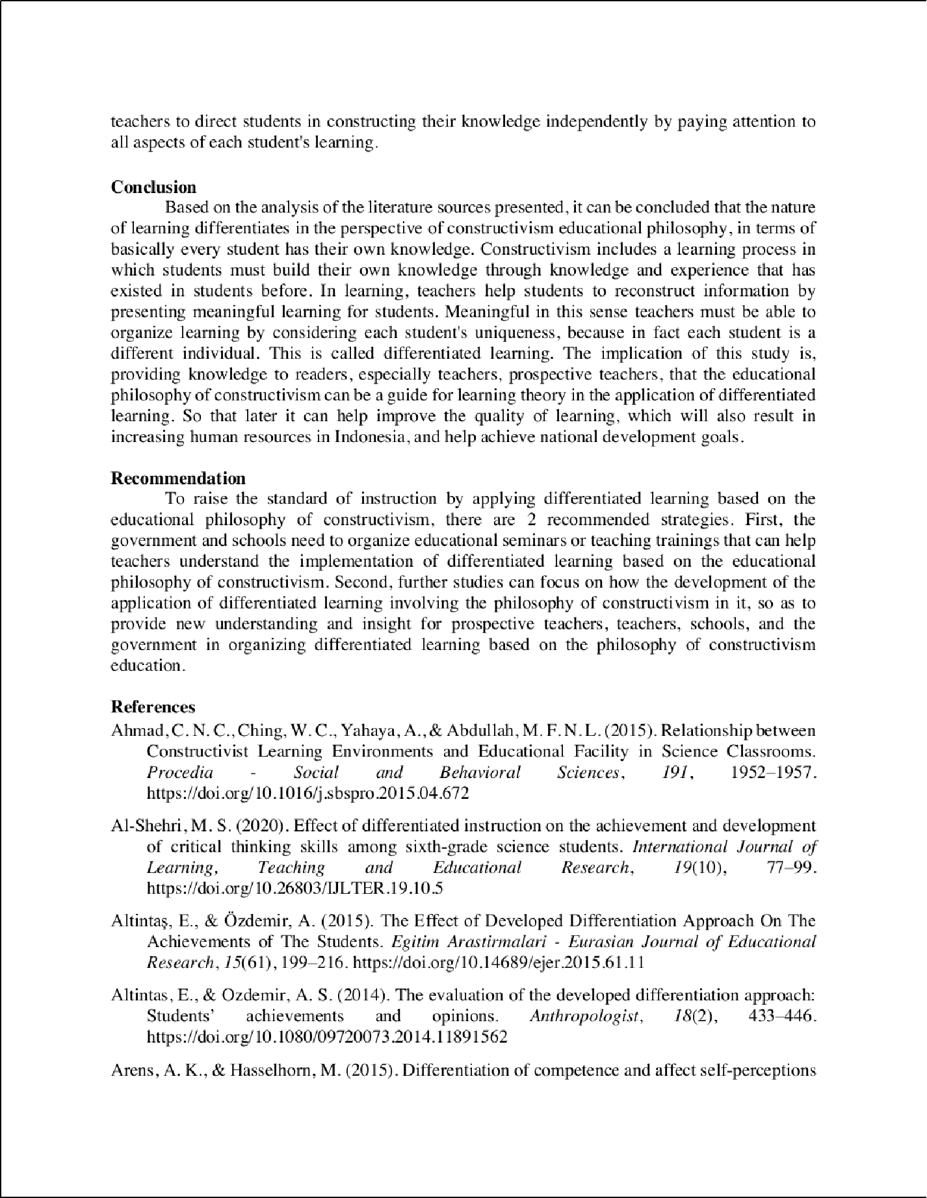

21

32

13
13

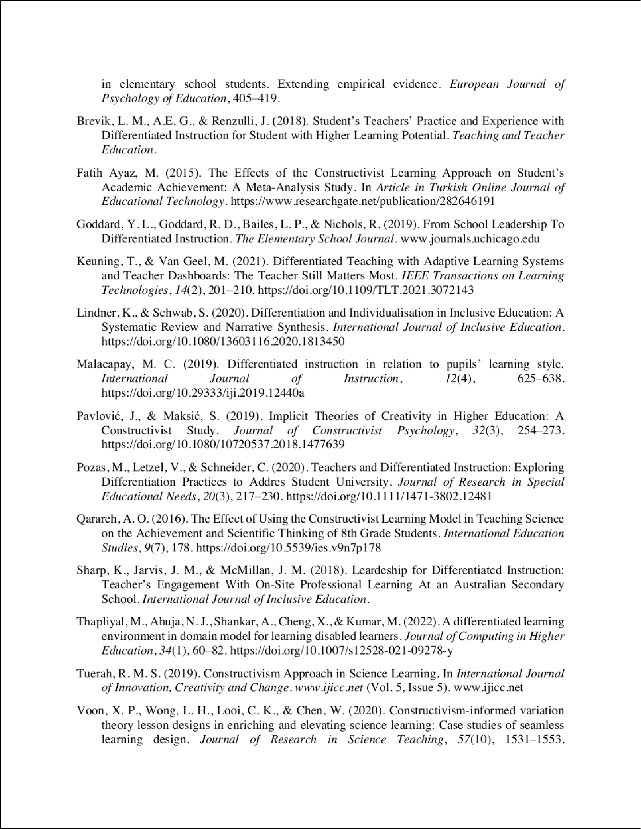

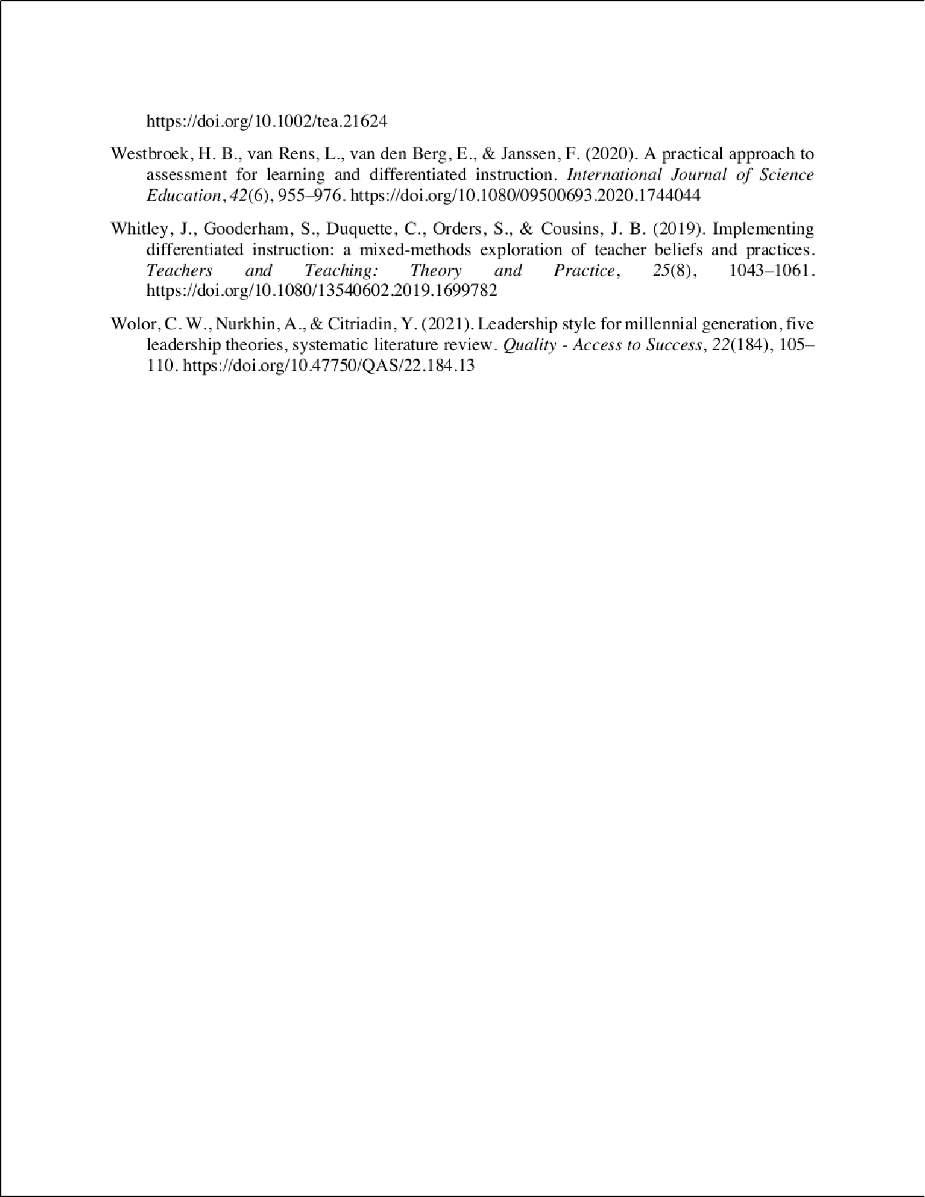

Filsafat
ORIGINALITY REPORT
18

%
SIMILARITY INDEX

11%
INTERNET SOURCES

13%
PUBLICATIONS

3%
STUDENT PAPERS

PRIMARY SOURCES
1 Ahmad, Che Nidzam Che, Wang Chiao Ching, Asmayati Yahaya, and Mohd Faizal Nizam Lee Abdullah. "Relationship between Constructivist Learning Environments and Educational Facility in Science Classrooms", Procedia - Social and Behavioral Sciences, 2015.
Publication
2%
2

admin.calitatea.ro
Internet Source %
2
2%

3 Qarareh, Ahmed O.. "The Eﬀect of Using the Constructivist Learning Model in Teaching Science on the Achievement and Scientiﬁc Thinking of 8th Grade Students", International Education Studies, 2016.
Publication
1%

4 Lisbeth M. Brevik, Ann Elisabeth Gunnulfsen, Joseph S. Renzulli. "Student teachers’ practice and experience with diﬀerentiated instruction for students with higher learning potential", Teaching and Teacher Education, 2018
Publication

5

6

7

8

9

10

11

12
jurnal.fkip.unila.ac.id
Internet Source

e-journal.undikma.ac.id
Internet Source

link.springer.com
Internet Source

Katharina-Theresa Lindner, Susanne Schwab. "Diﬀerentiation and individualisation in inclusive education: a systematic review and narrative synthesis", International Journal of Inclusive Education, 2020
Publication

Jessica Whitley, Suzanne Gooderham, Cheryll Duquette, Shari Orders, J. Bradley Cousins. "Implementing diﬀerentiated instruction: a mixed-methods exploration of teacher beliefs and practices", Teachers and Teaching, 2019
Publication

ijefm.co.in
Internet Source

repository.ung.ac.id
Internet Source

www.researchgate.net
Internet Source
1%
1%
1%
1%

1%

1%
1%
<1%

13

14

15

16

17

18

19

20
Wiwin Kobi, Herinda Mardin, M. Iqbal Liayong Pratama. "Implementation of Diﬀerentiated Learning as an Eﬀort to Increase Teacher Capacity at SMA Negeri 1 Tibawa", Mattawang: Jurnal Pengabdian Masyarakat, 2023
Publication

jinav.org
Internet Source

discovery.researcher.life
Internet Source

mail.ijlter.org
Internet Source

scholarworks.waldenu.edu
Internet Source

Submitted to Liberty University
Student Paper

Submitted to cotsu
Student Paper

Duden Saepuzaman, Syakti P. Sriyansyah, Saeful Karim. " Unpacking Pre-service Physics Teachers’ Understanding of the - - Diagram and the Associated Mathematics ", Journal of Physics: Conference Series, 2019
Publication

repository.stkippacitan.ac.id
<1%

<1%
<1%
<1%
<1%
<1%
<1%
<1%

21

22

23

24

25

26

27

28

29

30
Internet Source

Submitted to HCUC
Student Paper

jurnal.unimus.ac.id
Internet Source

Neeves, Erica. "Supporting Teachers through Standardized Testing: Elementary Teachers' Perceptions of Administrator Support", University of South Dakota, 2021
Publication

jlils.ppj.unp.ac.id
Internet Source

www.krepublishers.com
Internet Source

Science Education Research and Practice in Asia, 2016.
Publication

doaj.org
Internet Source

jurnal.ahmar.id
Internet Source

pt.scribd.com
Internet Source

researchspace.ukzn.ac.za
<1%
<1%
<1%
<1%

<1%
<1%
<1%
<1%
<1%
<1%

31

32

33

34

35

36

37

38
Internet Source

www.pedocs.de
Internet Source

Huﬀ, Howard Dean. "How Experienced Students See: Perceptions of Engagement with Instructors", The Chicago School of Professional Psychology, 2022
Publication

Mohamed, Debbie. "Comparing Problem- Based Learning to Direct Instruction in 10th Grade Chemistry", Capella University, 2023
Publication

Xin P. Voon, Lung H. Wong, Chee K. Looi, Wenli Chen. "Constructivism‐informed variation theory lesson designs in enriching and elevating science learning: Case studies of seamless learning design", Journal of Research in Science Teaching, 2020
Publication

edepot.wur.nl
Internet Source

ej-edu.org.ejfood.org
Internet Source

listens.online
Internet Source
<1%
<1%
<1%

<1%

<1%

<1%
<1%
<1%

39

40

41

42

43

44

45
stem2020.sites.olt.ubc.ca
Internet Source

tojqih.net
Internet Source

worldwidescience.org
Internet Source

Darnawati Darnawati, Jamiludin Jamiludin, Mursidin Mursidin, La Ili. "Developing online learning guidebook for junior high school level in Kendari City", Journal of Education and Learning (EduLearn), 2021
Publication

Ika Astuti, Achmad Ruslan Afendi. "Implementation of Diﬀerentiated Learning Through Play Activities in Early Childhood", EduLine: Journal of Education and Learning Innovation, 2022
Publication

Monika Thapliyal, Neelu Jyothi Ahuja, Achyut Shankar, Xiaochun Cheng, Manoj Kumar. "A diﬀerentiated learning environment in domain model for learning disabled learners", Journal of Computing in Higher Education, 2021
Publication

jurnal.radenfatah.ac.id
Internet Source
<1%
<1%
<1%
<1%

<1%

<1%

<1%

46
"Eﬀective Teaching Around the World", Springer Science and Business Media LLC, 2023
Publication
<1%

Exclude quotes On Exclude bibliography On
Exclude matches Oﬀ

