PORTRAIT OF DIGITAL LIBRARY ISLAMIC COLLECTION: STUDY OF PTKIN DIGITAL LIBRARY MANAGEMENT SYSTEMS IN NORTH SUMATERA

Muhammad Dalimunte¹ , Toguan Rambe², Kasron Nasution³ , UIN Sumatera Utara,¹ IAIN Padangsidimpuan²UIN Sumatera Utara³, Email: muhammadadalimunte@uinsu.ac.id¹ toguan@iain-padangsidimpuan.ac.id^{2,} kasronnasution@uinsu.ac.id³

Abstract:
This paper was born from the results of research that aims to look at the management of human resources and the management of digital systems in the libraries of state Islamic universities, specifically in the North Sumatra region, namely UIN North Sumatra Medan, IAIN Padangsidimpuan and STAIN Mandailing Natal. Management of human resources requires effective management, if the management is not effective it will decline further than other resources. This study uses a qualitative approach in data collection, researchers carry out observations, interviews and focus group discussions so that the resulting data is more comprehensive. with the needs of the college library. The results of the research obtained are the reality that there is an unbalanced comparison between users or users with human resources, this causes the service to be not good in the library. Increasing the quality of human resources in the PTKIN library in the North Sumatra region is very urgent to be carried out in order to optimize performance and become a driver of other resources more optimally. The development of human resources in the libraries at the three universities above only focuses on librarians, has not been implemented in its entirety in each unit. This optimization is also to support the competitiveness of libraries in this massive digitalization era, so that the development of scientific knowledge is progressively advanced in Islamic universities in North Sumatra.
Keywords: Digital library, Islamic College, Human Resources

Tulisan ini lahir dari hasil penelitian yang bertujuan untuk melihat pengelolaan sumber daya manusia serta pengelolaan sistem digital dalam perpustakaan perguruan tinggi Islam negeri, spesifiknya di wilayah Sumatera Utara, yakni UIN Sumatera Utara Medan, IAIN Padangsidimpuan dan STAIN Mandailing Natal. Pegelolaan terhadap sumber daya manusia memubutuhkan manajemen yang efektif, jika manajemenya tidak efektif justru akan merosot lebih jauh dibandingkan sumber daya yang lain. Penelitian ini menggunakan pendekatan kualitatif dalam pengumpulan data peneliti melaksanakan observasi, wawancara serta focus group discussion sehinga data yang dihasilkan lebih komprehensif, dalam operasionalnya peneliti menganalisa kebutuhan pada setiap unit diperpustakaan, sehingga akan terlihat bagaimana fungsi dan perannya didalam perpustakaan atau setiap unit yang ada harus menyesuaikan dengan kebutuhan perpustakaan perguruan tinggi. Hasil penelitian yang didapatkan realitasnya bahwa terjadi perbandingan yang tidak seimbang antara user atau pengguna dengan sumber daya manusia, ini menyebabkan layanan menjadi tidak baik dalam perpustakaan. Peningkatan kualiatas sumber daya manusia di perpustakaan PTKIN wilayah Sumatera Utara sangat urgen dilaksanakan guna mengomtimalkan kinerja dan menjadi pendorong sumber daya yang lain lebih optimal. Pengembangan sumber daya menusia di perpustakaan pada tiga perguruan tinggi diatas hanya fokus pada pustakawan, belum dilaksanakan secara keseluruhan disetiap unit. Pengoptimalan tersebut juga untuk mendukung daya saing perpustakaan diera digutalisasi yang begitu massif sast ini, sehingga pengembangan keilmuan niscata semakin maju di perguruan tinggi Islam di Sumatera Utara.
Kata Kunci : Perpustakaan digital, Perguruan Tinggi Islam, Sumber Daya Manusia.

Introdutions
Management as an important element of human resources in improving the quality of the organization, in this case the environment of state Islamic Universities. Management can be done by managing and developing human resources which are used as improvements in overcome deficiencies in carrying out work better, in accordance with the development of science and technology used by the organization.
Human resource development is an effective way to deal with challenges, including lagging human resources and the diversity of existing human resources within the organization, changes to agreed-upon activity techniques and turnover of human resources. It is important for organizations to invest in capital equipment to remain competitive and adapt to technological changes, but capital equipment cannot operate efficiently if the human resources are not capable and skilled. The logical consequence of making organizations more sustainable and more difficult to imitate is the investment in human resources. Human resources are the most strategic resources. No matter how carefully the work procedures are designed, the complete physical infrastructure, sophisticated hardware technology, and the latest available software are highly dependent on the human element who uses them and uses them.
The management of human resources that will support the management of the digital library of UIN Sumatera Utara Medan, IAIN Padangsidimpuan and STAIN Mandailing Natal, makes it one of the efforts so that everything related to the library can be accessed easily and quickly by anyone with an interest. Besides that, it is also a distributor so that what is done by the Library, in particular, and UIN Sumatra Utara Medan, IAIN Padangsidimpuan and STAIN Mandailing Natal as a whole can be directly felt by the community. This system is expected to provide important information to increase scientific strengthening at UIN Sumatera Utara Medan, IAIN Padangsidimpuan and STAIN Mandailing Natal, which carry the theme of karimah morality and revelation guiding science. Management in a system is called skills in management. The Digital Library System at UIN Sumatera Uttara Medan, IAIN Padangsidimpuan and STAIN Mandailing Natal serves all information related to scientific work which will be managed by the administrator. In this case, scientific work information will be retrieved from the internal repository so that users are limited to only accessing information on scientific work by the academic community based on categories or keywords.
In general, in an organization there is data processing that supports management information systems including: the highest leadership is responsible for all data processing functions assisted by three managers as assistants to the highest leadership including the operations manager who oversees the operation of computer equipment, system processing, computer observation, and scheduling usage. computer, then the input-contribution control manager in charge of input research, processing control, analysis and output control and error correction control, as well as the system development manager who is responsible for the implementation activities for creating new programs, correcting programs currently in use if necessary, and system documentation.
RESEARCH METHOD
The research used in this study used a qualitative approach. Data collection techniques were carried out by observation, documentation studies and interviews to the research locations, namely the UIN Sumatera Utara Medan Library, IAIN Padangsidimpuan and STAIN Mandailing Natal. Initial data analysis was carried out by checking the research location and observing the campus library and conducting interviews with resource persons. The last data analysis is done by unitization and interpretation of the data. The research design design in detail starts from planning, data collection and data analysis, to making the final conclusions of the study, the last stage is writing research results in the form of research journals.
DISCUSSION
COLLECTION LIBRARY CONCEPT
The National Education System contains that one of the requirements for running a university to have a library is contained in Law No. 20 of 2003 article 55. While the University Library (PPT) is a Technical Implementation Unit (UPT) which together with other units carry out the Tri College Dharma. Furthermore, related to university libraries as regulated in Law Number 43 of 2007 Article 24, that; (1) Every higher education institution operates a library that meets the national library standard by taking into account the National Education Standard. (2) The library as referred to in paragraph (1) has a collection, both the number of titles and the number of copies, which are sufficient to support the implementation of education, research, and community service, (3) Higher Education Libraries develop library services based on information and communication technology, (4) each university allocates funds for library development in accordance with laws and regulations in order to meet national education standards and library national standards.
In addition, there are several library functions in universities, namely: Educational function, the library is a source of learning for the academic community, therefore the library must be able to support the achievement of the goal of providing learning materials for each study program, collections of teaching and learning strategies and supporting materials for implementing learning evaluations. The second function is the Information function, the library is a source of information that is easily accessed by the public information seekers and users. Furthermore, the Research function explains that the library prepares the most up-to-date primary and secondary materials as materials for conducting scientific, technological and artistic research and studies. Recreation Function, Libraries must provide meaningful recreational collections to build and develop creativity, interest and innovation power of library users. The function of publication, the library should also help publish the work produced by the citizens of the university, namely the academic community and non-academic staff. The interpretative function explains that the library should conduct a study and provide added value to the sources of information it has to assist users in carrying out his tridharma.
The development of the functional library management information system is supported by the existence of a Higher Education Digital Library. Sismanto, 2008 (in Gatot, 2009) revealed that the idea of ​​a Digital Library was followed by the Office of the Ministry of Research and Technology with a Digital Library program aimed at providing easy access to scientific and technological data documentation in an integrated and more dynamic digital form. This effort is carried out to document various intellectual products such as theses, dissertations, research reports, as well as policy publications. The target group of this program is the small-scale documentation and information unit that exists among government institutions, and also focuses on government and private institutions that have specific information such as botanical gardens, zoos, and museums.

HUMAN RESOURCES MANAGEMENT
Human resource management is the utilization of assessment development, remuneration and management of individual members of the organization or group of workers. Human resource management involves all management decisions and practices that directly affect the human resources of the people who work for the organization. This is in line with human resource management according to Umar is a planning, organizing, directing and supervising the development, procurement, compensation, integration, maintenance, and termination of employment with a view to achieving organizational goals in an integrated manner. Human resource management activities are different in each organization. The functions of human resource management are as follows: as procurement, namely to obtain the right number and types of employees to achieve organizational goals. This function is mainly concerned with determining the need for labor and its withdrawal, selection and placement. Determining manpower needs concerns both the quality and number of workers, while selection and placement concerns how to select and attract workers, discuss application forms, psychological tests and interviews. The second function as development is carried out to improve skills through the necessary training to be able to carry out their duties properly. This activity is important because of technological developments and the increasingly complex tasks of managers. Furthermore, compensation can be interpreted as giving fair and proper rewards to employees in accordance with their contributions to achieve organizational goals. The integration function concerns the progress of individuals with the wishes of the organization and society, compensation, integration, maintenance, and termination of employment with a view to achieving organizational goals in an integrated manner.
Thus, we need to hold employees' feelings and attitudes into account in making organizational policies. Then the function of maintenance is to maintain and improve existing conditions. This function requires that the other four functions be performed continuously. This fungus is focused on maintaining the physical condition of employees and observing a pleasant demeanor. Discipline is the most important function of personnel management and the key to achieving goals, because goals without good discipline are difficult to achieve maximum goals. The last is dismissal, namely the termination of a person's employment relationship from a company. This dismissal is caused by the employee's wishes, the company's wishes, the employment contract ends, retirement and other reasons.

RESEARCH RESULTS
The libraries of UIN Sumatera Utara Medan, IAIN Padangsidimpuan and STAIN Mandailing Natal, are very large libraries with a sufficient number of human resources. In supporting the operational activities of the Central Library of UIN Sumatera Uttara Medan, IAIN Padangsidimpuan and STAIN Mandailing Natal thoroughly covering the fields of collection procurement, processing, automation, library material maintenance, circulation services, references, serials, information and administration. The UPT Library of UIN Sumatera Utara Medan, IAIN Padangsidimpuan and STAIN Mandailing Natal is run by a Head of Library who is assisted by a Head of Sub-Division of Administration, Head of Division and supporting staff. For educational backgrounds ranging from doctoral education, S3, S2 and S1. The library staff of UIN Sumatera Uttara Medan, IAIN Padangsidimpuan and STAIN Mandailing Natal consist of librarians and non librarians. Non-librarian staff carry out library user service duties in accordance with the tasks given in the service sector. Meanwhile, librarians carry out their duties in accordance with existing regulations.
Human resource management activities are different in each organization. The functions of human resource management are as follows: as procurement, namely to obtain the right number and types of employees to achieve organizational goals. This function is mainly concerned with determining the need for labor and its withdrawal, selection and placement. Determining manpower needs concerns both the quality and number of workers, while selection and placement concerns how to select and attract workers, discuss application forms, psychological tests and interviews. The second function as development is carried out to improve skills through the necessary training to be able to carry out their duties properly. This activity is important because of technological developments and the increasingly complex tasks of managers. Furthermore, compensation can be interpreted as giving fair and proper rewards to employees in accordance with their contributions to achieve organizational goals. The function of integration concerns individual progress with the wishes of the organization and society. Thus, we need to hold employees' feelings and attitudes into account in making organizational policies. Then the function of maintenance is to maintain and improve existing conditions. This function requires that the other four functions be performed continuously. This fungus is focused on maintaining the physical condition of employees and observing a pleasant demeanor. Discipline is the most important function of personnel management and the key to achieving goals, because goals without good discipline are difficult to achieve maximum goals. The last is dismissal, namely the termination of a person's employment relationship from a company. This dismissal is caused by the employee's wishes, the company's wishes, the employment contract ends, retirement and other reasons.
The libraries of UIN North Sumatra Medan, IAIN Padangsidimpuan and STAIN Mandailing Natal have several qualifications for prospective human resources or employees, namely in addition to educational background they also emphasize human resource expertise. Furthermore, in terms of procurement, namely to obtain the right number and type of employees to achieve organizational goals. such as determining the need for labor and its withdrawal, selection and placement. The recruitment process is one of the most important parts of the entire process of library human resource management at UIN North Sumatra Medan, IAIN Padangsidimpuan and STAIN Mandailing Natal. Determining manpower needs regarding both the quality and number of workers, selection and placement regarding the issue of how to select and attract workers, and other mechanisms are directly carried out by the personnel department, not only on procurement or recruitment, but recruitment mechanisms, policies, and terminations are carried out centrally by the campus staffing department. These stages are inseparable from the results of the needs analysis in each unit, so that all criteria and stages are adjusted to meet these needs. But in reality sometimes the ratio between users and existing human resources is not balanced, so that sometimes human resources are overwhelmed when providing services.
Library human resources consist of librarians, other functional staff and administrative staff, functioning to drive library activities. Their quality needs to be improved in order to be able to optimize performance and mobilize other resources. Human resource development at the library of UIN North Sumatra Medan, IAIN Padangsidimpuan and STAIN Mandailing Natal is carried out outside the campus and only for librarians, training has not been comprehensive for all units and has not been specifically carried out in the libraries of UIN Sumatra Uttara Medan, IAIN Padangsidimpuan and STAIN Mandailing Christmas yourself. Discipline is very concerned, the service is carried out optimally even though sometimes the human resources in the library are overwhelmed but still strive to provide excellent service to visitors. The libraries of UIN Sumatera Uttara Medan, IAIN Padangsidimpuan and STAIN Mandailing Natal as systems and information organizations need to have an effective evaluation mechanism. This makes it possible to assess the effectiveness of the library through clear measurements. The overall evaluation at the UIN Sumatra Uttara Medan Library, IAIN Padangsidimpuan and STAIN Mandailing Natal is currently carried out erratically or more conditionally, namely evaluating depending on the existing conditions, so there is no routine schedule for evaluation.

PTKIN DIGITAL LIBRARY SYSTEM MANAGEMENT IN NORTH SUMATRA
The PTKIN library in North Sumatra is gradually transforming starting with the establishment of the Digital Library concept from the end of 2015, then it was officially announced in 2016. North Sumatra State Islamic University Library In accordance with its vision is towards a superior and competitive library in Indonesia by 2025, realized by carrying out several missions including providing library services in the field of Islamic sciences and Indonesia. developing Islamic and Indonesian scientific sources, maintaining Islamic and Indonesian scientific sources and strengthening information technology-based library service systems. The presence of a digital library at PTKIN is one of the efforts so that everything related to the library can be accessed easily and quickly by anyone with an interest. The digital library at PTKIN North Sumatra has a centralized information system through database management in the form of reference information, a thesis collection of 23,403 titles/copy, thesis 475 titles/copy, and dissertation 187 titles/copy, as well as a collection of magazines, journals and newspapers. Database management in a system requires a good system design concept. Management in a system is called skills in management. The main factor in the failure of various systems is that the design of the work management system is not contextual to the specific needs and does not accommodate the system that is currently being implemented. One of the main keys to the success of implementing a performance management system lies in the sense of ownership of the system being built, changes in work culture, and the design of an integrated performance management system.
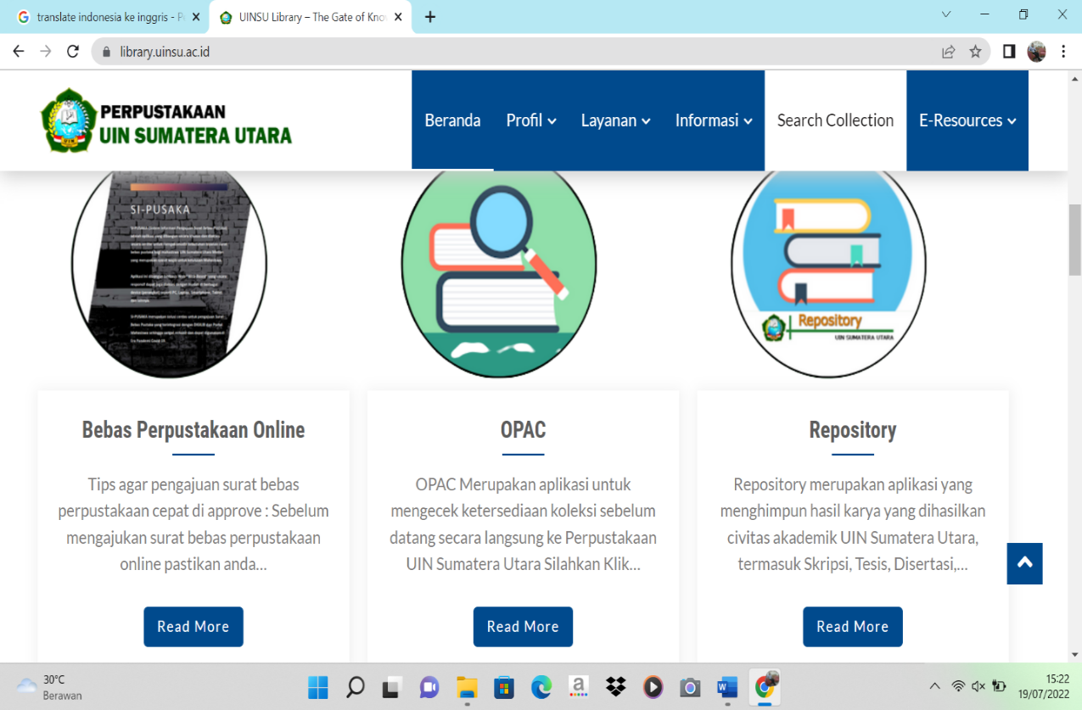

Picture, 1: north sumatra university library websit
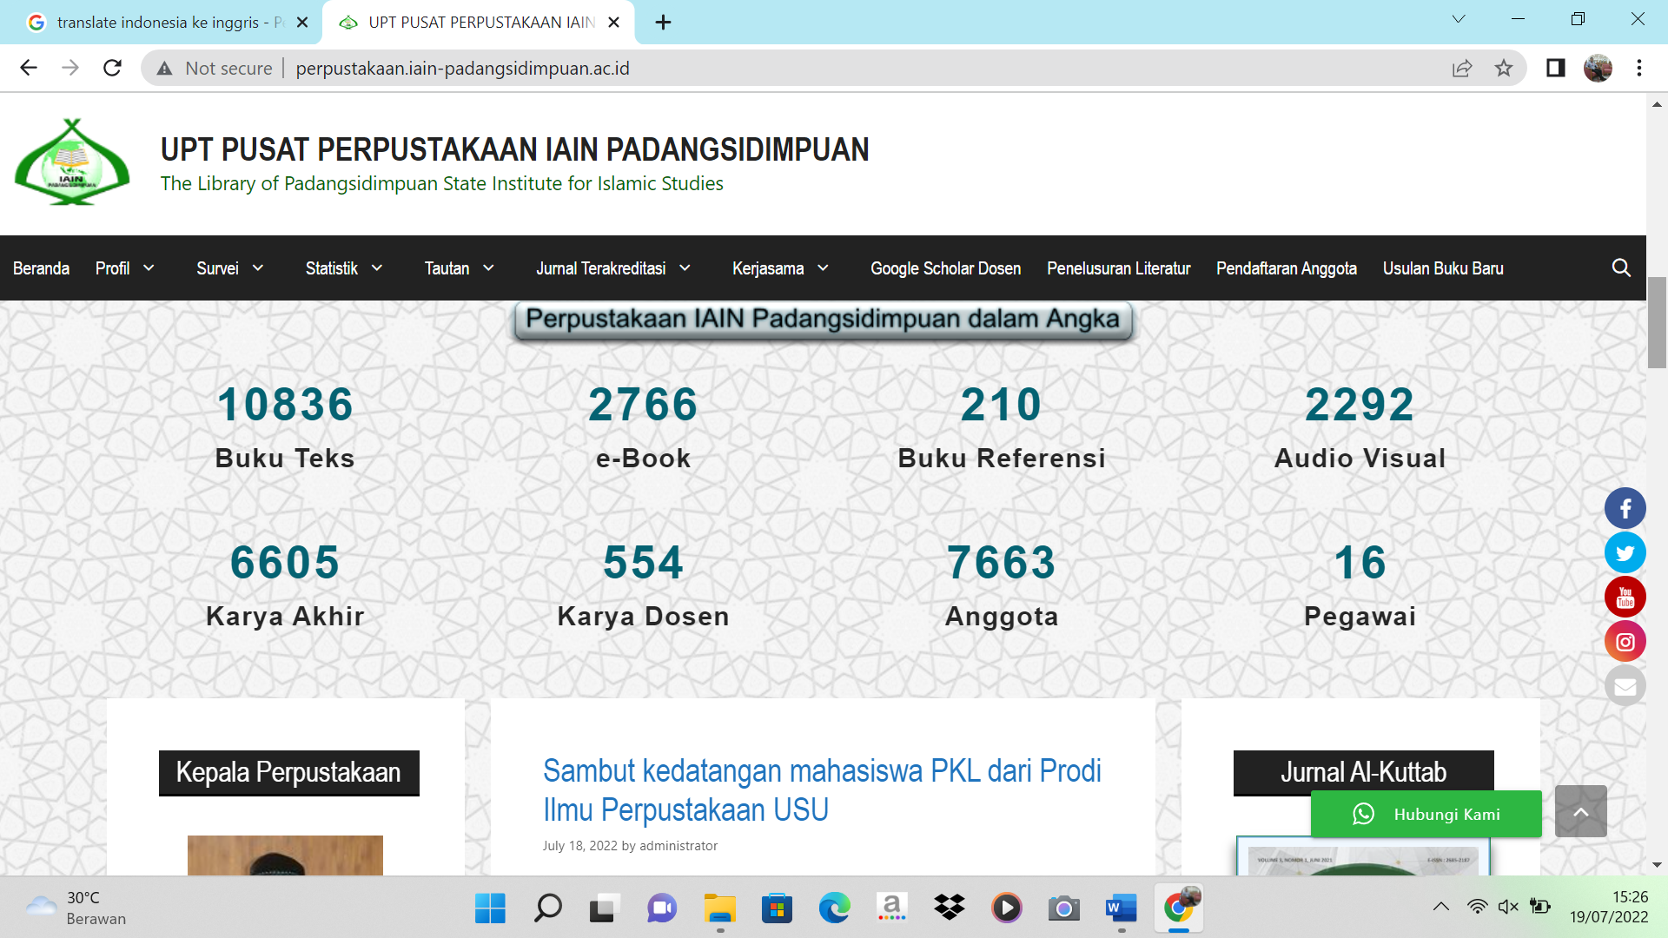

Picture, 2: IAIN Padangsidimpuan library website

In the digital library system at PTKIN North Sumatra, all information related to scientific works will be managed by the administrator. The acting administrator of the college library consists of several librarians on duty. In this case, scientific work information will be retrieved from the internal repository so that users are limited to only accessing information on scientific work by the academic community based on categories or keywords. In this study, it was conducted on the internal repository boundaries. shows the user performing a query to the internal repository to find journal or article data based on the keywords entered in the HTML form. Information management in the university's digital library system includes searching for keywords by year, the subject being sought is the title of the scientific work, the subject division is based on the faculty consisting of several study programs and the keyword is the name of the author of the scientific work. This shows that non-administrator users can access the menu displayed in the PTKIN digital library in North Sumatra. The difference is obtained if the user logs in as a member of the Digital Library, the scientific work displayed will more fully display the required data. A user can search scientific papers as well as scientific work metadata based on the category of scientific work or keywords. Meanwhile, an administrator after logging in will enter the admin area. An administrator can manage scientific categories, as well as add scientific papers. The addition of new scientific works in the university's Digital Library system is carried out with article metadata information taken from the internal repository following the OAI 2.0 metadata standard.
OAI (Open Archives Initiative) is an Open Archives program that develops and promotes interoperability standards aimed at facilitating the efficient dissemination of content. OAI is rooted in the open access and institutional repository movement. The continued support of this work remains a cornerstone of the Open Archives program. Over time, however, OAI's work has expanded to promote broad access to digital resources for eScholarship, eLearning, and eScience. OAI as a system whose goal is to provide an open metadata exchange protocol. Open means that the protocol can be freely obtained by any organization that needs it. OAI provides a protocol for harvesting collections from multiple repositories. PTKIN North Sumatra digital library through the support of OAI 2.0. Eprint is an open source software developed by the School of Electronics and Computer Science, University of Shoutampton, England United Kingdom. Eprint is a digital library application that simple and can be easily managed. In addition, it is integrated with metadata and is able to perform advanced search and other features. This application can be modified and adapted to local needs. The PTKIN library in the North Sumatra region, namely UIN North Sumatra and IAIN Padangsidimpuan, already has adequate access facilities, namely the availability of a repository to facilitate information retrieval for both students and lecturers at the university. As it is known that the repository is an important thing for a university that helps in managing institutional assets as part of their information strategy. Repositories help institutions develop a coordinated and logical approach to collecting, identifying, storing, disseminating and retrieving their intellectual assets. The main purpose of a university library having a repository according to Jain and Anurag 2008, 4 is:
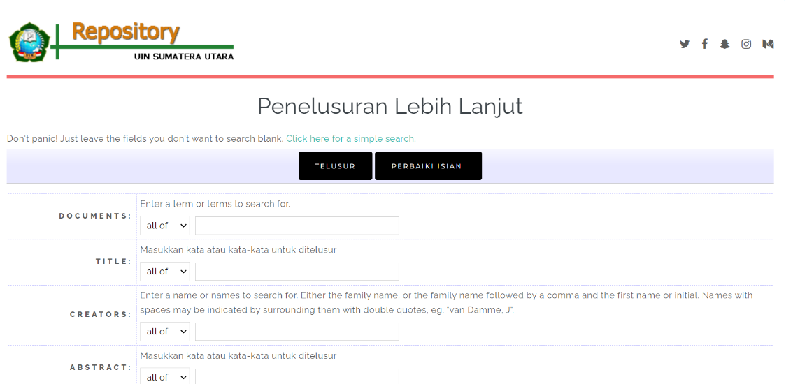
1. To create global visibility for an institution’s scholarly research. 2. To collect content in a single location. 3. To provide open access to institutional research output by self-archiving it. 4. To store and preserve other institutional digital assets, including unplublished or otherwise easily lost “grey” literature e.g. theses or technical reports. The above statement can be interpreted that the main objectives of the repository are as follows: 1. Creating global visibility for scientific research of an educational institution or institution. 2. Collecting content or content in one location. 3. Provide open access to institutional research results. 4. Storing and preserving other institutional digital assets, including unpublished literature or easily lost gray literature” such as theses or technical reports. The following is the display of the repository page at PTKIN in the North Sumatra region

Picture, 3: repository uin north sumatra
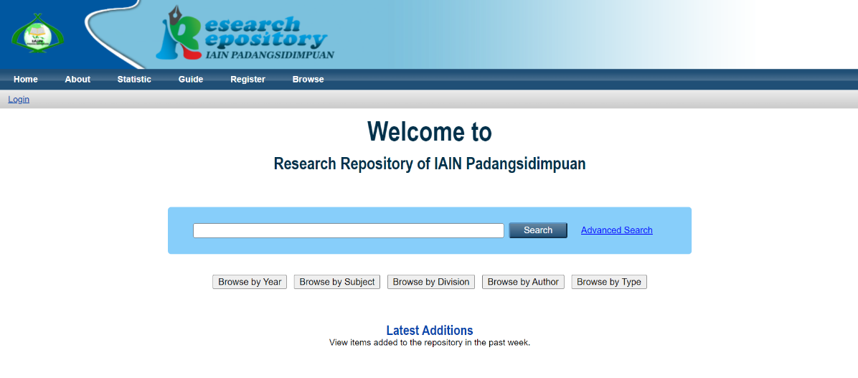

Picture, 5: repository IAIN Padangsidimpuan
Repository is an online archive to collect, preserve, and distribute digital copies of digital-intellectual scientific works of an institution. Repository is a place to store data collected from various sources of information, organize data with information schemes, as a reference source for the learning process and as a place to store knowledge generated in the learning process. The following is the informant's statement about the background in the construction of the North Sumatra UIN repository:
“Tentu yang menjadi latar belakang dieksposnya repository UIN Sumatera Utara Medan ini agar dapat mengikuti perkembangan zaman, termasuk perpustakaan yang sudah mengarah kepada digitalisasi.” (Interview, May 25, 2022).

Preparation in processing the repository is very necessary so that later it can provide maximum benefits for users. According to Sutedjo (2014) preparations for processing repositories include conducting comparative studies, providing competent human resources both in IT and librarianship, and providing the need for available hardware and software to build, manage and develop institutional repositories.The following is a statement expressed by the IAIN Padangsidimpuan Librarian Informant:
“Persiapan yang perlu dimatangkan dalam pengelolaan repository IAIN padangsidimpuan tentu sangat banyak, yang palung mendesak sebenarnya komputer dan jaringan digital yang kuat dan pengolahan data yang baik di perpustakaan digital” (Interview, May 23, 2022).

The same statement was also made by another informant, namely the things that need to be prepared in managing the repository in a university library are collecting the work of the academic community, systems or programs for data processing, computers and networks.

Conclusion
Human resource management that supports the management of a management information system is based on management skills. The main factor of a failure of various systems is because the design of the work management system is not contextual to the specific needs and does not accommodate the current system that has been implemented. One of the main keys to the success of implementing a performance management system lies in the sense of ownership of the system being built, changes in work culture, and the design of an integrated performance management system. The digital library at PTKIN in the North Sumatra region, namely UIN North Sumatra Medan, IAIN Padangsidimpuan and STAIN Mandailing Natal is one of the efforts so that everything related to literature can be accessed easily and quickly by anyone with an interest. The digital library system at the university serves all information related to scientific work and will be managed by the administrator.
In this case, scientific work information will be retrieved from the internal repository so that users are limited to only accessing information on scientific work by the academic community based on categories or keywords. The management of this digital library must also stimulate the organization to continuously develop and create new knowledge related to the act of managing an organization that can anticipate rapid, complex and irregular changes in the times. The operation of the digital library itself must be supported by knowledge management. In the repository section, the contents of the distributed documents are in full text form, although in other parts it is still in abstract form, this needs to be improved in document management so that it is more transparent, and still needs to improve network quality so that services are more optimal.

REFERENCES
Alfabeta Taufiqurokhman, (2011). Kebijakan Publik, Jakarta: Fakultas Ilmu Sosial dan Ilmu Politik Universitas Moestopo Beragama (PERS)
Hasugian, Joner. 2009. Dasar-dasar Ilmu Perpustakaan dan Informasi. Medan: USU Press.
Hermawan, Rachman dan Zulfikar Zen. 2006. Etika Kepustakawanan. Jakarta: Sagung Seto.
Ida, Farida, et al. 2005. Informasion Literacy Skill: Dasar Pembelajaran Seumur Hidup. Jakarta: UIN Press
Saleh A.R. (1994). Pelayanan Sirkulasi Dan Referensi, Bogor: Fakultas Pertanian Institut Pertanian,
Sri Sularsih, (2011). Standar Nasional Perpustakaan (SNP), Jakarta: Perpustakaan RI,
Sugiyono, (2009). Metode Penelitian Kuantitatif Kualitatif dan R & D, Bandung: Prenada
Tjitropranoto, Prabowo (1995). Penelitian dan Sumber Daya Manusia di Bidang Perpustakaan. Jurnal Perpustakaan Pertanian, IV (1), 1995: hal 1-9. Bogor: Pusat Perpustakaan Pertanian danKomunikasi Penelitian.
Yamin, M. (2009). Metodologi Penelitian Pendidikan dan Sosial Kualitatif dan Kuantitatif, Jakarta:Komplek Kejaksaan Agung, Cipaayung
Yuliatry Bunga, Standar Pelayanan Perpustakaan dan Informasi Bidang Layanan Koleksi Umum, Jakarta: Perpustakaan Nasional RI, 2015
Yusuf, Pawit M, ( 2000). Layanan Perpustakaan dan Informasi. Bandung: JIP FIKOM Universitas Padjadjan
Yusuf, Pawit, (2013). Ilmu Informasi, Komunikasidan Kepustakaan. Jakarta: Bumi Aksara,
Depdikbud. 1979. Pedoman Umum Perpustakaan Perguruan Tinggi. Edisi I. Jakarta: Departeman Pendidikan dan Kebudayaan RI Direktorat Jenderal Pendidikan Nasional.
Depdikbud, 2004. Pedoman Umum Perpustakaan Perguruan Tinggi. Edisi 3. Jakarta: Departeman Pendidikan dan Kebudayaan RI Direktorat Jenderal Pendidikan Nasional.
Tjitropranoto, Prabowo (1995). Penelitian dan Sumber Daya Manusia di Bidang Perpustakaan. Jurnal Perpustakaan Pertanian, IV (1), 1995: hal 1-9. Bogor: Pusat Perpustakaan Pertanian danKomunikasi Penelitian.
Andayani, U. (2016). Pustakawan akademik sebagai mitra riset di perguruan tinggi. Jurnal Al-Maktabah, 15(1), 29–40.
http://journal.uinjkt.ac.id/index.php/al-maktabah/article/view/4712/3243
Bara, A. K. (2012). Membangun kreativitas pustakawan di perpustakaan. Jurnal
Iqra’, 6(2), 40–51.
Bent, M., & Stubbings, R. (2011). The SCONUL seven pillars of information literacy a research lens for higher education. USA: SCONUL Working Group on Information Literacy.
https://www.sconul.ac.uk/sites/def ault/files/documents/coremodel.pdf
Cangara, Z. (2015). Reposisi pustakawan dalam era teknologi informasi. Jurnal
JUPITER, 15(1), 9–12.
http://journal.unhas.ac.id/index.php /jupiter/article/viewFile/23/21
Eko Kurniawan, (2020). Inovasi Perpustakaan UMY dalam Meniiingkatkan layananna di Masa Pandemi. Jurnal LIBRARIA: Kepustakaan Vol. 8 No I, 89-100.
https://journal.iainkudus.ac.id/index.php/Libraria/article/view/8522
Farhanah, N., Zulaikha, S. R. (2016). Hubungan antara kecerdasan emosi dengan kinerja pustakawan di perpustakaan. Jurnal Kajian Informasi & Perpustakaan, 4(2), 179–190.
http://jurnal.unpad.ac.id/jkip/article/view/9971/4798
Ilham Nur Muhammad, Dkk (2019), Tindakan vandalisme di Perpustakaan Fakultas Ilmu Komunikasi Universitas Padjadjaran, Jurnal Kajian Informasi & Perpustakaan Vol. 7, No. 1, 81-94
https://jurnal.unpad.ac.id/jkip/article/view/17757

Indah Prastika, Dkk. (2021) Peran Manajemen Perubahan Terhadap Kemajuan Organisasi, Jurnal: iMProvement: Jurnal Ilmiah untuk kemajuan Manajemen Pendidikan Vol 8 No 1, Hal. 18-28:

http://journal.unj.ac.id/unj/index.php/improvement/issue/view/1360
Nirmala Kusumawati,(2022). Analisis Perpustakaan Keliling Dalam Mengembangkan Budaya Literasi Masyarakat Kota Palembang Studi Pada Dinas Perpustakaan Provinsi Sumsel dan Perpustakaan Kota Palembang. Jurnal IQRA’: Jurnal Perpustakaan dan Informasi Volume 16 Nomor 1, 57-68
http://jurnal.uinsu.ac.id/index.php/iqra/article/view/11277/5297
Sunyianto, (2019). Pengaruh klim Komunikasi Organisasi Dan Loyalitas Kerja Terhadap Kinerja Karyawan Pada Sekolah Tinggi Ilmu Pertanian-Agrobisnis Perkebunan (STIP-AP) Medan. Jurnal Pengembangan Ilmu Komunikasi dan Sosial 3(1), 1–11
http://jurnal.uinsu.ac.id/index.php/K OMUNIKOLOGI/article/view/5312
Rodin, R. (2014). Teknologi informasi dan fungsi kepustakawanan. Jurnal Al- Maktabah, 13(1), 1–7.
http://journal.uinjkt.ac.id/index.php/al-maktabah/article/view/1569/1319

Rhoni Rhodin, (2018). Kinerja pustakawan perpustakaan perguruan tinggi islam di Provinsi Bengkulu, Jurnal Kajian Informasi & Perpustakaan Vol. 6, No. 2, 151-168
https://jurnal.unpad.ac.id/jkip/article/view/18429/9175
Rapchak, M., & Cipri, A. (2015). Standing alone no more: Linking research to a writing course in a learning community. Portal: Libraries and the Academy, 15(4), 661–675. https://muse.jhu.edu/article/595060
Shao, X., &, & Purpur, G. (2016). Effects of information literacy skills on student writing and course performance. The Journal of Academic Librarianship, 42(6), 670–678. https://doi.org/10.1016/j.acalib.2016. 08.006
White-Farnham, J., &, & Gardner, C. C. (2014). Crowdsourcing the curriculum: Information literacy instruction in first-year writing. Reference Services Review, 42(2), 277– 292. https://doi.org/10.1108/RSR-09- 2013-0046
White-Farnham, J., &, & Gardner, C. C. (2014). Crowdsourcing the curriculum: Information literacy instruction in first-year writing. Reference Services Review, 42(2), 277– 292. https://doi.org/10.1108/RSR-09- 2013-0046
Yusup, P. M., &, & Saepudin, E. (2017). Praktik literasi informasi dalam proses pembelajaran sepanjang hayat. Jurnal Kajian Informasi & Perpustakaan, 5(1), 91. http://jurnal.unpad.ac.id/jkip/article /view/11387/6030

