THE ROLE OF PPKN TEACHERS IN DEVELOPING
CIVIC DISPOSITION STUDENTS OF CLASS VII THROUGH P5 IN THE VOICE OF DEMOCRACY ACTIVITY OF OSIS AT SMPN 1 MATARAM

The following are the main points of the discussion:
Faculty of Teacher Training and Education, University of Mataram.
*E-mail:¹raudatulfitri224@gmail.com, 2zubairfkip@gmail.com, 3ahmadhudori04@gmail.com, 4almusukyedy@gmail.com

Abstract:This study aims to describe the role of PPKn teachers in developing civic disposition of grade VII students through the Pancasila student profile strengthening project (P5) in the OSIS democratic voice activity at SMP Negeri 1 Mataram. This study uses a qualitative approach with a case study research type with data collection techniques through documentation, observation, interviews. The data analysis technique used is the data analysis technique according to Milles and Huberman which consists of three stages, namely data reduction, data display, and drawing conclusions. The results of this study are that PPKn teachers have an important role in shaping student character in accordance with Pancasila values. The role of PPKn teachers is as a facilitator, project supervisor, evaluator. The supporting and inhibiting factors experienced by PPKn teachers are supporting factors, namely facilities and infrastructure and P5 guidebooks, while inhibiting factors are time and funding. The implementation of the Pancasila student profile strengthening project (P5) through the OSIS democratic voice activity was carried out well and ran according to the guidelines used, namely the module in accordance with the project guidebook. | Article History  Accepted:2  Revised:  Published:.. Year 2017  Keywords :  PPKn teacher, Civic disposition, P5 OSIS democratic voice

Introduction

According to Tristiana et al. (2012), education is a learning process designed to develop knowledge, skills, values, attitudes, and individuals. Education is a responsibility between the government and society. Without the support and active participation of the community, education will never be successful or implemented optimally as expected by the national goals of education (Hudori, 2021: 3). In general, education aims to train and develop the abilities possessed by individuals so that they are useful both for themselves and others. In addition, education also aims to form a positive personality trait in the individual. This means that education does not just provide one direction of goals but many goals to be achieved through education, both in terms of knowledge, attitudes, and skills.
According to Ahmad (2021: 144), education is an effort to educate the nation because through education it is hoped that civilization and values ​​will emerge that support values ​​and morals so that they can reflect human nature. Therefore, education in Indonesia has developed over time, one form of which is by the government issuing a new curriculum to evaluate the previous curriculum, namely the 2013 curriculum to become the Independent Curriculum. With the independent curriculum which is a new approach in the Indonesian education system that gives teachers the freedom to develop students' character and potential optimally. Unlike the previous curriculum, the independent curriculum emphasizes flexibility and freedom in teaching methods, which allows teachers to adjust the material to the needs and conditions of students.
The Pancasila student profile has been regulated by the government as stipulated in the regulation of the Minister of Education and Culture No. 20 of 2020 concerning the 2020-2024 education and culture strategy. The Pancasila student profile is the government's effort for education in Indonesia in strengthening the values ​​of Pancasila through the formation of student character and strengthening student academic competence. The six indicators of the Pancasila student profile that are used as benchmarks for success in implementing the Pancasila student profile applied in schools, namely having faith, being devoted to God Almighty and having noble morals. independent, globally diverse, thinking critically, working together, and being creative. With the Pancasila student profile, students can develop character values ​​and form good behavior at school (Khoeratunisa et al., 2023).
The independent curriculum produces a Pancasila student profile with civic disposition having a synergistic relationship in forming students with Pancasila character and good citizenship attitudes. Through the flexibility of the independent curriculum and P5's focus on Pancasila values, students are encouraged to develop academic competencies, skills, civic dispositions leading to attitudes and behaviors as responsible citizens. All of this works together to create a competent and characterful young generation.
The Merdeka Curriculum provides significant flexibility for teachers to develop students' character in PPKn learning through a flexible, contextual, and project-based approach. Thus, students not only learn the theory of Pancasila and citizenship, but also internalize these values ​​and apply them in their daily lives, shaping them into citizens with character and responsibility.
According to Nurgiansah & Rachman (2022: 443), to shape students' character, schools need an educational platform in the form of content material in subjects to develop values, morals, and attitudes. One of the subjects that has a mission to educate the nation's life and have noble morals is the Pancasila and Citizenship Education (PPKn) subject. Because in civic education there are important competencies in the PPKn subject, namely civic knowledge, civic skills, and civic disposition. Of the three competencies, civic disposition is considered important in the process of developing students' civic attitudes because it includes both private and public characters.
According to Diana Owen (Pasandaran: 2018), civic disposition is a sense of caring for the rights and welfare of others, being fair to everyone without exception, being sensitive to the surrounding environment, respecting and appreciating each other, and having a sense of social responsibility. The importance of this civic disposition is applied to students to show good character so that they do not deviate from moral values ​​and norms that are not in accordance with existing rules. Then there are PPKn teachers whose role is important in developing character in students. Not only presenting Civic Education subject matter as educators, but also providing good examples for their students. Often, these PPKn teachers are used as a reference in society in assessing the good or bad behavior of their students.
PPKn teachers directly have a very important role in developing the character and personality of their students, therefore teachers of this subject are required to have adequate competence in their efforts to develop the character and personality of their students (Fauziah 2021: 1).
According to Oktaviani et al (2017), the ability of PPKn teachers is different from other teachers because PPKn teachers state that teacher competence is seen from 3 aspects. The first aspect is acting as indicated by the provisions in the four norms, namely religion, morality, politeness, and law. All of this is expected by PPKn teachers to be one in words, deeds, and in harmony. What is taught to students must become a mentality and lifestyle that is always applied consistently and appropriately.
The second aspect, useful words, but binding role models. As role models, the traits and words taught by educators are meaningful statements and more than that must be repeated and applied in the behavior of the educators themselves. The third aspect, PPKn teachers must also have a truly solid character so that they can direct and guide students well. This requires that educators basically have adequate or good emotions. Their abilities and capacities, both academically and pedagogically, are not enough if they are not accompanied by their emotions that must be able to be managed by PPKn teachers. Therefore, in an effort to form this character, creative and innovative PPKn teacher strategies are needed.
One of the elements that helps students is not only in terms of knowledge and skills but also instilling values. Teachers in the implementation of education are one of them as facilitators for students, so that students can apply democratic values ​​in a democratic country freely but also in a directed manner, which later the teacher will also direct the students so that students can develop their abilities, express, write, and can solve problems optimally.
Students' understanding of democracy is driven by society, teachers, and the community environment. Democracy must be taught in schools to prevent future crises in the domain of democracy. Some democratic education strategies that can be used in the classroom are tolerance, respecting other people's perspectives, self-confidence, and freedom of speech (Nurjanah & Saadah, 2022). The stages in developing students' democratic attitudes by implementing the Pancasila Student Profile Strengthening Project begin with the formation of a facilitator team, followed by determining school readiness, determining the theme, and time of implementation. The Pancasila Student Profile Strengthening Project is planned according to the needs and circumstances in the school.
The implementation of P5 at SMP Negeri 1 Mataram was attended by all grade VII students through the theme of democratic voice. All school residents will carry out democratic elections for the OSIS chairman. A democratic school will involve all school residents in decision-making. This democratic education is directly related to the substance of democracy itself. Systematic efforts made by schools to help students and school residents understand, internalize, and introduce the concepts, principles, and values ​​of democracy according to their role in national and state life are known as democratic education in schools (Rukmini, 2021). The purpose of this study was to describe the implementation of the Pancasila student profile strengthening project (P5) towards strengthening character through OSIS democratic voice activities at one of the junior high schools in Mataram City.
Based on the results of initial observations conducted on Tuesday, August 29, 2023, located at SMP Negeri 1 Mataram, the school has implemented the Merdeka curriculum in class VII. One of the characteristics of the implementation of KM is the Pancasila Student Profile Strengthening program with one of the themes used, namely the voice of democracy, which has been implemented by the school by electing the OSIS chairman in the 2023/2024 academic year. There are several challenges for teachers in developing students' civic disposition in the P5 program with the theme of the voice of democracy, namely the lack of insight into social issues that cause students to be indifferent to democracy today, for example, not participating in elections, not participating in campaigns, not expressing opinions when conducting discussions or forums so that there is a lack of awareness of students' rights and obligations. And the number of students at the school tends to be fat, consisting of 40 students with various student traits and characters, so cooperation is needed by teachers and the school to minimize these problems. Based on the description above, the researcher is interested in conducting a study entitled "The Role of PPKn Teachers in Developing Civic Disposition of Grade VII Students Through the Pancasila Student Profile Strengthening Project (P5) in the OSIS Democracy Voice Activity at SMP Negeri 1 Mataram".
Research methods

This study uses a qualitative approach according to Corbin and Strauss (2015: 5), which is a form of research where researchers in collecting and analyzing data become part of the research process as participants with informants who provide data. The type of research used in this study is a case study research type according to Dwitami (2016), which is a type of research that seeks to find meaning, investigate processes and gain deep understanding and meaning about an individual, society or situation.
The types of data and data sources in this study are qualitative data according to Sugiyono (2016: 156), which are carried out with primary (main) and secondary (supporting) data sources. With data collection techniques of interviews, observations, and documentation. After that, the data analysis technique of Miles and Huberman in Sugiyono's book (2018: 246) explains that the activity of qualitative data analysis is carried out when data collection takes place in a certain period until complete so that the data is saturated. The techniques used are data reduction, data presentation, and drawing conclusions.

Results and Discussion

Based on the results of research on the role of PPKn teachers in developing the civic disposition of grade VII students through the Pancasila student profile strengthening project (P5) in the OSIS democratic voice activity at SMP Negeri 1 Mataram, the following are:

The Role of PPKn Teachers in Developing Civic Disposition of Grade VII Students Through the Pancasila Student Profile Strengthening Project (P5) in the OSIS Democracy Voice Activity at SMP Negeri 1 Mataram

Facilitator

The teacher acts as a facilitator who helps students understand the concepts and values ​​of Pancasila in learning. The teacher guides students to relate the P5 project to real practices in everyday life, and provides students with the opportunity to actively participate in the project activities held.
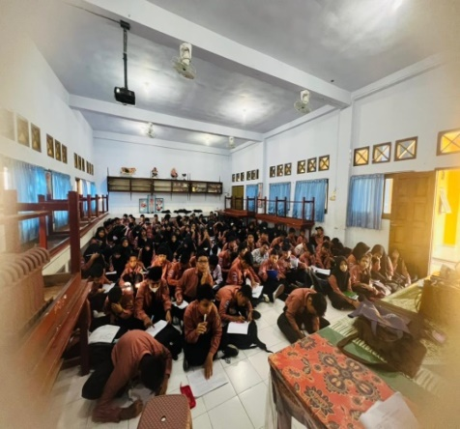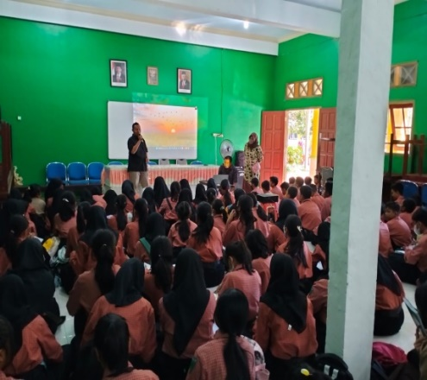
Figure 1. Socialization of Democracy

A facilitator is someone who helps students to learn and have the skills needed to achieve learning goals. (Warsono and Hariyanto 2013: 20), states that as a facilitator, teachers prepare pedagogical, psychological and cognitive development facilities for their students. Pedagogical facilities according to Suyono and Hariyanto (2017: 16), namely the science or art of teaching that refers to the teacher's learning strategy or teaching style, in this case concerning the delivery of material to students.

Psychological facilities of teachers can be interpreted as one of the branches that studies individual behavior in the context of education, namely teachers must be able to make students calm in their behavior at school, especially during the learning process, and teachers must be able to make students comfortable with speech, obedience to teachers in the learning process. Finally, facilities in the development of student cognitive, namely teachers must be able to make learning in the classroom easy for students to understand, students are able to think about the learning given by the teacher to students.

Project Supervisor

The teacher acts as a mentor who accompanies students in planning, implementing, and evaluating the P5 project. In addition, as a mentor, the teacher provides direction and guides students in building initiatives during the project so that students are always active in the project and guides students in managing time and work during the project (Satria et al., 2021).
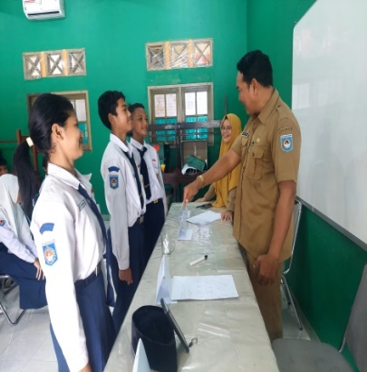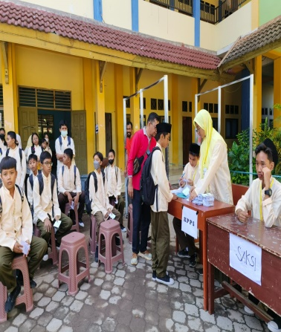
Figure 2.Election Activities

In this case, the teacher provides direction on how students develop creative and innovative project ideas in accordance with the implementation of the OSIS democratic voice project at SMP Negeri 1 Mataram.

Evaluator

The teacher acts as an evaluator who assesses the extent to which students have succeeded in internalizing Pancasila values ​​through the P5 Voice of Democracy project. The teacher provides constructive feedback to students regarding the strengths and weaknesses of the project that has been carried out, as well as providing suggestions for improving the Pancasila Voice of Democracy OSIS student profile strengthening project in the future.
- Supporting and Inhibiting Factors Experienced by PPKn Teachers in Developing Civic Disposition of Grade VII Students Through P5 in the OSIS Democracy Voice Activity at SMP Negeri 1 Mataram

Supporting Factors

Facilities and infrastructure

Based on the description of the results of the research data, facilities and infrastructure are supporting factors for PPKn teachers and other teachers in developing civic disposition through P5, the theme of the voice of democracy of OSIS at SMP Negeri 1 Mataram. The facilities provided by the school are in the form of learning rooms and a fairly large place in the process of implementing the project with the theme of the voice of democracy, namely in the election of the chairman and vice chairman of OSIS.
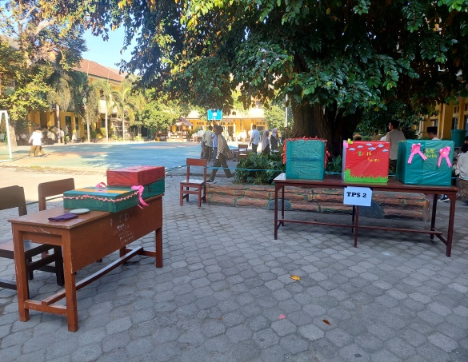
Figure 3.School Field with Ballot Box

According to Mustari (2014: 119), facilities and infrastructure are all facilities needed in the teaching and learning process, both mobile and immobile, so that the achievement of educational goals can run smoothly, effectively, regularly and efficiently. While what is meant by educational infrastructure is a facility that indirectly supports the running of the education or teaching process, therefore, adequate learning facilities are very important for achieving satisfactory student learning outcomes. Where the place is also included in the facilities to support comfort in learning.

The existence of the P5 Guidebook

In the context of implementing P5, the Ministry of Education and Culture, Research and Technology through the educational standards, curriculum and assessment agency has published a P5 independent curriculum guidebook in 2022, which provides inspiration in designing and implementing P5, starting from early childhood education (PAUD)/TK, SD, SMP, to SMA level (Annisa 2024).

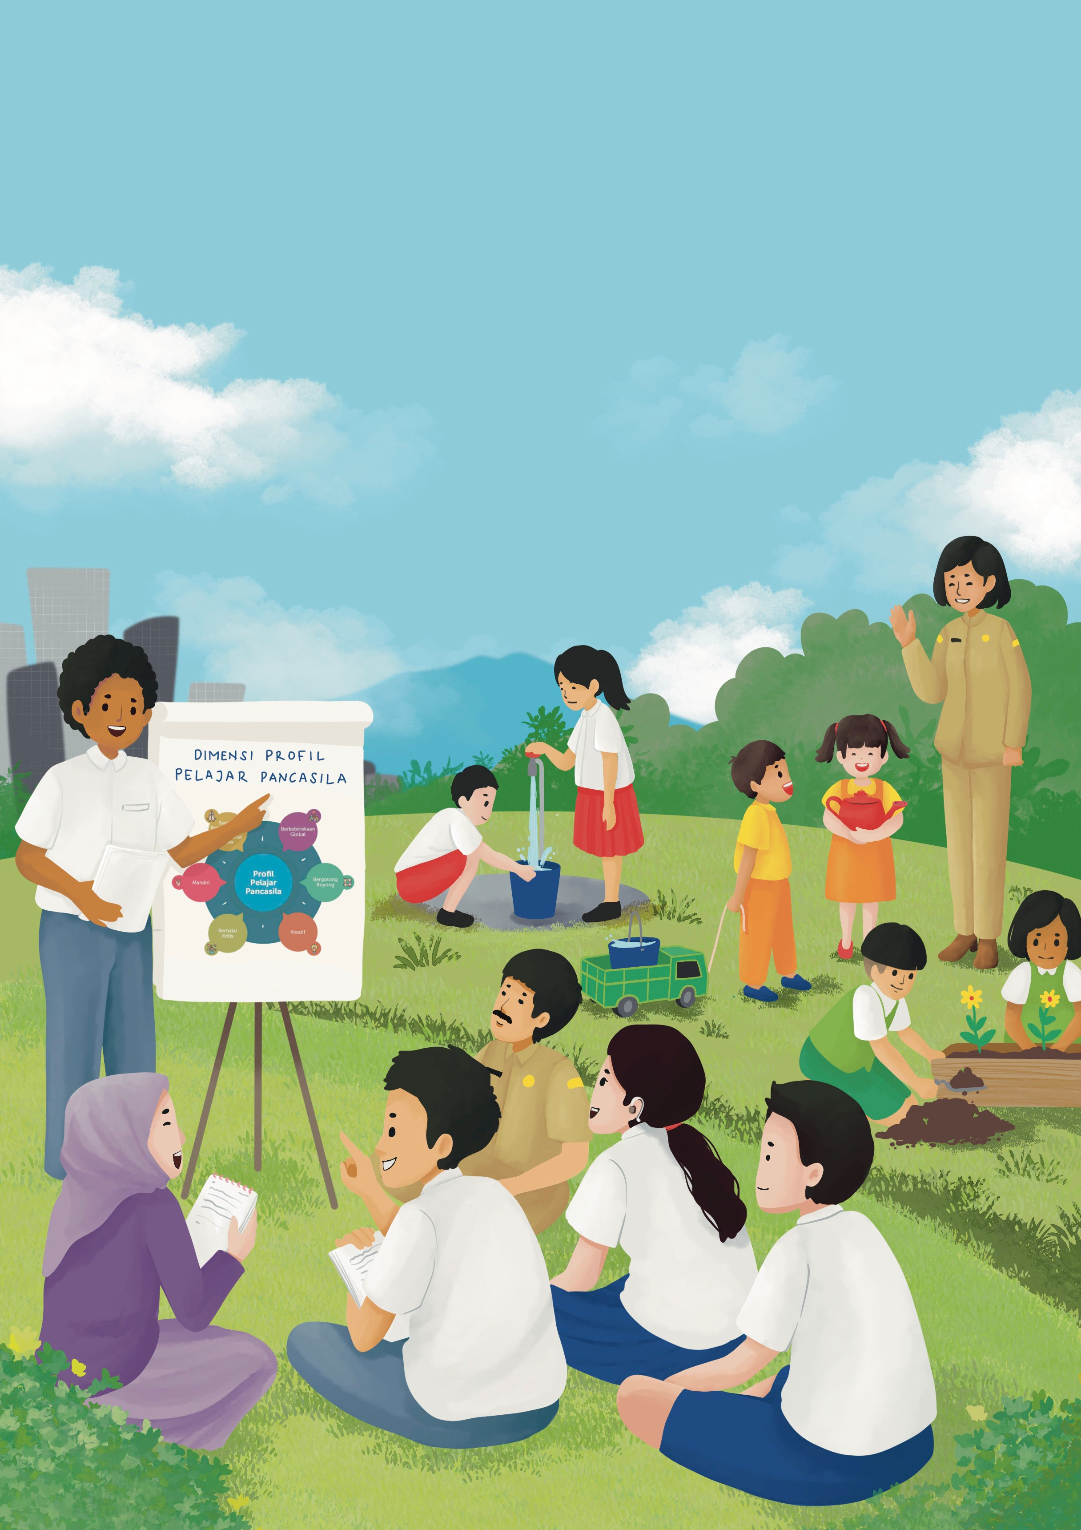

Figure 4. P5 Guidebook

This development guide covers the preparation of the school ecosystem, design, management, assessment process, reporting of results, evaluation, and follow-up actions of P5. So that the existence of the P5 implementation guidebook becomes a reference for SMP Negeri 1 Mataram in implementing P5 activities.

Inhibiting Factors

Time

Based on the description of the research data results, in terms of time, the school still experiences time constraints due to the block system implemented every day by taking 2 hours of lessons at the beginning or at the end of the lesson for a period of 2 weeks. So that the school cannot carry out the project optimally.

Funding

Based on the description of the results of the research data, in terms of financing, the school is still insufficient to support the implementation of P5 activities at SMP Negeri 1 Mataram. Funds or budgets function as supporting data for the implementation of P5 (Pravitasari 2023). The lack of funds will have an impact on the implementation of P5 such as the facilities used. As was the case during the implementation of the election of the chairman and vice chairman of OSIS at SMP Negeri 1 Mataram. Due to limited funds in the OSIS election activities, teachers and the facilitator team utilized used goods such as used cardboard to be used as ballot boxes. And the school also made self-help contributions from students and teachers at the school related to the implementation of project activities.
Conclusion

Based on the results of the research and discussion above, the researcher can conclude the research on the role of PPKn teachers in developing the civic disposition of grade VII students through the Pancasila student profile strengthening project (P5) in the OSIS democratic voice activity at SMP Negeri 1 Mataram as follows:
- The role of PPKn teachers in developing the civic disposition of grade VII students through the Pancasila Student Profile Strengthening Project (P5) in the OSIS democratic voice activity at SMP Negeri 1 Mataram has several roles, namely project supervisor, facilitator, and evaluator.
- The Pancasila student profile strengthening project (P5) activities implemented at SMP Negeri 1 Mataram have supporting factors for teachers, namely: facilities and infrastructure and P5 guidebooks. Meanwhile, the inhibiting factors for the Pancasila student profile strengthening project (P5) activities implemented at SMP Negeri 1 Mataram are: time constraints and limited funds in supporting project activities.
- The form of civic disposition of students that can develop can be seen from the teacher's reflection activities on students in class after the Pancasila student profile strengthening project was carried out. In the form of student behavior, students can be seen from their responsibility, respect for the rights of others, and cooperation in class, teachers can measure the treatment of these students.
Reference
Artati, DP, Hanifah, N., & Gusrayani, D. (2024). Analysis of the Role of Teachers in the Implementation of the Pancasila Student Profile Strengthening Project in the Independent Curriculum (Vol. 5, Issue 2).
Bhetari, Ayuning. (2021). "The Relationship Between Civic Knowledge and Civic Disposition with Social Sensitivity of Civic Education Students at the University of Lampung."
Fauzan, A., Kurniawansyah, E., & Salam, M. (2021). Development of a book on the revitalization and reactualization of Pancasila in national and state life facing the challenges of globalization. Journal of Civic Education: Media for Pancasila and Citizenship Studies (Vol. 4, Issue 2).
Godlif Malatuny, Y. (2017). Journal of Pedagogy and Educational Dynamics ARTICLR INFO ABSYTACT. 5(1).
Hudori, A., & Gunawati, D. (2021). Civic Engagament Kampoeng Baca Pelangi Community In Educating and Reducing Psychological Impacts For Child Victims Of The Lombok Earthquake (Vol. 9, Issue 1).
Juliani, AJ, & Bastian, A. (2021). Character education as an effort to realize Pancasila Students. In Proceedings of the national seminar of the postgraduate program of PGRI University of Palembang.
Juliani, AJ, & Bastian, A. (2021). Character education as an effort to realize Pancasila Students. In Proceedings of the national seminar of the postgraduate program of PGRI University of Palembang.
Khalik, AS (2022). Utilization of Facilities and Infrastructure in Learning at Sd Negeri 1 Nggulanggula, Siompu District, South Buton Regency.
Latipa, L., Sulistyarini., & Atmaja, TS (2022). Formation of Civic Disposition in Students at the State Islamic Senior High School in Singkawang City. Khatulistiwa Journal of Education and Learning (JPPK), 11 (7), 507.
Maryani, K., & Sayekti, T. (2023). Implementation of the Pancasila Student Profile Strengthening Project in Early Childhood Education Institutions. Murhum: Journal of Early Childhood Education.
Muhammad. A. 2019. Revitalization of Civic Disposition Through Civic Education Subjects at State Senior High School 16 Medan Academic Year 2019/2020. Thesis. Faculty of Teacher Training and Education, Muhammadiyah University: North Sumatra Medan.
Nurul, NI, Mustari, M., Kurniawansyah, E., & Alqadri, B. (2024). The Impact of Implementing Pancasila Student Profile Activities in Developing Students' Independent Attitudes at SMAN 2 Mataram. Scientific Journal of Educational Profession, 9(1), 481–490.
Ningsih, EP, Fitriyati, I., & Rokhimawan, MA (2023). Planning of the Pancasila Student Profile Strengthening Project as an Implementation of the Independent Curriculum. Muallimuna: Journal of Elementary Madrasah.
Putri, PN, Alwan Bahrudin, F., & Fitrayadi, S. (2022). The Role of Pancasila and Citizenship Education Teachers in Instilling Civic Disposition for Students at SMA Negeri 3 Tangerang City.

Sarosa, S. (2021). Analysis of qualitative research data.PT Kanisius: Yogyakarta
Safitri, A., Wulandari, D., & Herlambang, Y. (2022). Pancasila Student Profile Strengthening Project: A New Orientation of Education in Improving the Character of Indonesian Students. Basicedu Journal, 6 (4), 7076-7086.
Sulistriani, S., Santoso, J., & Oktaviani, S. (2021). The role of teachers as facilitators in science learning in elementary schools. Journal Of Elementary School Education (JOuESE), 1(2), 57-68.
Wahidah, N., Zubair, M., Fauzan, A., & Alqodri, B. (2023). Implementation of Pancasila Student Profile at SMP Negeri 1 Mataram. Scientific Journal of Educational Profession, 8(1b), 696-703.

