ASSISTANCE IN MANAGEMENT AND TECHNOLOGY-BASED MOSQUE DIGITALIZATION TO IMPROVE THE QUALITY OF COMMUNITY SERVICES

Cihwanul Kirom¹, Iwan Fahri Cahyadi²*, Johan Afandi³, Riyan Adni⁴, Bayu Tri Cahya⁵, Betania Kartika Muflih⁶
^{1,2*,3, 4,5}Master of Sharia Economics IAIN Kudus
⁶Study Program of Management, Faculty of Economics and Business,
International Institute For Halal Research International Islamic University Malaysia IIUM.
*Corresponding Author. Email: johanafandy@iainkudus.ac.id

Abstract: The purpose of community service activities is to improve the quality of mosque management and operations, utilizing digital technology to strengthen the relationship with the congregation. Specific objectives include introducing an effective and transparent financial system, improving event management through training, optimizing the use of digital technology for communication and broader outreach, enhancing the skills of staff and volunteers through training, and collaborating with local organizations to expand resources and support larger initiatives. The methods used in these activities include educational methods, training, and mentoring.
The target of this community service activity is the Program for Management Assistance and Technology-Based Mosque Digitalization in Kudus Regency, which aims to assist mosque administrators, such as imams and takmirs, in optimizing administrative tasks and activities. Congregation members will benefit from easy access to mosque information through a mobile application or website. The general public will also experience improved mosque services and transparency in fund management. Technology and education enthusiasts play a role as facilitators, and religious institutions also participate to strengthen cooperation in providing religious information and activities. This program creates an ecosystem that supports mosque management and digitalization, with the hope that community collaboration will enhance mosque services and management through technology in the long term.
Article History:
Received:
Reviewed:
Accepted:
Published:

Key Words: Technology-Based Mosque;
Congregation Service Management;
Easy Access

How to Cite:
This is an open-access article under the CC-BY-SA License.

Introduction
The role of the mosque plays a crucial part in the lives of Muslim communities, serving as a place for worship, learning, and socialization. Utama (Ucu 2015).In the digital era, effective mosque management and digitalization have become increasingly important as they can enhance the efficiency and effectiveness of mosque administration (Manajemen dan Agung 2020). Ideally, a mosque should serve various functions, including education, religious studies, and community activities. In this context, good management enables mosque administrators to optimize the management of human resources, finances, and facilities (Suprihanto 2018). With effective management, mosques can provide better services and strengthen their role in society (Lestari, 2019). .Digitalization also plays a crucial role in improving communication, financial management, and transparency in mosque administration. (T.M.A.M 2022)
The purpose of this community service is to enhance the quality of mosque management and operations while leveraging digital technology to strengthen the relationship between the mosque and its congregation (Suprihanto 2018). Specific goals include improving financial management, enhancing event management, optimizing technology usage, increasing staff skills, collaborating with local organizations, and mentoring young Muslims around the mosque. The benefits of this service include increased efficiency and effectiveness in mosque management, improved service quality for the congregation, financial transparency and accountability, as well as enhanced skills for staff and volunteers (Manajemen dan Agung 2020).
Mosque management involves resource management to achieve desired goals. (Imanuddin et al. 2021). The management process encompasses fundamental functions, including planning, organizing, directing, and supervising. Its focus is on optimizing resource utilization to effectively achieve organizational goals. (Zamroni dan Fahana 2021)
Mosque digitalization involves the implementation of technology in mosque administration, such as web-based applications and information systems (Https://www.dimasindonesia.com/home n.d.). This can enhance communication, financial management, and transparency. Digitalization also facilitates the development of human resources potential in the mosque.(Zamroni dan Fahana 2021).
Takmir masjid is an organization responsible for overseeing all mosque-related activities, including mentoring young Muslims around the mosque. (Siswanto 2005) They have duties related to organizing religious activities, (Andriana Pertiwi 2013) maintaining mosque cleanliness and upkeep, and fostering good relationships with the congregation and the local community. (Imanuddin et al. 2021).
Society 5.0 is a technological evolution that combines modern technology with the role of humans. The concept aims to ease human life through the utilization of knowledge and technology. https://masjidkudus.com/.
Relevant Previous Research: There is existing research relevant to this community service, focusing on mosque digitalization, mosque management, and mosque mentoring. This research has contributed to developing an understanding of mosque management and digitalization, strengthening mosque services and roles in the community.

Method
The PKM (Community Partnership Program) activities are conducted in the mosques in Kudus, specifically in the Ngembal area, as partners. In this initiative, our partners have expressed their willingness to participate in this partnership program, including providing training spaces, sound systems, applications, and other facilities to support the smooth execution of this partnership. All activities run smoothly and can enhance the mosque management and digitalization capabilities.
The chosen method for implementing PKM involves direct activities to support the participants' abilities, such as discussions, lectures, and practical application usage through the utilization of open-access software via the Masjidkudus.com web application within the partner group. Preparations for these activities commence after the signing of the agreement contract between the Head of Research and Development Institution (LP2M) and continue with the Faculty of Islamic Economics and Business (FEBI) in conjunction with the Head of the Community Service Program Team (PKM). Internal planning has already begun in internal meetings to allocate tasks according to each team member's expertise, including Governance Management, Motivation Training, Character Building, Multimedia Workshops, and the application of Masjidkudus.com.
The community service method is carried out in four main phases. The first phase is the preparation and coordination stage, in which community service coordinators coordinate with mosque partners and conduct surveys and observations to confirm the service location agreement. The second stage, the survey and observation phase, involves identifying targets, surveying needs, program planning, direct observation, and interviews with relevant stakeholders.
The third stage is the dissemination of information, where information about the benefits of digitalization and effective management principles is conveyed to mosque administrators, worshippers, and related communities. The final step, the training, guidance, and mentoring phase, involves providing practical skills in using information technology and modern management, as well as providing active guidance for implementing technology and management using the created web application http://masjidkudus.com/.
Additionally, there is a schedule for community service activities that includes proposal submission, surveys and observations, information dissemination, training, mentoring, guidance, and report preparation. After the community service activities are conducted, follow-up steps involve advanced training and collaboration to achieve mosque development goals in Kudus Regency. The main target is to develop the potential and creativity of mosques in product, management, finance, and digital-based publication aspects, making mosques more open in facing the Society 5.0 era.

Result and Discussion
Authors and Affiliations
The template is designed so that author affiliations are not repeated each time for multiple authors of the same affiliation. Please keep your affiliations as succinct as possible (for example, do not differentiate among departments of the same organization). This template was designed for two affiliations.
Identify the Headings
The results and findings from the implementation of community service activities reflect the effectiveness of the four main phases undertaken. The coordination phase serves as a crucial foundation for formulating the implementation strategy of the community service. Collaboration with various parties, including the Abdimas team, academics, students, application developers, and mosque administrators (takmir), has successfully directed the implementation that aligns with the local community's needs. The Abdimas team plays a significant role in formulating action strategies and facilitating the necessary collaborations, emphasizing the importance of teamwork in understanding community needs. This coordination phase has resulted in an implementation strategy that focuses on meeting the local community's needs, including training mosque administrators in the use of digital technology. Collaboration with academics and students has also brought innovative thinking into the mosque digitalization project. Collaboration with application developers has enabled the creation of an effective and user-friendly technology platform.
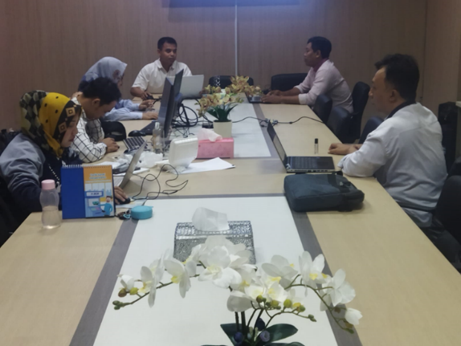
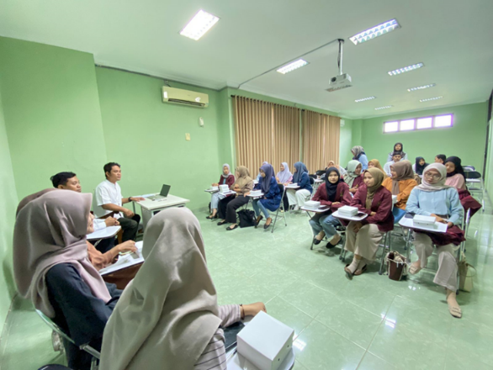
Figure 1 Activity Planning. Figure 2 Activity Planning distribution mail.
In the survey and observation phase, we gained a better understanding of the needs and challenges faced by mosques in the Kudus region. The survey and observation results provided deep insights into the condition of mosques, technology infrastructure, management needs, and community preferences. This data forms the basis for more focused and effective planning, ensuring that the digitalization project can provide maximum benefits
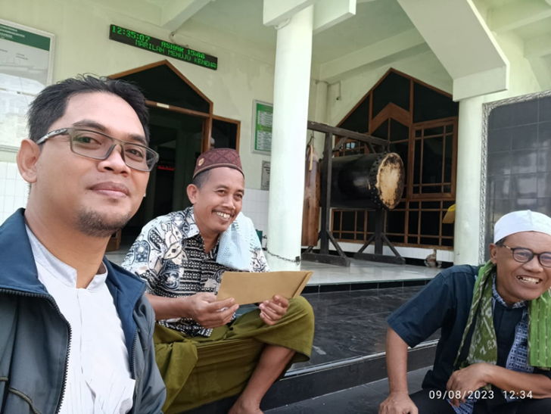
Figure 3 Coordination with Religious and Educational Institution Participants
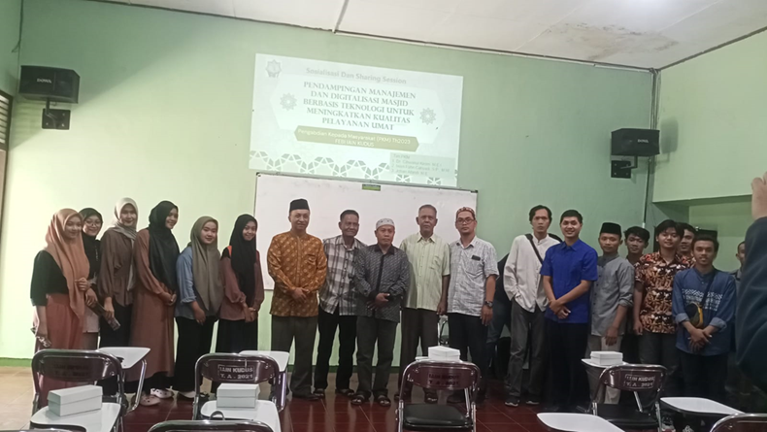
Figure 4 Implementation of Activities with Takmir and Mosque Administrators Participants
Finally, the training, guidance, and mentoring phase has brought significant changes in how mosque administrators and takmir manage the mosque. Training provides practical skills in using information technology and modern management. Guidance assists them in implementing effective technology and management in their daily practices. Mentoring is a long-term oversight that ensures sustainable development and adaptation to technological changes.
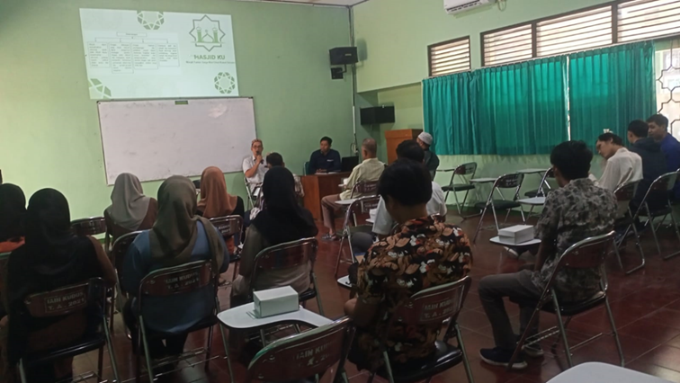
Figure 5. Material Dissemination Phase with Mosque Administrators and Religious Institutions in Kudus, Figure
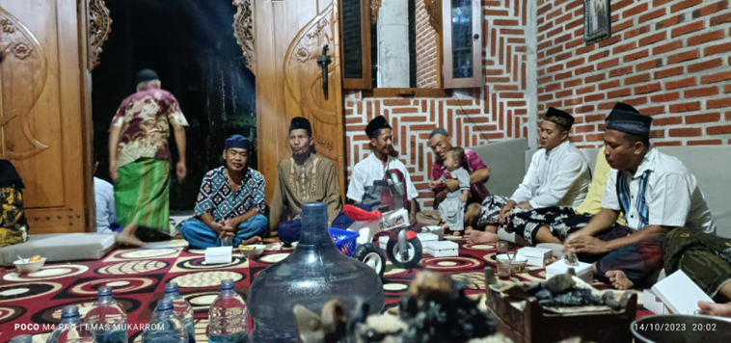
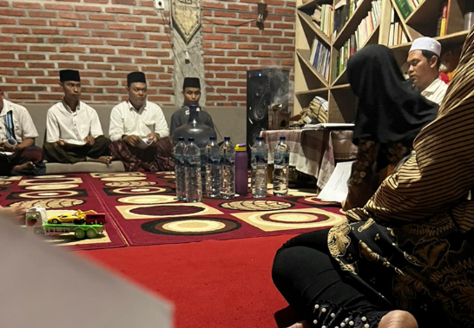
Figure 6. Participants in Mosque Digitalization Training attended by Takmir and Mosque Administrators
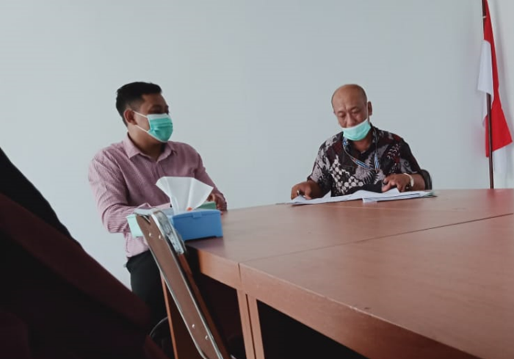
Figure 7. Mosque Digitalization Assistance with Mosque Takmir.
With the adoption of digital technology, mosque administrators and takmir have improved efficiency in mosque administration, enhanced communication with worshippers, provided religious information, and organized religious activities. The result is a more organized mosque, connected to its congregation, and capable of providing better services according to community needs. All these phases play a crucial role in transforming traditional mosques into effective and open service centers in the digital era.

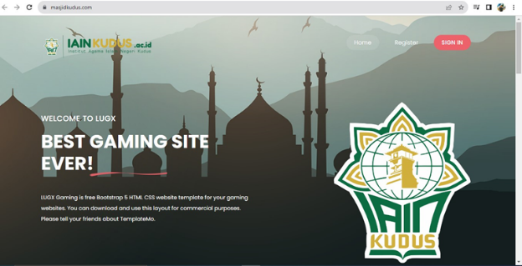
Figure 8. Web Page of the Mosque Digitalization Application
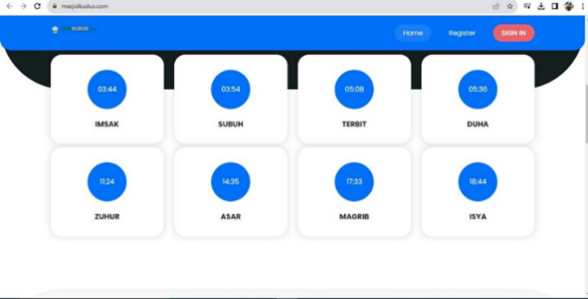
Figure 9. Sholat Time Menu Page
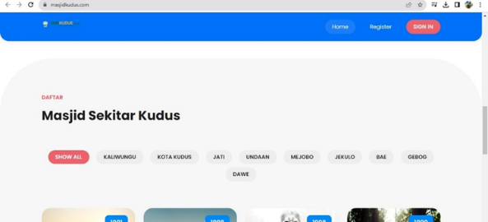
Figure 10. Menu page for various mosques in Kudus.
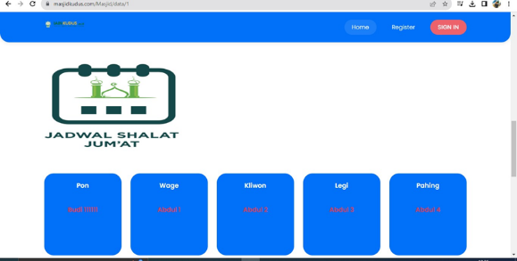
Figure 11. Menu page for Friday Prayer Imam & Takmir Schedule
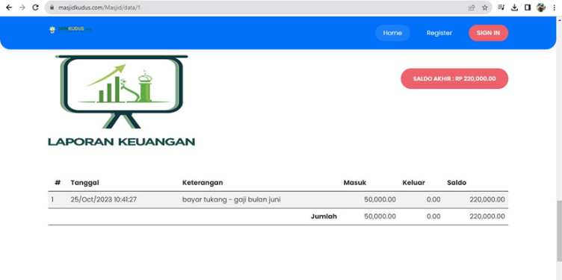
Figure 12. Menu page for Mosque Financial Reports

Conclusion
The Program Kreativitas Mahasiswa (PKM) activities focused on mentoring management and technology-based mosque digitalization in Kudus have had a significantly positive impact on improving the quality of services to the community. Through a planned and sustainable approach, mosque administrators (takmir) and religious institution managers have been introduced to relevant digital solutions. The impact has resulted in tangible changes in mosque management and service to the community. Digitalization has helped mosque takmir manage finances more efficiently, facilitate the monitoring of religious activities, and expand access to religious information for worshippers. Communication between the mosque and the community has also become more effective through the use of digital technology. The quality of service to the community has improved because the mosque is more connected to its worshippers and can provide more relevant and easily accessible information and services.
Furthermore, these PKM activities have raised greater awareness of the importance of digitalization in mosque management and services in this digital era. Mosque takmir and religious institution managers have played an active role in taking concrete steps towards this positive change, which is a crucial initial step. The PKM activities have paved the way for a brighter future where mosques are not only places of worship but also centers of education, communication, and better service. We hope that the results of these PKM activities will continue to grow and evolve, ensuring that mosque management and digitalization remain relevant and beneficial to the community and the people of Kudus.

Recommendation
Expansion of Geographic Coverage: The first recommendation is to expand the scope of PKM activities to other areas in Kudus. Although these activities are currently only conducted in the Ngembal region, the benefits of mosque digitalization and technology-based management improvement can be applied throughout Kudus. By involving takmir and religious institutions from various regions, we can extend the positive impact of mosque digitalization, enhance the quality of service to the community, and create consistent efficiency in mosque management throughout Kudus.
Sustainability through Training and Maintenance: The second recommendation is to maintain the sustainability of these activities through regular training and the upkeep of adopted technology. Mosques that have adopted digitalization need ongoing training for takmir to fully utilize the technology. Additionally, regular maintenance of the hardware and software used in digitalization is essential to ensure that everything runs smoothly. By maintaining the sustainability of these activities, we can ensure that mosque management and digitalization remain effective and beneficial to the community and the people of Ngembal and the entire Kudus region.

References

References
There are no sources in the current document.

