Metadata Scopus Database and Google Scholar Visualization

Scopus database and google scholar visualization is shown in the following figure :
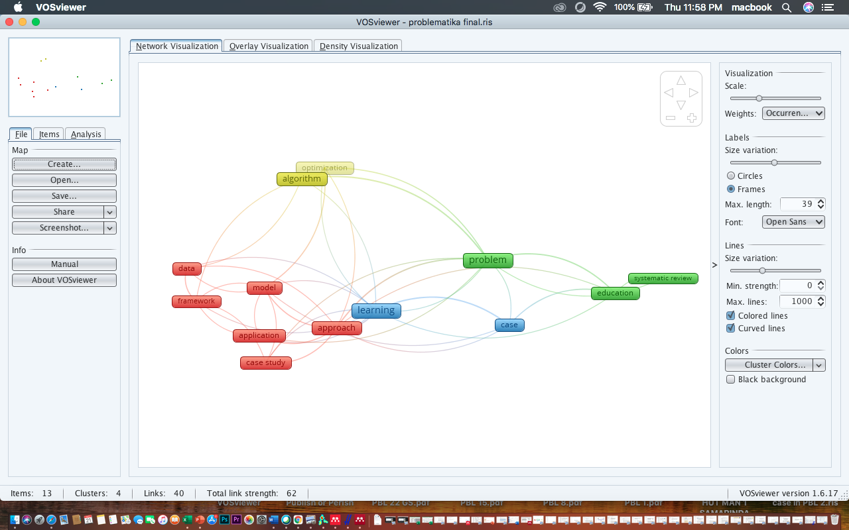
Figure 1. Scopus Database Network Visualization

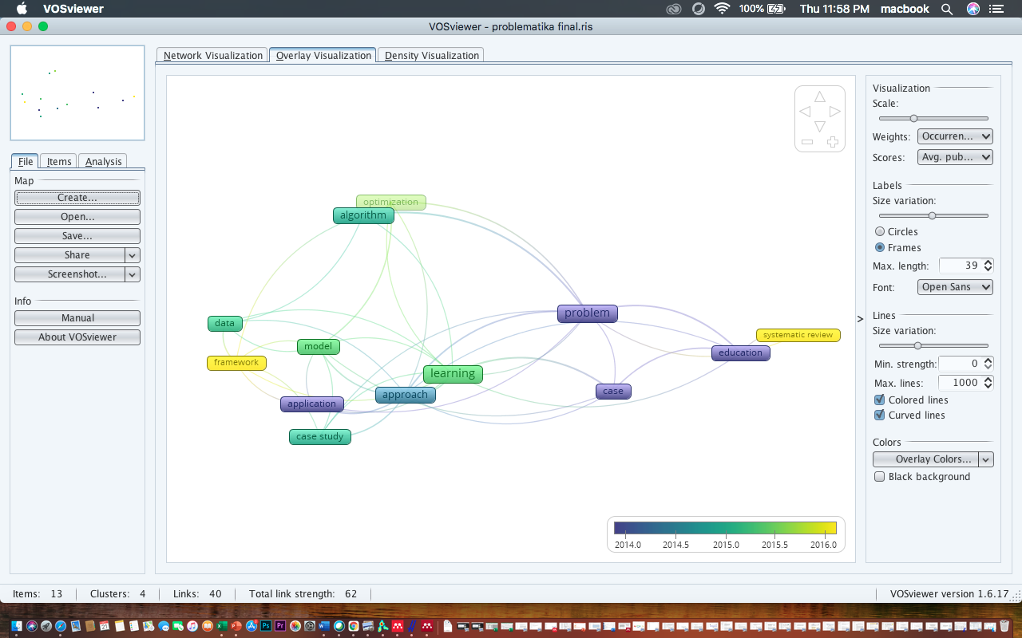
Figure 2. Overlay Visualization of Scopus Database

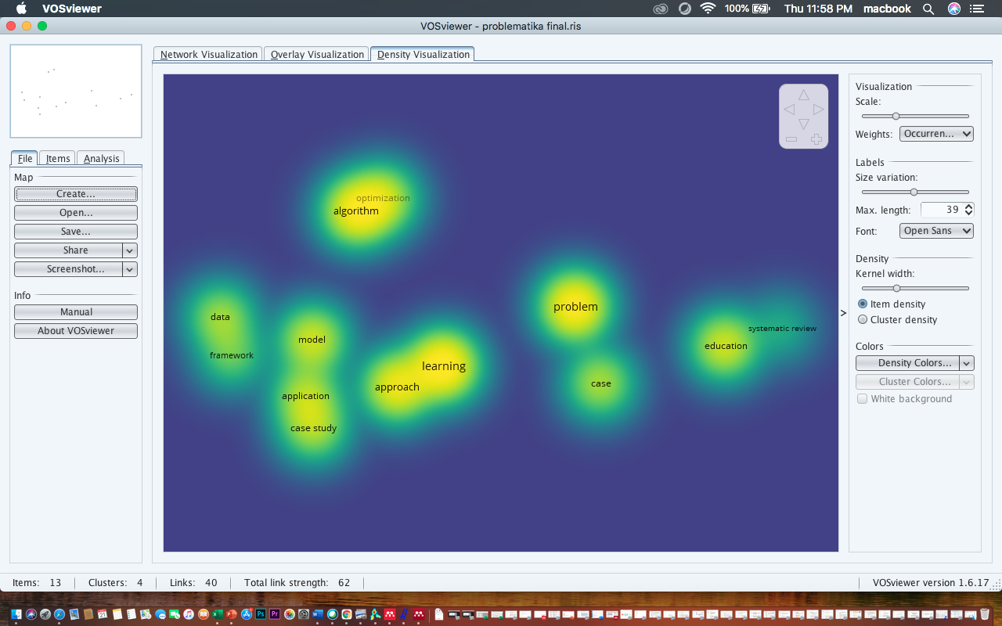
Figure 3. Density Visualization of Scopus Database

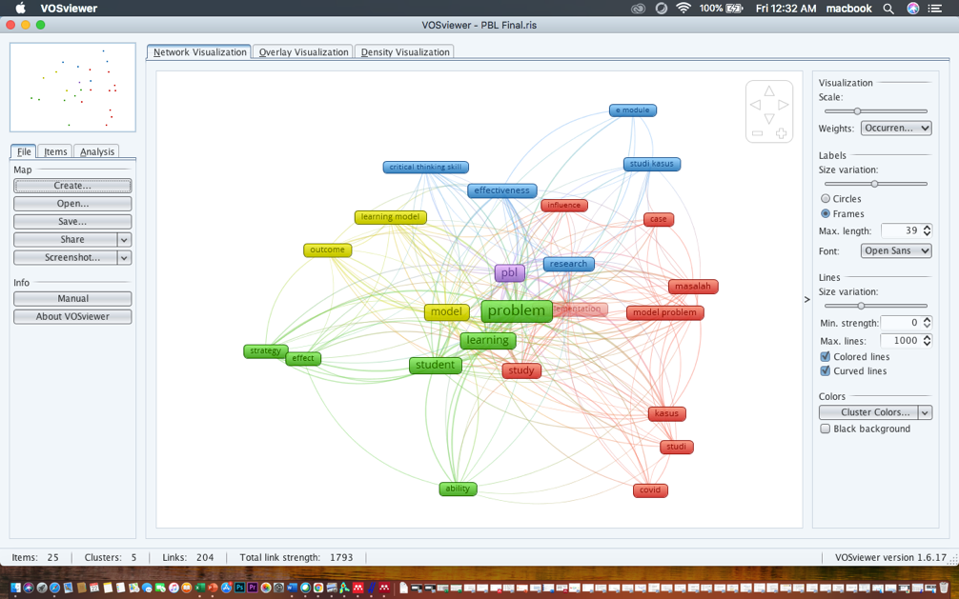
Figure 4. Google Scholar Database Network Visualization

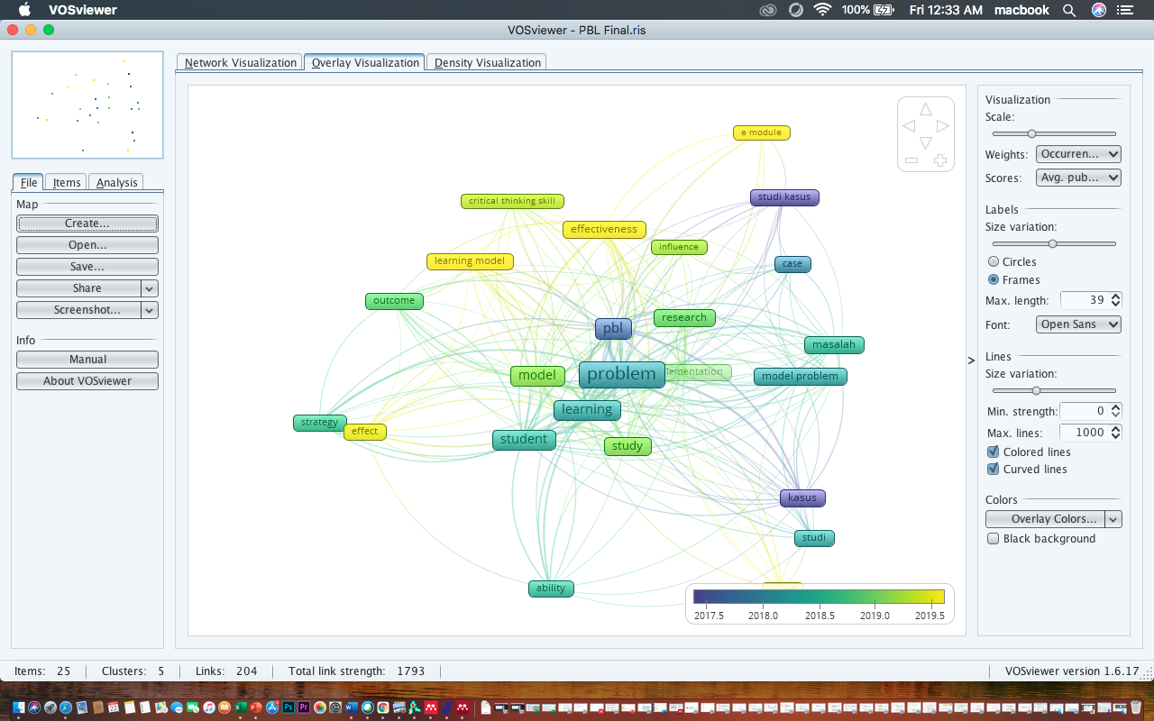
Figure 5. Overlay Visualization of google scholar database

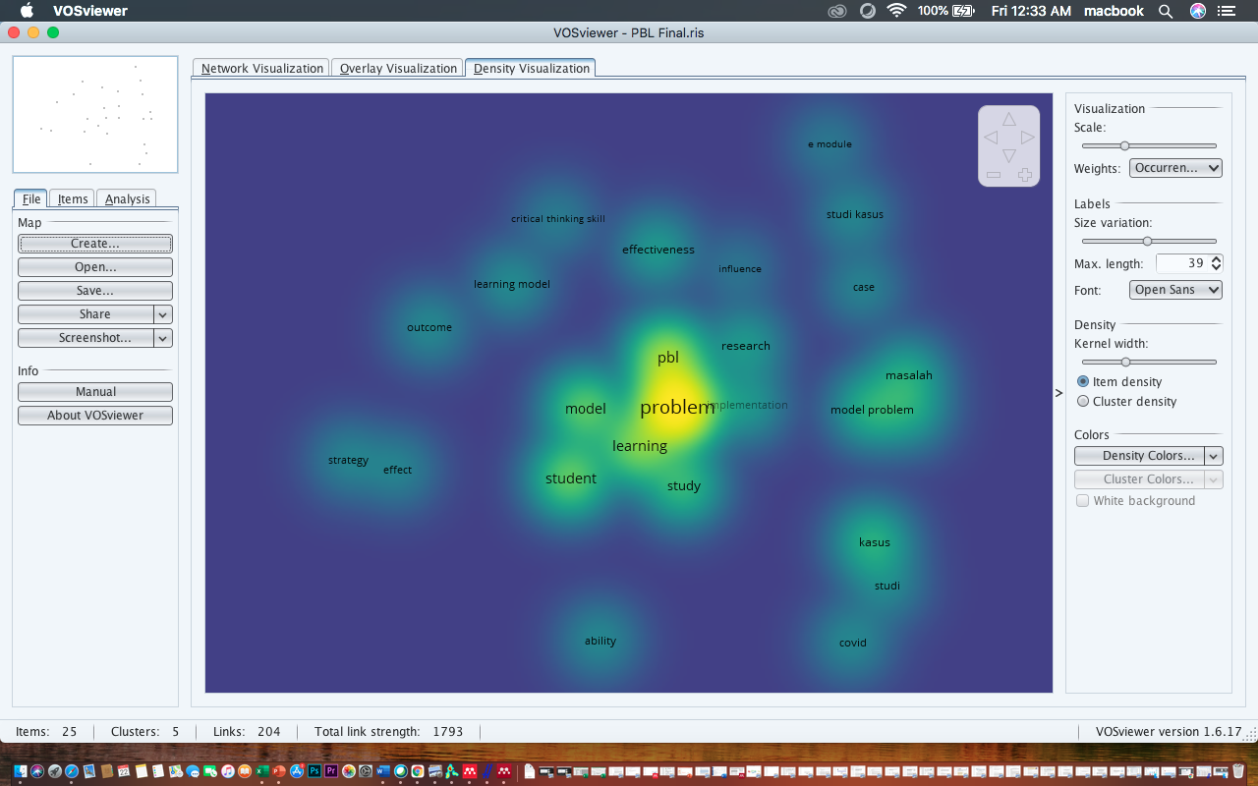
Figure 6. Density Visualization of Google Scholar database

