DEVELOPMENT PROBLEM-BASED LEARNING-ORIENTED E-WORKSHEET TO TRAIN ANALYTICAL SKILLS ON CHEMICAL EQUILIBRIUM MATERIAL
Vivi Damayanti^{1*}, Dian Novita²
¹ | Department of Chemistry Education, Faculty of Mathematics and Natural Sciences State University of Surabaya, Jl. Ketintang, Ketintang, Kec. Gayungan, Indonesia, 60231
* | Corresponding Author e-mail: vividamayanti58@gmail.com

Article History  Received: dd-M-Year  Revised: dd-M-Year  Published: dd-M-Year  Keywords: analysis skills; chemical equilibrium; e-worksheet | Abstract (10 pt)  The goal of this study is to explore the potential for teaching students analytical skills on chemical equilibrium material through the use of an online worksheet focused on problem-based learning. Based on validity, practicality, and effectiveness, an E-LKPD feasibility score can be obtained. The research and development (R&D) methodology used in this study makes use of Tiagharajan's 4D development process, which consists of the steps Define, Design, Develop, and Disseminate. Based on the findings of the research, the e-worksheet earned mode 3 on the validation sheet, indicating that it is legitimate. With an 86.44% percentage, the e-worksheet was judged to be very practical based on the results of the student response questionnaire. The e-worksheet is certified effective in terms of analyzing t test findings with a significance value of 0.00, implying that Ho is rejected and Ha is accepted. The n-gain score for analytical skills was 0.55 on element analysis, 0.59 on relationship analysis, and 0.59 on organizing analysis. Based on these findings, it is possible to infer that the problem-based learning-oriented e-worksheet produced to educate students' analytical abilities on chemical equilibrium content is suitable for usage.
How to Cite: First author., Second author., Third author, etc.. (20xx). The title. Hydrogen: Jurnal Kependidikan Kimia, vol(no). doi:https://doi.org/10.33394/hjkk.v10i2

 https://doi.org/10.33394/hjkk.xxxxx.xxxx |  | This is an open-access article under the CC-BY-SA License.  

INTRODUCTION
According to the curriculum for 21st century learning, students must be able to master the abilities necessary for the twenty-first century in order to enter the workforce and apply what they have learned to everyday situations. 21st-century skills including communication, teamwork, critical thinking, and problem solving are prerequisites for students, sometimes known as the 4Cs. According to Facione, critical thinking skills are split into six categories. Analytical abilities are an important aspect of critical thinking. According to Regulation 5 of 2022, the Minister of Education and Culture, analysis skills are defined as " demonstrating the capacity to evaluate difficult concepts and issues, draw conclusions, and make arguments for their positions using reliable facts". Analytical skills must be taught to kids in school in accordance with high school graduation competence criteria.
Analytical aptitude refers to the capacity to analyze, categorize, sort, seek for patterns, find causative elements, and so forth (Novita, Santosa, & Rinanto, 2016). Analytical skills are extremely effective for teaching pupils how to identify the root causes of all of the difficulties they confront on a daily basis and then devise solutions to them. Analysis ability belongs to higher-level cognitive processes or develops into one of these higher-level thinking talents. Bloom's Taxonomy classifies analytical capabilities into three categories: element/element analysis, relationship analysis, and principle organizing analysis (Kusnawa, 2012).
According to the results of the analysis ability exam of 29 students from SMAN 13 Surabaya class XI IPA 6 performed on March 02, 2023, students' ability in element analysis is 60%, relationship analysis is 39%, and analysis of organizing principles is 42%. The results of the analysis ability exam indicate that students' analytical skills need to be enhanced in each component. According to the data, around 95% of students are unable to finish case study tasks, and just 2-5 individuals are able to work on exam problems that need analytical abilities. As a result, it is possible to conclude that the capacity to analyze pupils remains poor and that learning skills must be improved. Analytical abilities may be developed and employed in a variety of educational courses, including chemistry.
Chemistry is a fundamental part of science that investigates the presence of matter as it relates to substance composition, structure, and properties, as well as transformations, dynamics, and energetics (Subagia, 2014). Thus, chemistry is a highly difficult discipline to study. Chemistry in high school has numerous topics that cannot be articulated without the use of analogies, and studying chemistry demands a high level of thinking ability. To help students grasp chemistry courses, learning can be linked to solving chemical science issues in the form of theories, ideas, laws, and facts. Chemical equilibrium material is one of the chemistry resources that contains topics that need to be understood more thoroughly.
Chemical equilibrium material is one of the materials included in the autonomous curriculum's phase F learning objectives, which reads "students can comprehend and explain the equilibrium of chemical reactions", "understand chemical concepts in living things", and " it is expected of students to be able to describe how chemical ideas are applied in daily life". The findings based on the pre-research answer questionnaire 95% of students believe that chemical equilibrium material takes more expertise and is less relevant to everyday concerns. One of the learning strategies used to solve everyday problems is problem-based learning.
A learning approach called problem-based learning (PBL) concentrates on resolving typical problems that come up in daily life (Shoimin, 2017). Five learning phases are included in the syntax of the Problem Based Learning (PBL) learning paradigm: Phase 1: Orienting students to the problem, Phase 2: Coordinate students to study, Phase 3: Directing the research, Phase 4: Developing and presenting work, and Phase 5: Examining and assessing the problem-solving process (Arends, 2008).
This PBL learning paradigm requires students to solve challenges and exercise critical thinking. Furthermore, it teaches kids tolerance and the need of listening to diverse points of view. Explain to children that all problems or issues must have a solution. Another advantage is that employing this PBL learning paradigm makes it simpler for pupils to memorize when asked to address real-world situations. The PBL learning model is well-suited to overcoming the problem of analyzing secondary school students' abilities because it involves the teacher presenting real-world problems related to the material and learning objectives, allowing students to directly participate in analyzing existing problem-solving (Rahmadani, 2019). When adopting the learning model, learning materials must adhere to its syntax. E-worksheets are one type of learning resource that may be employed.
Learning media is a device that can help the learning process by making messages easier to understand and facilitating the achievement of more effective and efficient learning goals (Nurrita, 2018). E-worksheets are one type of learning material that teachers and students can utilize during the learning process (Syafitri & Tressyalina, 2020). E-worksheets are electronic work guides that help students grasp the subject matter. They may be used on a computer desktop, laptop, smartphone, or mobile (Umriani, 2020). Electronic worksheets have the ability to simplify tasks and reduce time and space requirements, which improves learning outcomes. (Suryaningsih & Nurlita, 2021). Aside from that, e-worksheets are easy to access from anywhere and at any time using a laptop or smartphone (Apriliyani & Mulyatna, 2021). There are several applications and websites available today that may be used to create interactive e-worksheets, the most common of which being liveworksheets. Liveworksheet is a web-based platform with the domain name liveworksheet.com. This application will make it easier for teachers to convert worksheets that can be saved as png, jpg, pdf, or dokumen into interactive online lessons that can include videos and other components that improve students' understanding while learning.
According to the aforementioned description, the researcher plans to carry out a study named "Development of Problem-Based Learning-Oriented E-Worksheet To Train Analytical Skills On Chemical Equilibrium Material" which is expected help develop students' analytical abilities while they study chemistry, especially chemical equilibrium material with a problem based learning approach and is meant to serve as a guide for educators in developing learning media.

METHOD
The study's focus is on research and development. Research and Development (R&D) is a research process used to create a given product and evaluate its efficacy, according to Sugiyono (2019). This study's research approach is based on a 4D development technique that Tiagharajan modified, which includes Define, Design, Development, and Diseminate (Kurniawan & Dewi, 2017). However, this e-worksheet's development is restricted to the development phase that will be chosen by students in grade XI SMAN 13 Surabaya. The design of the research area that will be implemented is as follows:
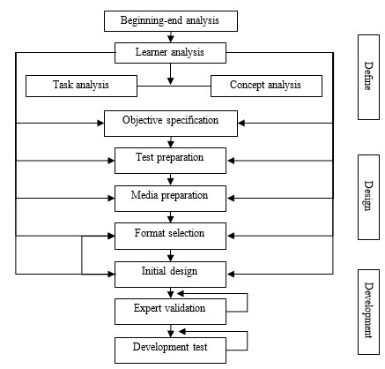
Figure 1. Design Chart 4-D Development Stages Up to Develop Stage
One-Group Pretest-Posttest Design, which permits research on one group to be done without the requirement for other groups to act as controls. The following images depict this design.
O₁ X O₂
Figure 2. One-Group Pretest-Posttest Design
Caption:
O1 = pretest to determine the initial state of students before being given a PBL-enabled e-worksheet to develop analytical capabilities on chemical equilibrium material
O2 = posttest to determine the final state of students after being given a PBL-enabled e-worksheet to develop analytical capabilities on chemical equilibrium material.
The validity of the electronic worksheet is decided by the validation data examined through the assessment of two chemistry lecturers and one chemistry instructor who filled out the validation sheet given. The assessment score criteria were calculated using a Likert scale, as shown in the table below:
Table 1 Likert Scale Validation Sheet
Scale | Indicator
4 | Very Valid
3 | Valid
2 | Less Valid
1 | Invalid
(Riduwan, 2016)
Ordinal data from the validation results can be evaluated by finding the mode for each aspect or indicator under the following circumstances:
- An aspect is deemed legitimate if its mode score ≥ 3.
- An aspect is deemed invalid if its mode score < 3.
(Lutfi, 2021).
The results of the surveys that the students answered on the ease of use of the e-worksheet are used to assess its practicality. The proportion of learner answer questionnaire data is examined using the Guttman scale. The findings acquired include negative and positive comments; therefore, grading is based on table 2 below, which shows the Guttman scale.
Table 2 Guttman Scale for Learner Response Questionnaire
Answer | Positive Answer Score | Negative Answer Score
Yes | 1 | 0
No | 0 | 1
A quantitative descriptive approach will be used to examine the learner response data results, and the results will be presented as a percentage of the Guttman Scale data as determined by the formula:
$$Total Score=\frac{sum of result scores}{criteria score}x100\%$$
The percentages obtained were then interpreted into five response criteria, as presented in Table 3 below:
Table 3 Category of E-Worksheet Practicality
Range | Category
0-20% | Very impractical
21- 40% | Less practical
41-60% | Practical enough
61-80% | Practical
81-100% | Very Practical
(Riduwan, 2016)
If the percentage of research results ≥ 61% is obtained, the e-worksheet developed has practical criteria.
The efficiency of the e-worksheet in training analytical abilities may be evaluated using the results of pretests and posttests administered before and after learning with the designed e-worksheet. The pretest determines students' beginning abilities, while the posttest determines the efficacy of using the generated e-worksheet. The following computation was used to determine the n-gain score for the descriptive quantitative analysis of the test outcomes of the students:
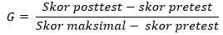
The average score will then be translated into the gain level criterion listed in Table 4 below:
Table 4 Gain Level Criteria
G | Category
Gain ≥ 0,7 | High
0,3 ≤ n-gain ≤ 0,7 | Medium
n-gain < 0,3 | Low
(Hake, 1999)
According to these standards, the e-worksheet is deemed successful if it raises the moderate group's n-gain score by at least 0.3. Additionally, the paired sample t-test hypothesis test was used in SPSS to assess the pretest and posttest results. This hypothesis test is performed after the data has been normalized and homogeneously distributed. A significance level greater than 0.05 indicates that the data is consistently shared. If the significance value is less than 0.05, it means that the data is not dispersed regularly. The hypothesis for this test is:
H₀: Students using PBL-oriented electronic spreadsheet learning materials have no improvement in their ability to analyze chemical balance materials.
H₁: Students that use PBL-oriented e-worksheet learning materials have improved their ability to analyze chemical equilibrium material.
The significance value is the base for this test's decision-making. Here's the explanation:
- When the significance value is < 0.05, H0 is disregarded and H1 is acknowledged
- If the significance level is ≥ 0.05, H0 is approved and H1 is disapproved
(Wahab dkk., 2021)

RESULTS AND DISCUSSION (12pt)
The purpose of this study is to describe the viability of using e-worksheets focused on problem-based learning to develop analytical skills. The three factors that determine whether an electronic spreadsheet is viable are validity, practicality, and effectiveness.
Define
The first step in doing an initial analysis is to watch chemistry lessons. The observation exercise revealed that the learning paradigm adopted was still teacher-centered. In addition to observations, interviews with chemistry teachers, questionnaires, and pre-research tests were used to investigate the topic. The interview findings revealed that the students' analytical abilities remained poor since they were rarely provided practice questions to improve their analytical skills. This is strengthened by the results of pre-research findings of grade XI students at SMAN 13 Surabaya, which revealed 60% of students' skill in elemental analysis, 39% in relationship analysis, and 42% in analysis of organizing principles. The average cognitive understanding of pupils about chemical equilibrium materials is 42%.
SMAN 13 Surabaya's class XI pupils follow an autonomous curriculum. Students are required to actively participate in learning while implementing the autonomous curriculum (student center). The study's materials are based on the independent chemistry curriculum for class XI and its learning objectives.
According to the interview findings, the learning medium utilized at SMAN 13 Surabaya is the Learner Activity Sheet, which contains content that has yet to be modified to the learning model in accordance with the autonomous curriculum's features. As a result, a Learner Activity Sheet is required to teach students' analytical abilities using a learning model that is consistent with the features of an autonomous curriculum and can be applied to everyday situations for chemical equilibrium content.
The subjects of this study were 17–18-year-old class XI SMAN 13 Surabaya students. Based on Piaget's cognitive theory, the characteristics of students at this age are the development of reasoning, abstraction, and inference skills from knowledge already in existence (Marinda, 2020). This point allows students to have the ability to solve a problem. Using the available learning materials, students can now improve their analytical abilities, which are currently lacking in light of the findings of their pre-research.
The e-worksheet seeks to help students develop analytical abilities that are appropriate for the PBL learning approach. The duties involve identifying issue formulations, developing hypotheses, collecting and evaluating data, and drawing conclusions based on observations. Table 5 shows the association between PBL syntax and learner activities with features of analytical skills.
Table 5 Relationship between PBL Syntax and Analysis Ability
Syntax Problem Based Learning | Learner Tasks in the E-Worksheet | Characteristics of Analysis Ability
Phase 1 Orient learners to a problem. | Understand and analyze the problems contained in the e-worksheet. | -
Phase 2 Organize learners to research. | Learners formulate a problem and hypothesis about the problem. | Analyze elements and relationships
Phase 3 Assist in group investigations. | Learners make observations together with their group to solve the given problem. | Relationship analysis
Phase 4 Develop and present results | Learners analyze data from the observations given. | Relationship analysis
Phase 5 Analyze and evaluate the problem-solving process. | Learners make problem solving and conclusions from the problems given. | Analysis of organizational principles
Design
The design stage begins after the defining stage collects various information about the product to be designed. This step seeks to create a PBL-oriented e-worksheet to strengthen analytical abilities on chemical equilibrium materials using data from the defining stage.
The e-worksheet was created using a website called liveworksheet, and students may quickly fill in the answers on the internet and save them by hitting the "submit" button. In the liveworksheet, the teacher can use words, images, and videos to help the students find information on their own and participate actively in their education, rather than relying on the teacher's explanation.
The e-worksheet follows a preset framework to strengthen PBL-oriented analysis abilities on chemical equilibrium materials. The e-worksheet to be created will have an initial cover, introduction, idea map, learning resources, learning exercises, and a bibliography. The following are the outcomes of the e-worksheet design process.
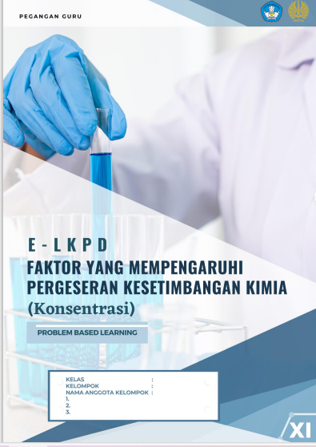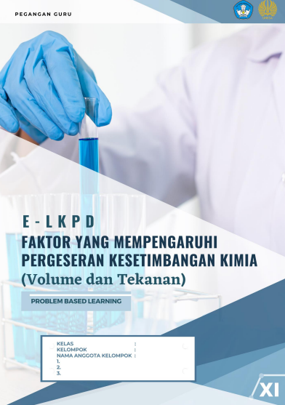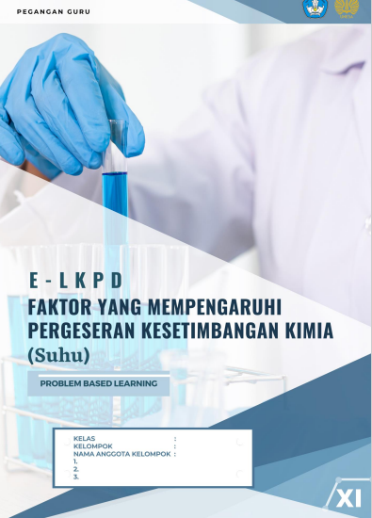
Figure 1. E-worksheet Cover Design
The title, the logos of the Ministry of Education and Culture, Unesa, the learning model, the learners' identities (name, group, group member names, and absentee numbers), the class identity, and images related to the practicum of factors affecting chemical equilibrium are all on the front of the worksheet electronic cover.
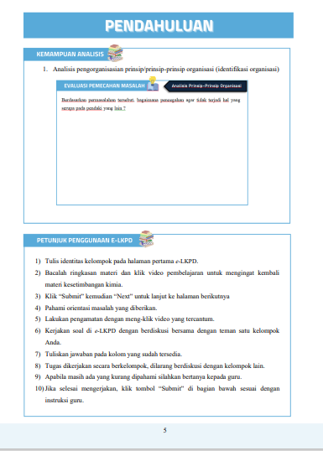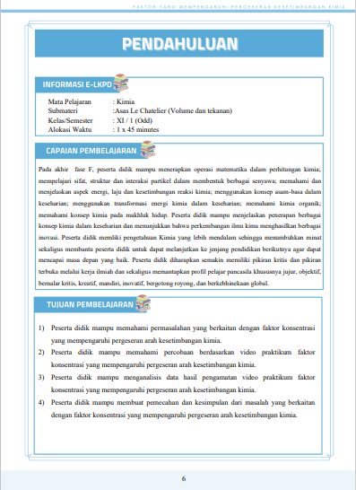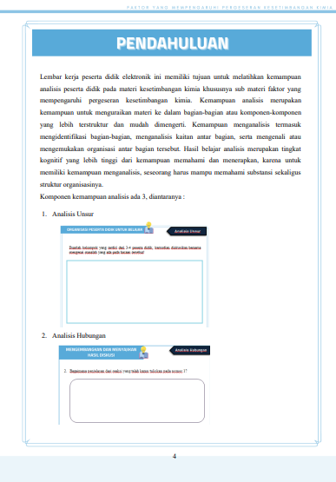
Figure 2. E-Worksheet Introduction Design
The introduction includes an overview of analytical skills as well as examples of each part of analytical skills, use instructions, information (topic, submaterial, class, semester, and time allocation), learning outcomes, and learning objectives to be met during the learning process.
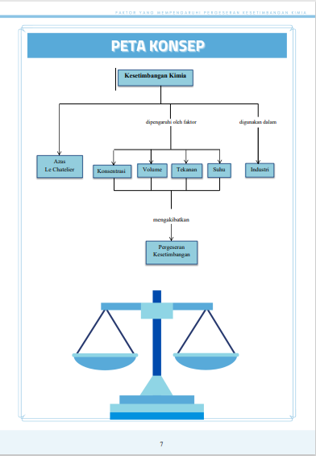
Figure 2. E-Worksheet Concept Map Design
The idea map comprises a summary of the material provided through a structural description, with the goal of allowing students to quickly comprehend the essential content of chemical equilibrium material that will be conveyed throughout learning.
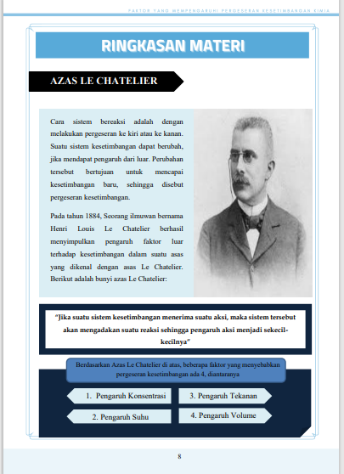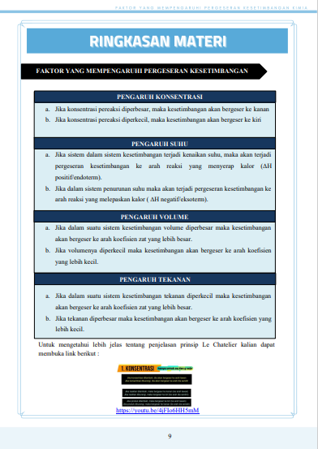
Figure 4. E-Worksheet Material Summary Design
The content summary includes a discussion of chemical equilibrium material, particularly the elements that influence chemical equilibrium, with the goal of providing students with a foundation before studying and solving the issues, as well as a short video that explains the topic.
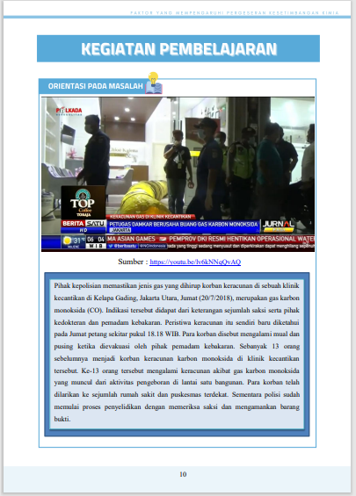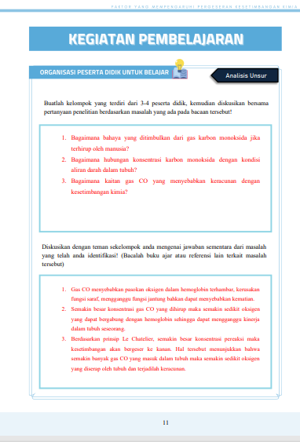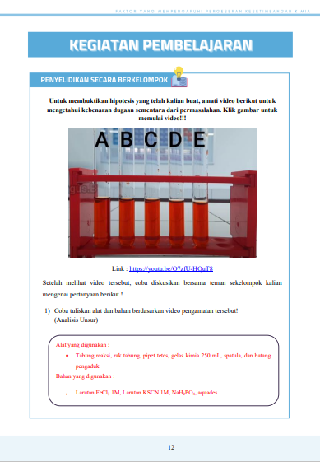
Figure 4. E-Worksheet Learning Activities Design
Learning activities include tasks that are organized according to the PBL terminology shown in Table 5. In the learning exercises, a practicum video is offered as a reference that students will use to answer subsequent questions.
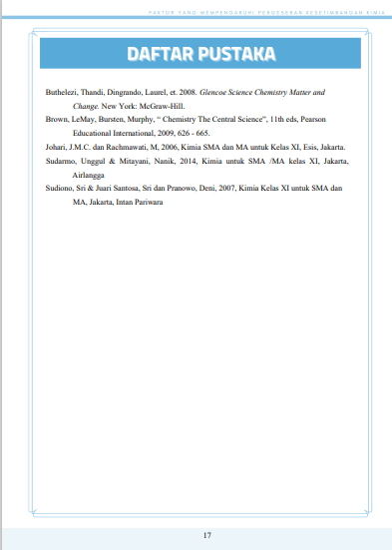
Figure 4. E-Worksheet Bibliography Design
The bibliography contains references used in the e-worksheet in the form of books and website links.
Development
The development stage's objective is to produce the final draft of a useful teaching tool. At this stage of development, product validation and field testing are conducted to provide data on the feasibility and efficacy of e-worksheet values.
Validity
Validity is determined by the findings of media validation performed by three expert validators. The validation sheet has four components of validity that must be reviewed: the viability of the language, design, presentation, and content, all of which are assessed using the manner. The following is the mode acquisition for every aspect of validity.
Table 6 E-Worksheet Validity Results
Validity aspect | Modus
Validity aspect | Concentration Factor | Pressure and Volume Factors | Temperature Factor
Content eligibility | 3 | 3 | 3
Presentation | 4 | 3 | 3
Language | 3 | 4 | 4
Design | 3 | 4 | 4
Based on the validation results table, mode 3 with valid criteria is obtained for the four elements of validity on the e-worksheet as a whole and the three components. The validity of the e-worksheet on the feasibility of content, presentation, language, and design is shown by its mode score of ≥3 (Lutfi, 2021).
Practicality
The learner activity observation sheet and the learner answer questionnaire provide practical information. An overview of the responses from the students is provided below.
Table 7 Recapitulation of Learner Response Questionnaire
Aspects | Percentage | Category
Content | 90% | Very Practical
Presentation | 89,5% | Very Practical
Language | 82,5% | Very Practical
Design | 83,75% | Very Practical
The outcomes of a summary of the students' answers to the generated e-worksheet are displayed in Table 7. The content component includes the adequacy of the clarity of the electronic worksheet material to increase students' knowledge for a percentage of 90%, as well as the objective of exercising analysis skills for a percentage of 90%. The presentation factor pertains to students' ease of use of the e-worksheet, which received an 89.5% rating. The language component, which relates to how words or concepts are used on the electronic worksheet, received an 82.5% rating. While the design component is connected to students' enthusiasm in utilizing the e-worksheet, with a proportion of 83.75%. Based on the examination of the students' response questionnaire, all assertions received a percentage in the extremely practical category of ≥61 percent. The e-worksheet generated has an overall practicality score of 86.44%. It can say that the electronic worksheet is classified as extremely practical. This is corroborated by earlier research; the PBL-oriented e-worksheet generated was rated as extremely practical to use with a practicality rating of 98.44% on the answer questionnaire (Hidayah, Azizah, & Nasrudin, 2024).

Effectiveness
The results of the pretest and posttest show how beneficial the e-worksheet is for enhancing students' analytical skills. The following are the N-gain scores for each component's analytical skills on the pretest and posttest.
Table 8 N-gain of Analysis Ability
Ability | N-gain | Category
Elemental Analysis | 0.55 | Medium
Relationship Analysis | 0.59 | Medium
Organizing Analysis | 0.59 | Medium
Based on the n-gain findings from the analysis ability exam, we can conclude that each component of analysis ability has increased. Relationship analysis receives an n-gain of 0.59 and a moderate category for organizing analysis, whereas element analysis receives an n-gain of 0.55. As a result, the produced e-worksheet may help students improve their analytical abilities in all aspects of analysis, including element analysis, relationship analysis, and organizational analysis. The T test in SPSS was used to assess the critical thinking skills pretest and posttest values in addition to the N-gain. The normality test of analytical abilities using the Shapiro-Wilk approach yielded the following findings.
Table 9 Analysis Skills Normality Test Results
 | Statistic | df | Sig.
Pretest | .941 | 34 | .068
Posttest | .940 | 34 | .062
The results of the Shapiro-Wilk normality test show that the data from the students' analytical skills pretest and posttest have a significance value > 0.05, indicating that the data is normally distributed (Wahab dkk., 2021). The data from the students' analytical skills pretest and posttest have a significance value > 0.05, indicating that the data is normally distributed, according to the results of the Shapiro-Wilk normality test (Bierera & Muchlis, 2021). Furthermore, there will be a paired sample t-test run. The following outcomes were obtained using the paired sample t-test analytical ability:
Table 10 Paired Sample T-Test Result of Analysis Ability
t | df | Sig. (2-tailed)
-11.727 | 33 | .000
According to Table 10 of the t-test results, Ho is rejected and Ha is accepted with a 2-tailed significant value of <0.05. Ho asserts that the pretest and posttest do not significantly differ from one another. Ha, however, asserts that there is a significant difference between the pretest and posttest. According to the t test findings, it is possible to infer that the designed e-worksheet is successful in teaching students analytical abilities.

CONCLUSION
Based on the findings and discussions, it is possible to infer that this development research generates goods in the form of Problem Based Learning oriented electronic worksheet learning media to teach class XI high school students' analytical abilities on chemical equilibrium material. According to research and discussion results, it is said that the creation of a worksheet meets the eligibility standards for validity, practicality, and effectiveness. The e-worksheet's validity was determined using mode 3 and valid criteria. According to the conclusions drawn from the student response survey,, the total degree of practicality of the generated e-worksheet was 86.44%, indicating that it is extremely practical. The findings of the paired sample t-test indicate a significant change in analytical abilities between before and after learning e-worksheets (p-value = 0.00 < 0.05). This is corroborated by the findings of n-gain per analysis component, which indicate an increase in element analysis, relationship analysis, and organizing analysis. As a result, it is possible to infer that the generated e-worksheet is successful in teaching students analytical skills on chemical equilibrium content.

RECOMMENDATIONS
This study is constrained by the learning model known as Problem Based Learning; it is envisaged that in the future, the researchers will be able to build e-worksheets utilizing different learning models that are aligned with the most recent curriculum.

ACKNOWLEDGEMENTS
It feel grateful to the lecturer and chemistry teacher at SMAN 13 Surabaya for their assistance in putting this research into practice.

BIBLIOGRAPHY
Arends, R. I. (2008). Learning to Teach: Belajar untuk Mengajar Buku Dua (Penerjemah: Helly Prayitno Soetjipto dan Sri Mulyantini Soetjipto). Yogyakarta: Pustaka Pelajar.
Bierera, E., & Muchlis. (2021). Pengembangan LKPD Berbasis PBL untuk Melatihkan Keterampilan Berpikir Analitis Pada Materi Elektrolit dan Nonelektrolit. UNESA Journal of Chemical Education, 10(2), 149–158.
Hake, R. . (1999). Analyzing Change/Gain Scores. AREA-D American Education Research Association’s Devision.D: Measurement and Reasearch Methodology.
Hidayah, S. N., Azizah, U., & Nasrudin, H. (2024). International Journal of Current Science Research and Review Development of Problem-Based-Learning ( PBL ) -Oriented Electronic Student Worksheets ( e-Worksheet ) to Improve Critical Thinking Skills of Class XI Senior High School Students on Factors that . 07(06), 4284–4292. https://doi.org/10.47191/ijcsrr/V7-i6-80
Kurniawan, D., & Dewi, S. V. (2017). Pengembangan Perangkat Pembelajaran Dengan Media Screencast-O-Matic Mata Kuliah Kalkulus 2 Menggunakan Model 4-D Thiagarajan. Jurnal Siliwangi: Seri Pendidikan, 3(1).
Kusnawa, W. S. (2012). Taksonomi Kognitif Perkembangan Ragam Berpikir. Bandung: PT Remaja Rosdakarya Offset.
Lutfi, A. (2021). Research an Development (R&D) : Implikasi dalam pendidikan kimia. Surabaya: Jurusan Kimia FMIPA UnIversitas Negeri Surabaya.
Marinda, L. (2020). Kognitif dan Problematika. An-Nisa’ : Jurnal Kajian Perempuan Dan Keislaman, 13(1), 116–152.
Novita, S., Santosa, S., & Rinanto, Y. (2016). Perbandingan Kemampuan Analisis Siswa melalui Penerapan Model Cooperative Learning dengan Guided Discovery Learning. Proceeding Biology Education Conference, 13(1), 359–367.
Nurrita, T. (2018). Pengembangan Media Pembelajaran Untuk Meningkatkan Hasil Belajar Siswa. MISYKAT: Jurnal Ilmu-Ilmu Al-Quran, Hadist, Syari’ah Dan Tarbiyah, 3(1), 171. https://doi.org/10.33511/misykat.v3n1.171
Rahmadani, R. (2019). Metode Penerapan Model Pembelajaran Problem Based Learnig (PBL). Lantanida Journal, 7(1), 75. https://doi.org/10.22373/lj.v7i1.4440
Riduwan. (2016). Dasar-dasar Statistika. Bandung: Alfabeta.
Subagia, I. W. (2014). Paradigma Baru Pembelajaran Kimia SMA. Seminar Nasional FMIPA UNDIKSHA IV, 1(1), 152–163.
Sugiyono. (2019). Metodelogi Penelitian Kuantitatif dan Kualitatif Dan R&D. Bandung: Alfabeta.
Suryaningsih, S., & Nurlita, R. (2021). Pentingnya Lembar Kerja Peserta Didik Elektronik (E-LKPD) Inovatif dalam Proses Pembelajaran Abad 21. Jurnal Pendidikan Indonesia, 2(7), 1256–1268. https://doi.org/10.36418/japendi.v2i7.233
Syafitri, R. A., & Tressyalina. (2020). The Importance of the Student Worksheets of Electronic (E-LKPD) Contextual Teaching and Learning (CTL) in Learning to Write Description Text during Pandemic COVID-19. 485(Iclle), 284–287. https://doi.org/10.2991/assehr.k.201109.048
Umriani, F. S. (2020). Studi Pendahuluan: E-LKPD Berbasis PBL untuk Meningkatkan Kemampuan Literasi Matematis Peserta Didik. Jurnal Kajian Pendidikan Matematika, 6(1), 131–140.
Wahab, A., Junaedi, J., & Azhar, M. (2021). Efektivitas Pembelajaran Statistika Pendidikan Menggunakan Uji Peningkatan N-Gain di PGMI. Jurnal Basicedu, 5(2), 1039–1045. https://doi.org/10.31004/basicedu.v5i2.845

