Students' Scientific Literacy in Critical Thinking Skills in Science Learning: A Bibliometric Analysis from the Scopus Database
Jalilah Azizah Lubis¹, Yuni Pantiwati², Abdulkadir Rahardjanto³

^{1,} Program Pascasarjana (S3) Universitas Muhammadiyah Malang,
^{1,2} Universitas Muhammadiyah Tapanuli Selatan
^{2,3} Universitas Muhammadiyah Malang, Malang, Indonesia
*Email : jalilahazizah@webmail.umm.ac.id

Abstract : This study aims to analyze the development of students' scientific literacy in science education through a bibliometric approach based on Scopus data (2019–2024). Using the PRISMA method, 104 selected articles were analyzed through VOSviewer and Excel to map the dynamics of publications, citations, collaborations between countries, and research focus. The results show a significant increase that scientific literacy and critical thinking skills are dynamic research areas with significant impacts on global education. The bibliometric analysis has described the development, collaboration, and focus of current research, while opening up opportunities for more effective pedagogical innovation and educational policies. These findings form the basis for future research that is more focused on specific contexts and interdisciplinary approaches.
Keywords : Scientific Literacy, Critical Thinking Skills, Bibliometrics, International Collaboration

INTRODUCTION
Students' scientific literacy has become a critical competency for addressing 21st-century challenges. As the ability to understand, analyze, and apply scientific concepts in daily life, scientific literacy not only supports the development of scientific knowledge but also enables students to make informed and responsible decisions in social, economic, and environmental contexts (Rahmadanita, 2022). In education, scientific literacy is considered foundational for nurturing a generation capable of critical, creative, and solution-oriented thinking amid increasingly complex global issues.
The importance of scientific literacy in education has spurred numerous studies exploring its aspects, from curriculum and teaching methods to learning outcomes (Barnes et al., 2024; Eymur & Çetin, 2024). However, despite extensive research, gaps remain in understanding how scientific literacy is developed and integrated with critical thinking skills. Additionally, there is a lack of comprehensive mapping of research trends, collaborations among researchers, and the most productive institutions and countries in this field (Cintamulya et al., 2024; Feng Qinna, 2023; Yang, 2023). This underscores the need for a systematic and in-depth analysis of the evolution of scientific literacy research.
Bibliometrics, as a quantitative analysis method for academic publications, offers an effective approach to mapping research developments in a specific field (Zupic & Čater, 2015). Using data from the Scopus database, a leading repository of high-quality scientific publications, this study aims to analyze trends, patterns, and dynamics in scientific literacy research in education. The bibliometric analysis will identify dominant topics, researcher collaboration networks, and contributions from institutions and countries in advancing scientific literacy linked to students' critical thinking skills.
This study seeks to understand how scientific literacy has been integrated into critical thinking skills. By mapping the progression of scientific literacy research, it aims to identify areas requiring further attention and opportunities for future studies. The findings are expected to provide valuable insights for researchers, educators, and policymakers in formulating more effective and innovative strategies for developing scientific literacy. Globally, scientific literacy is also a key indicator in international education assessments, such as the Programme for International Student Assessment (PISA). These assessments often serve as benchmarks for evaluating national education systems and identifying areas for improvement (Rahmadanita, 2022; Ware et al., 2019). Thus, a deeper understanding of scientific literacy research has both academic relevance and practical implications for enhancing global education quality.
Through a bibliometric approach, this study aims to contribute significantly to understanding the dynamics of scientific literacy research in education. By mapping research trends and collaboration networks, it will provide a holistic overview of scientific literacy development in the educational context. Future research should investigate improvements in content mastery and competency-based learning skills, offering recommendations for more effective educational policies and practices (Ware et al., 2019; Woodley et al., 2019).
Despite the widely recognized importance of scientific literacy, challenges persist in understanding its development, measurement, and integration into education systems. While numerous studies have explored aspects of scientific literacy, few have comprehensively analyzed its research evolution through bibliometrics (Zupic & Čater, 2015). This study aims to provide a holistic picture of scientific literacy research in education, including dominant topics, researcher collaborations, and the most productive institutions and countries.
The bibliometric approach is expected to significantly contribute to educational stakeholders, including researchers, educators, and policymakers, in understanding the dynamics of scientific literacy research and formulating more effective development strategies. Additionally, the findings may serve as a foundation for further in-depth studies focusing on specific aspects of scientific literacy that influence critical thinking skills in education.
This study collects data on scientific literacy research using a bibliometric approach based on Scopus data. The article presents a comprehensive bibliometric analysis of students' scientific literacy linked to critical thinking skills in education, covering publication trends, international research collaborations, and research focus. By analyzing journals, conferences, and other related academic publications, the study aims to provide a systematic overview of recent research and recommendations for future research agendas.

METHOD
This study employs a descriptive bibliometric analysis method consisting of four key stages: identification, screening, eligibility, and inclusion (Habibi & Artha Glory Romey Manurung, 2023). In the identification stage, researchers searched the Scopus database using keywords aligned with the research theme: "students' scientific literacy and critical thinking skills." This step identified 4,317 relevant articles. The next stage, screening, filtered 201 articles from the initial pool using criteria such as critical thinking skills and publication years (2019–2024). Of these, 65 articles did not meet the criteria and were excluded, leaving 136 articles. Further screening based on subject area and document type (articles only) resulted in 73 articles proceeding to the eligibility stage. Here, researchers evaluated whether the 73 articles were suitable for inclusion in the final analysis. Only English-language publications were included, reducing the number to 68 articles.
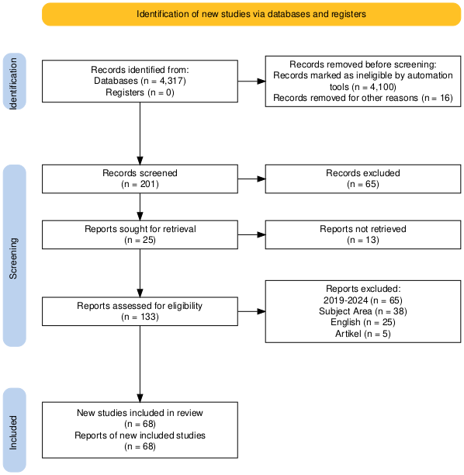
Gambar 1. Tahapan dalam penyempurnaan Data
Researchers used various tools to process the data. Microsoft Excel was used to display tables of publication and citation trends. VOSviewer visualized international collaborations and research focus areas. The PoP application calculated citation metrics such as NCP, C/CP, and h-index.
RESULT AND DISCUSSION
In this section, we will discuss the trend in the number of publications, the trend in the number of citations, the trend in research collaboration between countries, and the focus of research related to students' scientific literacy in Education. The trend in the number of publications reflects the development in the number of scientific publications that have been published in this field during the period 2019 to 2024. This trend provides an overview of the growth of research conducted by scientists and academics in studying students' scientific literacy associated with critical thinking skills in Education. Furthermore, the trend in the number of citations illustrates the extent to which the research has influenced further research and become a reference for other scientists. The increase in the number of citations indicates the level of recognition and widespread acceptance in the scientific community of research on students' scientific literacy associated with critical thinking skills in education. International collaboration can produce higher quality research and be associated with a wide range because it involves diverse perspectives and expertise. Finally, the trend in research focus refers to research areas that receive special attention in the study of students' scientific literacy associated with critical thinking skills in education during the period 2019 to 2024.

Trend in number of publications
The trend in the number of publications is shown by grouping the number of publications by year of publication. The trend in publications from 2019 to 2024 related to research on student science literacy associated with critical thinking skills in education can be seen in Figure 2.

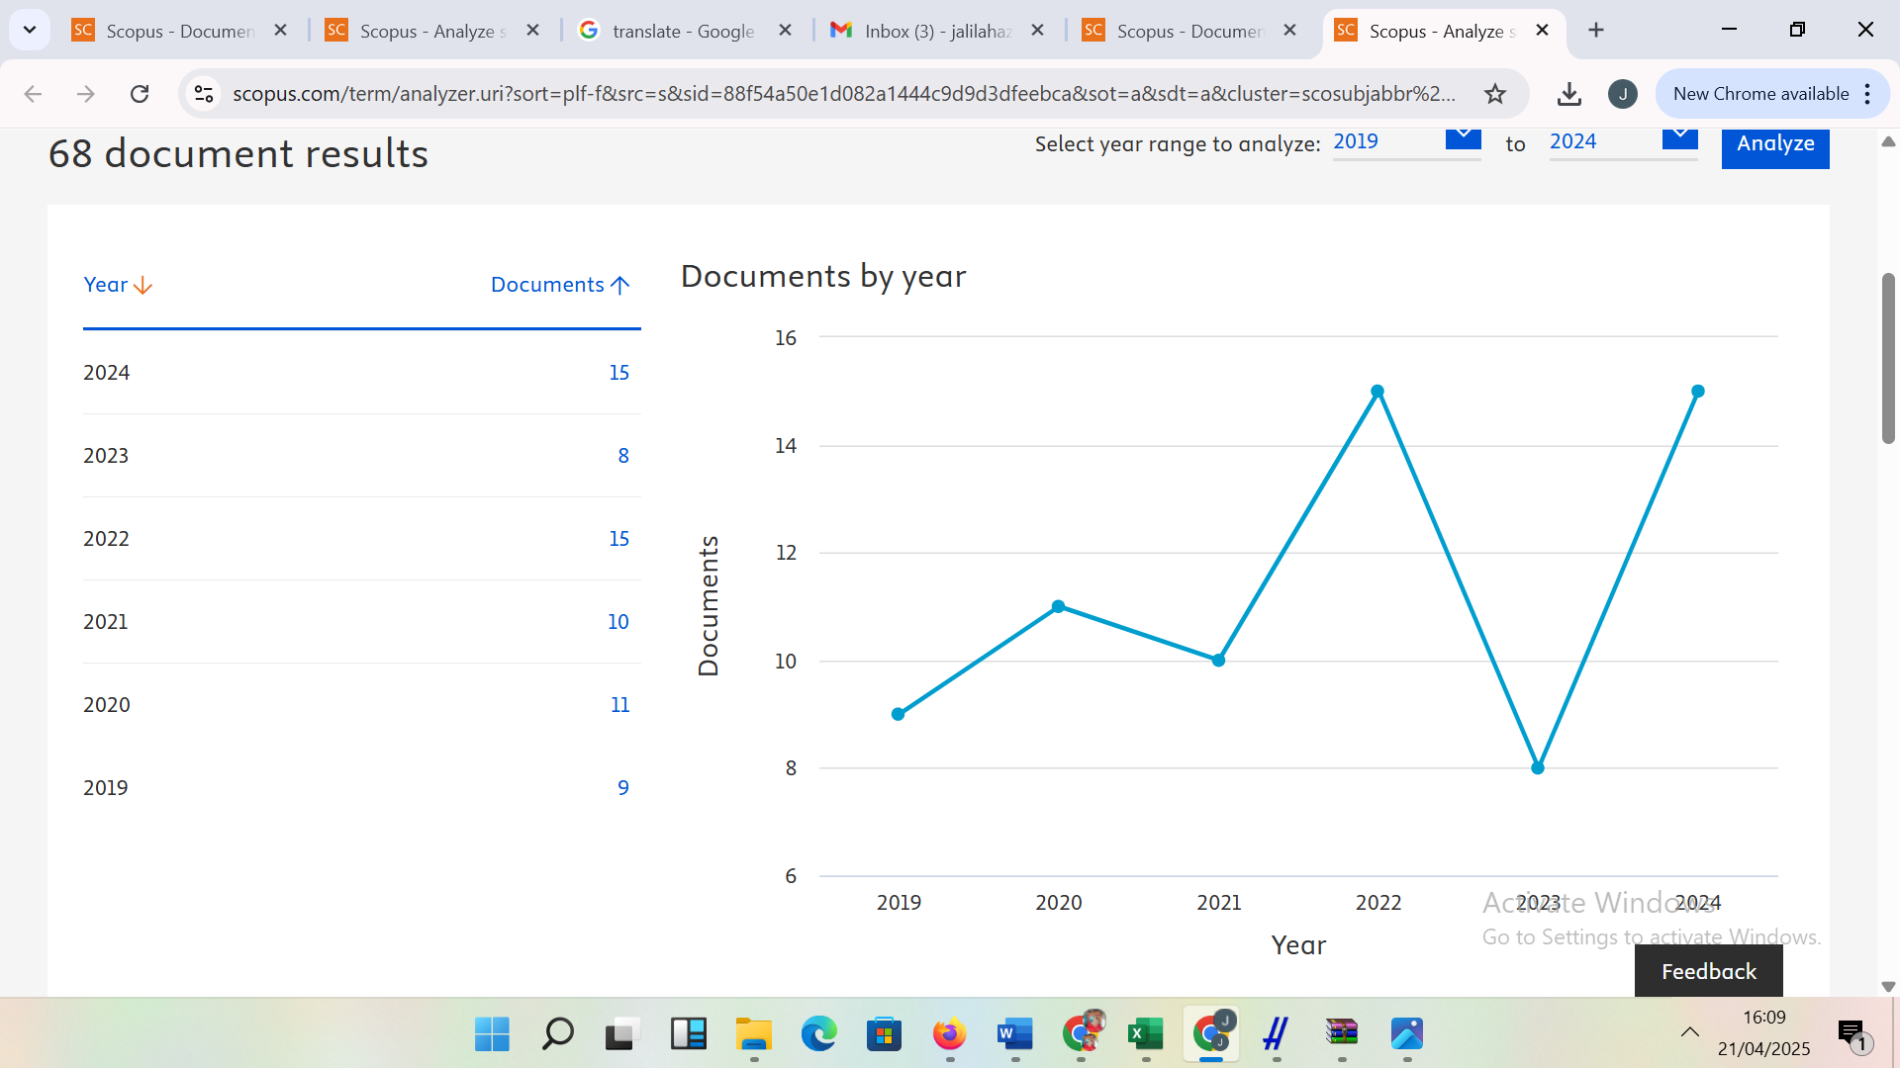
Figure 2. Publication Trends

The graph shown shows the trend of publication of documents related to students' scientific literacy associated with critical thinking skills based on Scopus data in the period 2019 to 2024. There is a significant increase in the number of publications, especially in the last year. This shows that students' scientific literacy associated with critical thinking skills is increasingly becoming a topic of interest and relevance in the world of education. This increase may be triggered by global awareness of the importance of students' scientific literacy in facing 21st-century challenges, such as climate change, technological advances, and global health issues (e.g., the COVID-19 pandemic). In addition, international assessments such as PISA (Programme for International Student Assessment) may also have driven research interest in this field. There are spikes in certain years, which may be caused by certain events or policies that encourage increased research. For example, a sharp increase in a particular year could be related to the launch of a new curriculum that emphasizes students' scientific literacy associated with critical thinking skills, or the holding of an international conference discussing this topic. These spikes could also reflect a response to global challenges, such as the pandemic, which forces the world of education to focus more on students' scientific literacy as part of relevant education. Increased collaboration between researchers, institutions, and countries. This can be seen from the possibility of an increase in the number of publications involving authors from different countries or institutions. This collaboration is important to broaden perspectives and improve the quality of students' scientific literacy research. International collaboration often produces more comprehensive and broadly related research, because it combines different perspectives and resources.
The shift in research focus in the early years, research may focus more on measuring students' scientific literacy, while in the later years, research may discuss more innovative learning methods or technology integration in teaching students' scientific literacy, the end result of which will be associated with students' critical thinking skills. This shift reflects the dynamics in the field of education, where practices and policies continue to evolve to respond to students' needs and global challenges. The increasing number of publications on students' scientific literacy associated with critical thinking skills is increasingly recognized as an important component in education. This can encourage policymakers to pay more attention to the development of curricula and learning methods that support students' scientific literacy so that they can develop students' critical thinking skills. In addition, this trend can also influence national and international education policies, with more countries investing in research and development of students' scientific literacy related to critical thinking skills. This indicates that research on this topic continues to be more specific with a more targeted approach.

Table 1. Citation Trends
Tahun | TP | TC | NCP | H | G
2024 | 15 | 10 | 6 | 2 | 2
2023 | 8 | 18 | 5 | 3 | 3
2022 | 15 | 142 | 15 | 7 | 11
2021 | 10 | 87 | 8 | 5 | 9
2020 | 11 | 114 | 11 | 7 | 10
2019 | 9 | 184 | 8 | 7 | 9
TP : Total Publication ; TC : Total Citation ; NCP : Number Citation Paper; H: h-index; G: g-index

Total Publications Fluctuate with peaks in 2022 and 2024 (15 publications), and a low point in 2023 (8 publications). Indicates the highest productivity, possibly related to research focus or major projects. The drastic decline in 2023 (only 8 publications) could be due to external factors such as the pandemic, changes in institutional policies, or shifts in research topics. The peak of citations occurred in 2019 (184 citations), followed by a significant decline until 2024 (10 citations). The decline in citations in 2023–2024 may reflect a lack of visibility or relevance of recent research, or a delay in the citation process (it usually takes 2–3 years to accumulate citations). In terms of Cited Articles, the highest value was in 2022 (15 cited articles) and the lowest in 2024 (6 articles). Because there was consistency in cited articles in 2019–2022, it shows the quality of research that is recognized. In 2024, the quality of articles decreased due to the short time for citation. The highest H-Index and G-Index were in 2022 and 2020 (value 7), the lowest in 2024 (value 2), while the highest G-Index was in 2022 (value 11), the lowest in 2024 (value 2). High H-Index and G-Index in 2019–2022 indicate that researchers/institutions have influential publications with balanced citations. Low values ​​in 2023–2024 indicate the dominance of new publications with few citations or a lack of high-impact articles. The publication with the most citations was in 2019, which was the beginning of the pandemic.

Table 2. Publications with the Most Citations
Penulis | Judul | Nama Jurnal | Kutipan | Hasil Penelitian
( Kinslow, A.T., Sadler, T.D., guyen, H.T, 2019) | Socio-scientific reasoning and environmental literacy in a field-based ecology class | Environmental Education Research | 76 | This study describes how an existing field-based ecology course was modified to frame learning around local environmental socio-scientific issues. We used a convergent parallel mixed methods approach to examine changes in social-scientific reasoning (SSR) over time for middle school students in this course as a measure of scientific and environmental literacy. Results suggest that a focused SSI field-based environmental education curriculum can support the development of social-scientific reasoning and environmental literacy competencies among middle school students.
( Afandi, Sajidan, Akhyar, M., Suryani, N.,2019 ) | Development frameworks of the Indonesian partnership 21 ^{st} -century skills standards for prospective science teachers: A Delphi study | Jurnal Pendidikan IPA Indonesia | 42 | From the results of this study, we have determined four IP-21CSS that are considered by the panelists as the right standards for prospective science teachers in Indonesia ranging from 4.5 to 5 or at a high level. These standards include: (1) 4C (critical thinking, creative thinking, collaboration, and communication); (2) ICT (technology, media, and information literacy); (3) spiritual values ​​(religious beliefs and spiritual awareness); and (4) character building (teacher attitudes and scientific attitudes). Therefore, it can be concluded that the implementation of 21st century education learning that emphasizes each of the IP-21CSS indicators needs to be considered as an important component in the lecture process for prospective science teachers in Indonesia.
(Baran, M., Karakoyun, F., Maskan, A., 2019) | The Influence of Project-Based STEM (PjbL-STEM) Applications on the Development of 21st-Century Skills | Journal of Turkish Science Education | 32 | Significant improvement in students’ 21st century skills, such as the level of use of autonomy and cooperation skills and their level of environmental sensitivity. Students also reported that the activities had a positive effect on many of their 21st century skills such as communication, and collaboration, problem solving, creativity, critical thinking, responsibility, environmental awareness, and information technology literacy. Based on the findings, the following suggestions are proposed: PjbL-STEM activities can be carried out more in educational institutions owned by the Ministry of National Education. Teacher training activities can be carried out, and in-service training can be organized to support the implementation of innovative methods.
(Nelms, A.A., Segura-Totten, M., 2019) | Expert–novice comparison reveals pedagogical implications for students’ analysis of primary literature | CBE Life Sciences Education | 29 | Our results reveal that lecturers have more complex schemas than students and that they reduce cognitive load through two main mechanisms: summarizing and note-taking. Lecturers also engage with articles at a higher cognitive level, described as constructive by the ICAP framework, compared to students. More complex schemas, which effectively reduce cognitive load, and deeper engagement with the text may help explain why lecturers encountered fewer comprehension difficulties than students in our study. Finally, lecturers analyzed and evaluated data more frequently than students when reading texts. The findings include a discussion of successful pedagogical approaches for instructors seeking to improve students’ comprehension and analysis of research articles.

Based on the data presented, there are four studies with varying numbers of citations, ranging from 29 to 76. The number of citations reflects the level of influence and relevance of the research in their respective fields. The study with the highest number of citations of 76 citations explains how a modified field-based ecology course focused on environmental socio-scientific issues can improve the socio-scientific reasoning (SSR) and environmental literacy of high school students (Sarabi et al., 2020). A convergent parallel mixed methods approach was used to measure changes in SSR over time. The results show that a focused field-based curriculum can support the development of environmental literacy and socio-scientific reasoning competencies (Kinslow et al., 2019). The second with 42 citations explains four 21st century skill standards for prospective science teachers in Indonesia, including: 4C (critical thinking, creativity, collaboration, communication), ICT, spiritual values, and character building (Anazifa & Djukri, 2017). These standards are considered very relevant to the lecture process of prospective science teachers. The third highest with 32 citations explains that the Implementation of PjbL-STEM shows a significant increase in students' 21st century skills, such as autonomy, collaboration, communication, and technological literacy. This study recommends teacher training to support the implementation of this innovative method in educational institutions (Thiagarajan, 1974). Teachers are expected to be able to utilize various online applications and platforms to create interactive and engaging learning materials for students. In addition, by using technology, teachers can also provide direct feedback to students and monitor their progress more effectively. The fourth highest with 29 citations found that lecturers have more complex cognitive schemes than students in analyzing primary literature. They reduce cognitive load by summarizing and taking notes, and engage at a higher cognitive level. These findings provide insights for effective pedagogical approaches. From all these studies, it is concluded that these studies emphasize the importance of innovative approaches (such as PjbL-STEM and field-based curriculum) and teacher training to improve 21st century skills and scientific literacy (Nelms & Segura-Totten, 2019). However, some studies have relatively low citation counts, perhaps due to more recent publication or a more specific journal scope.
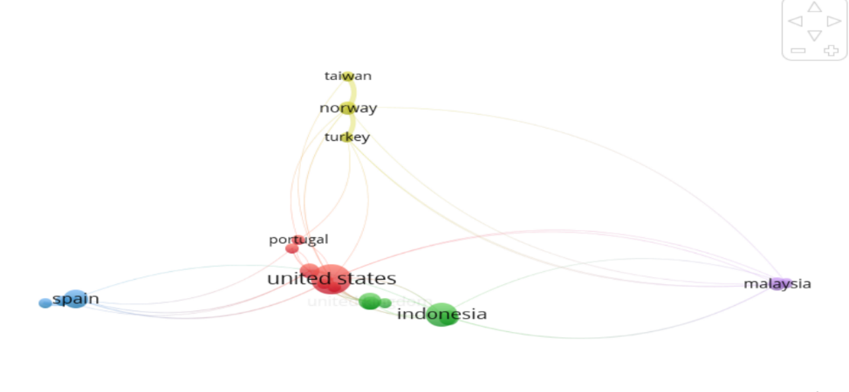
Trends in Research Collaboration Between Countries

Figure 3. Research collaboration between countries
The image shows a research collaboration between countries involving Taiwan, Norway, Turkey, Portugal, Spain, the United States, Italy, Indonesia, and Malaysia. This collaboration reflects a global effort to improve students' scientific literacy and its relationship to critical thinking skills.

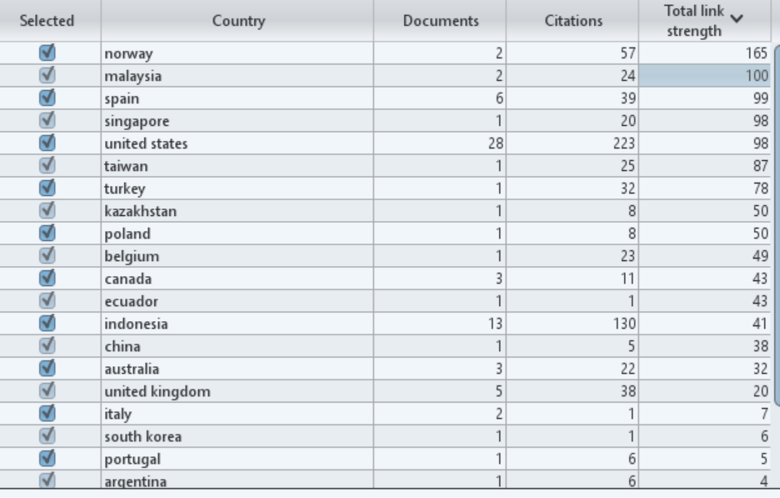

The United States, Taiwan, and Norway emerged as major hubs for scientific literacy research collaboration. This is in line with studies showing that countries with advanced science education systems tend to be active in international collaboration (Li et al., 2020). Meanwhile, developing countries such as Indonesia and Malaysia are involved in collaboration, although with lower frequency. This shows an effort to adopt best practices from developed countries on the integration of 21st century skills in the science curriculum (Adedokun & Popoola, 2024).

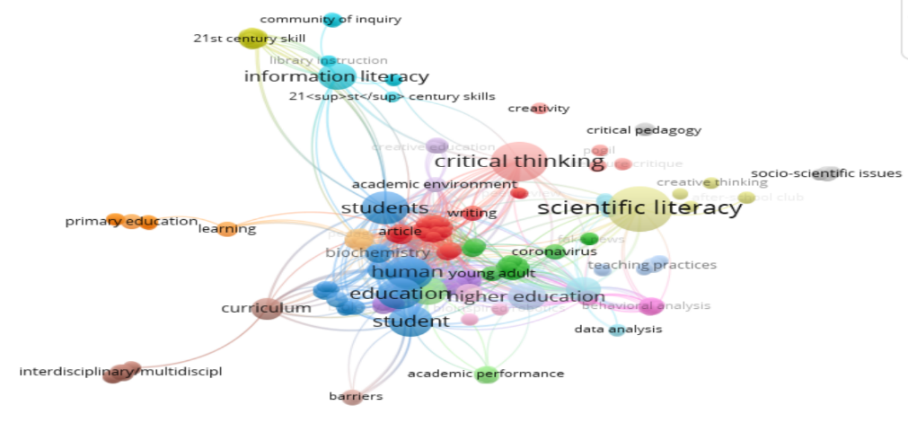
Gambar 4. Fokus Penelitian

Figure 4. Network of Interrelated Keywords or Themes

The figure above shows a network of interrelated keywords or themes, reflecting the main areas of research and the novelty of this study. In terms of research focus, scientific literacy is used as a foundation for understanding scientific concepts and applying knowledge in real-life contexts by exploring scientific literacy as a basis for developing students' critical thinking skills. This is in line with the definition of scientific literacy emphasizing the ability to use scientific knowledge to identify questions, evaluate evidence, and make decisions, encouraging students to think critically, such as analyzing information, evaluating arguments, and solving complex problems (Dharmayanti et al., 2024; Susongko et al., 2024). These skills are very relevant in the digital era, where students are faced with a lot of information that needs to be filtered critically (Facione, 2015) by using an active approach in science learning.

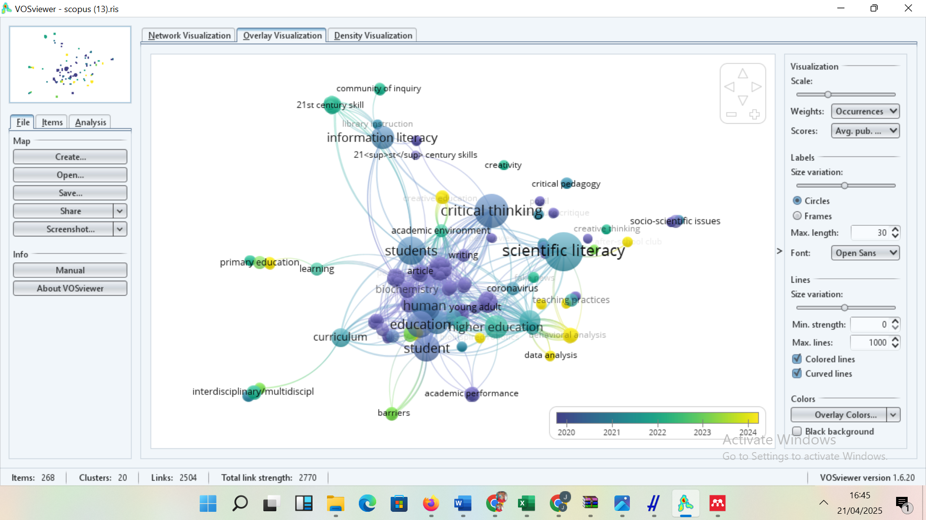
Figure 5. Research recency
The novelty of this study lies in the use of VOS Viewer analysis to uncover clusters of themes that may not have been explored in depth in previous studies, such as the role of digital media or socio-scientific contexts in linking the two concepts. This study also fills a gap in the literature by focusing on a specific context (e.g., high school students in Indonesia) or a new pedagogical approach (such as STEM integration). 21st century skills in Indonesia show that local contexts often require adaptation of existing scientific literacy models (Afandi, 2019). An interdisciplinary approach that links scientific literacy not only with pure science, but also with fields such as cognitive psychology or environmental education (Cintamulya et al., 2024).
CONCLUSION
Students' scientific literacy is a critical competency in 21st-century education, not only to understand scientific concepts but also to make informed decisions in social, economic, and environmental contexts (OECD, 2019). Its integration with critical thinking skills is the foundation for forming a generation that is able to solve complex problems creatively and provide solutions. From the results of the Bibliometric analysis, it was found that there was a significant increase in publications related to scientific literacy and critical thinking skills, especially in 2022 and 2024. This reflects global awareness of the importance of this topic, driven by challenges such as climate change, pandemics, and international assessments. Citation Trends Publications in 2019 dominate the number of citations (184 citations), indicating a strong influence on further research. However, the latest publications (2023–2024) still need time to accumulate citations. Meanwhile, International Collaboration with the main contribution from countries with strong education systems. This collaboration enriches the perspective and methodology of research. Research in 2019-2024 has dominant Topics Project-based learning (PjBL-STEM) for the development of 21st century skills (Baran et al., 2021). Integration of science literacy with local and spiritual values ​​(Afandi, 2019). The role of socio-scientific approaches in improving environmental literacy (Kinslow et al., 2019).

REFERENCE LIST
Adedokun, O. O., & Popoola, S. O. (2024). Computer Self-efficacy, Computer Literacy Skills, Cognitive Skills and Use of Electronic Resources by Social Science Doctoral Students in Nigerian Federal Universities. International Journal of Information Science and Management, 22(4), 185–205. https://doi.org/10.22034/ijism.2024.2007424.1187
Afandi, S. A. M. , & S. N. (2019). Development Frameworks of the Indonesian Partnership 21st-Century Skills Standards for Prospective Science Teachers: A Delphi Study. Jurnal Pendidikan IPA Indonesia, 8(1). https://doi.org/10.15294/jpii.v8i1.11647
Anazifa, R. D., & Djukri. (2017). Project- based learning and problem- based learning: Are they effective to improve student’s thinking skills? Jurnal Pendidikan IPA Indonesia, 6(2), 346–355. https://doi.org/10.15294/jpii.v6i2.11100
Baran, M., Baran, M., Karakoyun, F., & Maskan, A. (2021). The Influence of Project-Based STEM (PjbL-STEM) Applications on the Development of 21st-Century Skills. Journal of Turkish Science Education, 18(4), 798–815. https://doi.org/10.36681/tused.2021.104
Barnes, Z. T., Schrodt, K., & Fields, R. S. (2024). Science, Literacy, and Students with Disabilities: What Middle School Science Teachers Need to Support Students with Disabilities in Their Classrooms. Reading and Writing Quarterly, 40(6), 586–599. https://doi.org/10.1080/10573569.2023.2299672
Cintamulya, I., Murtini, I., & Warli, W. (2024). Optimizing Collaboration and Communication Skills of Pre-Service Biology Teachers Based on Cognitive Styles through Scientific Paper Tasks. Participatory Educational Research, 11(6), 262–279. https://doi.org/10.17275/per.24.89.11.6
Dharmayanti, P. A. P., Padmadewi, N. N., Utami, I. G. A. L. P., & Suarcaya, P. (2024). Digital Literacy Competence for Scientific Writing: Students’ Perceptions and Skills. Journal of Language Teaching and Research, 15(5), 1550–1560. https://doi.org/10.17507/jltr.1505.16
Eymur, G., & Çetin, P. S. (2024). Investigating the role of an inquiry-based science lab on students’ scientific literacy. Instructional Science, 52(5), 743–760. https://doi.org/10.1007/s11251-024-09672-w
Facione, P. (2015). Critical Thinking: What It Is and Why It Counts. https://www.researchgate.net/publication/251303244
Fakhriyah, F., Rusilowati, A., Nugroho, S. E., Saptono, S., Ridlo, S., Mindyarto, B., & Susilaningsih, E. (2022). The scientific argumentative skill analysis reviewed from the science literacy aspect of pre-service teacher. International Journal of Evaluation and Research in Education, 11(4), 2129–2139. https://doi.org/10.11591/ijere.v11i4.22847
Feng Qinna, L. H. * , W. L. T. C. N. S. (2023). Effects of gender diversity on college students’ collaborative learning: From individual gender to gender pairing. Heliyon, 9(6). https://doi.org/https://doi.org/10.1016/j.heliyon.2023.e16237
Habibi, R., & Artha Glory Romey Manurung. (2023). SLR Systematic Literature Review: Metode Penilaian Kinerja Karyawan Menggunakan Human Performance Technology. Journal of Applied Computer Science and Technology, 4(2), 100–107. https://doi.org/10.52158/jacost.v4i2.511
Kinslow, A. T., Sadler, T. D., & Nguyen, H. T. (2019). Socio-scientific reasoning and environmental literacy in a field-based ecology class. Environmental Education Research, 25(3), 388–410. https://doi.org/10.1080/13504622.2018.1442418
Li, Y., Wang, K., Xiao, Y., & Froyd, J. E. (2020). Research and trends in STEM education: a systematic review of journal publications. International Journal of STEM Education, 7(1), 11. https://doi.org/10.1186/s40594-020-00207-6
Nelms, A. A., & Segura-Totten, M. (2019). Expert–Novice Comparison Reveals Pedagogical Implications for Students’ Analysis of Primary Literature. CBE—Life Sciences Education, 18(4), ar56. https://doi.org/10.1187/cbe.18-05-0077
OECD. (2019). PISA 2018 Results (Volume I) What Students Know and Can Do: What Students Know and Can Do (2nd ed., Vol. 1). OECD Publishing.
Pujawan, I. G. N., Rediani, N. N., Antara, I. G. W. S., Putri, N. N. C. A., & Bayu, G. W. (2022). REVISED BLOOM TAXONOMY-ORIENTED LEARNING ACTIVITIES TO DEVELOP SCIENTIFIC LITERACY AND CREATIVE THINKING SKILLS. Jurnal Pendidikan IPA Indonesia, 11(1), 47–60. https://doi.org/10.15294/jpii.v11i1.34628
Rahmadanita, A. (2022). Rendahnya Literasi Remaja di Indonesia: Masalah dan Solusi. Jurnal Pustaka Ilmiah, 8(2), 55. https://doi.org/10.20961/jpi.v8i2.66437
Sarabi, R. E., Abdekhoda, M., Dehnad, A., & Khajouei, G. (2020). Environmental literacy and accountability of undergraduate students of medical sciences. Webology, 17(1). https://doi.org/10.14704/WEB/V17I1/a216
Susongko, P., Wahab, N. B. A., Arfiani, Y., & Kusuma, M. (2024). Validation and implementation of 3-dimensional scientific literacy test (lisa3d test): measuring scientific literacy for senior high school students based on scientific reasoning, scientific inquiry, and nature of science. Jurnal pendidikan ipa Indonesia, 13(3), 459–470. https://doi.org/10.15294/591rx526
Thiagarajan, S. A. O. (1974). Instructional Development for Training Teachers of Exceptional Children: A Sourcebook. Indiana Univ., Bloomington. Center for Innovation in Teaching the Handicapped. National Center for Improvement of Educational Systems (DHEW/OE). https://eric.ed.gov/?id=ED090725
Ware, M., Sampson, C., Lann, D., Linard, E., & Chance, L. G. (2019). Bridging the Gap: Bringing Professionals into the Classroom to Effectively Teach Environmental Science Concepts. American Biology Teacher, 81(9), 618–624. https://doi.org/10.1525/abt.2019.81.9.618
Woodley, S. K., Freeman, P. E., & Ricketts, T. D. (2019). Combining novel research and community-engaged learning in an undergraduate physiology laboratory course. Advances in Physiology Education, 43(2), 110–120. https://doi.org/10.1152/advan.00177.2018
Yang, X. (2023). Creating learning personas for collaborative learning in higher education: A Q methodology approach. International Journal of Educational Research Open, 4. https://doi.org/10.1016/j.ijedro.2023.100250
Zupic, I., & Čater, T. (2015). Bibliometric Methods in Management and Organization. Organizational Research Methods, 18(3), 429–472. https://doi.org/10.1177/1094428114562629

